Concierge startup Djenee smashes record for equity crowdfunding in Asia in less on FundedByMe

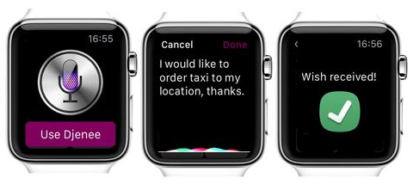
Using Djenee is as easy as speaking to your Apple Watch

Crowdfunding is fast becoming a route for start-ups to raise funds, and if Djenee’s (read “genie”) record-breaking campaign on FundedByMe is any indication, it’s here to stay. Djenee, a start up focused on personal on-demand digital concierge service, will be basing operations in Singapore. Raising almost S$500,000 on the first day of the campaign on FundedByMe, the campaign set a new standard for equity crowdfunding in Asia.

Investor interest in Djenee comes hot on the heels of Magic, a similar service based in the US, which recently raised money at a US$40million valuation just after six months of operations.

If pundits’ predictions on the end of apps are to believed, digital concierge services like Djenee (read ‘Genie’) will dominate how we get stuff done on our smart devices.

“People have busy lives, and are desperately trying to simplify. Tech hasn’t done much to solve that problem. There are a million apps out there and we’re still as busy as ever. This is why we built Djenee. You simply ask Djenee, and it gets done,” said Co-Founder and CEO Pär Helgosson.

Pär continued, “We think we’re onto something huge, and the response to our campaign is a sure sign that agree with us.”

Helgosson and his team were previously from The Service Corporation, specialising in providing sourcing and support services to high-growth companies. With decades of experience, the team is focusing its energies and expertise on making Djenee the next phenomenon in service delivery.

“We’re extremely excited about partnering with Djenee to raise their very first round of funding, which broke records for Asia and with investors from all around the world. This is a start for crowdfunding in Asia and we expect South-East Asia to exceed US$1 billion as a market by itself in the next few years. FundedByMe will give companies a global stage for companies in Asia to find investors, so that these companies accelerate and build powerful momentum from day one,” said Daniel Daboczy, CEO and Co-Founder of FundedByMe.

The campaign is still live here.

Crowdfunding in Asia is quickly gaining momentum, with Malaysian authorities announcing licenses for equity crowdfunding platforms to operate in the country. Asia-focused crowdfunding platforms CoAssets, FundedByMe, and New Union also launched a regional alliance in May this year.

