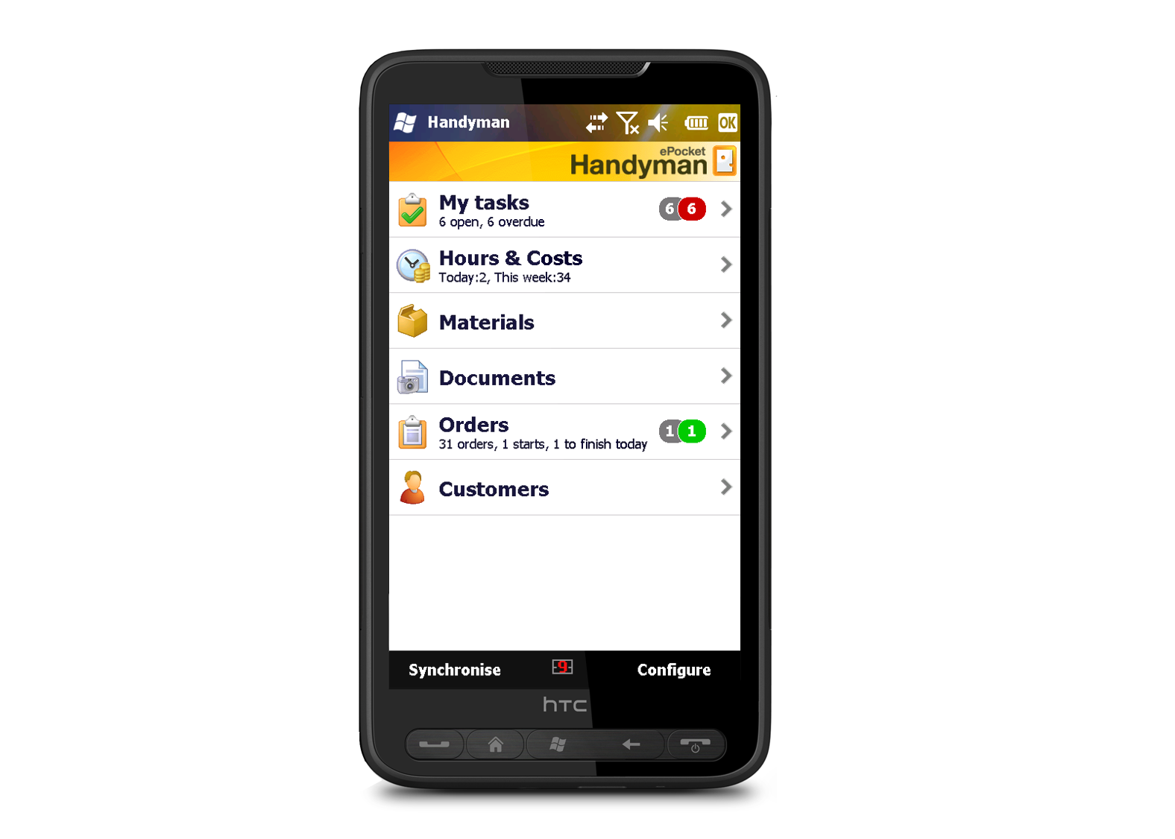[](http://www.epockethandyman.com)

PRESSRELEASE · Wednesday, 19 May 2010

# ePocket Handyman — mobile field service software integration with Microsoft Dynamics

**ePocket Solutions AS** has its main office in Oslo, Norway, and several offices in Europe. Via a partner network ePocket Solutions AS has coverage in 14 other countries including Denmark, Finland and the Baltic states. In Scandinavia, ePocket is the market leader and the company is expanding its European customer base rapidly.

**Handyman** is the world’s most advanced service management software suite, adapted to the needs of mobile service technicians and their office-based co-workers. Handyman allows the service technician in the field to exchange data with office- based co-workers using a PDA or smartphone. The ability to access and input data on the move speeds up critical processes improves service quality and minimizes downtime.

**ePocket Solutions AS** has deep expertise in both the technology and process of field service management The all star software development team and innovative software design practices behind the Handyman platform ensures consistency and completeness in managing almost any service task. ePocket Solutions agile software development methodology helps provide regular product updates to customers with minimum disruptions to their business.

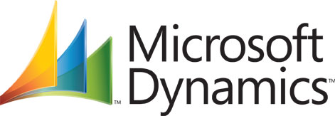

For more **information** : [**www.ePocketHandyman.com**](http://www.ePocketHandyman.com)

Jarl Spandow, Mobile phone: +47 900 34 713

E-mail: [jarl.spandow@epocket.no](mailto:jarl.spandow@epocket.no)

ePocket Solutions, a leading provider of standardized mobile software solutions to service organizations, has announced the successful integration of its flagship Handyman product with Microsoft Dynamics Axapta and Navision. ePocket Handyman is amongst the world’s most advanced mobile work order management solutions and it enables mobile users equipped with a PDA or a Laptop to view open work-orders, register work tasks as they are completed, and manage onboard inventories in their service vehicle as well as purchase materials on-line from wholesalers´ catalogs.

ePocket Solutions is one of the first field service software companies worldwide to offer a standardized integration with Microsoft Dynamics Axapta as well as Navision. Handyman uses a standard XML interface to integrate with ERP solutions thereby facilitating easy integrations with any third party software. The recent integration with Microsoft Dynamics is a testimony to ePocket’s commitment to provide standard adaptors for all leading ERP solutions.

ePocket Solutions CEO Jarl Spandow says; “We are pleased to announce this important integration to our partners and customers. Microsoft Dynamics is one of the fastest growing ERP suites today and is in use at many of our customer sites. Dynamics represents a key part of our business strategy as a Microsoft development partner”

**The Handyman Add-In for Microsoft Dynamics Navision provides following capabilities**

* Export from NAV to Handyman including basic data for employees, salary codes, departments, order categories, stores, material catalogues and material groups, customers, work orders and store movements.
* Import from Handyman to NAV including work orders (sales, service and projects), store movements, store control and import/export status messages
* Access order-specific Handyman functions through NAV user interface including addition of checklists to orders, Handyman resource planner, Handyman reports for orders, warnings and system messages.

**next page >>**

**The Handyman Add-In for Microsoft Dynamics Axapta provides following capabilities**

* Export from MS Dynamics Axapta to Handyman including basic data for employees, salary codes, customers, items and stores with content.
* Import from Handyman to MS Dynamics Axapta including orders, store movements and store control

**About Microsoft Dynamics**

Microsoft Dynamics is a line of software products covering financial, customer relationship and supply chain management solutions that help businesses work more effectively. Delivered through a network of channel partners providing specialized services, these integrated, adaptable business management solutions work with familiar Microsoft software to streamline processes across an entire business.

<http://www.microsoft.com/dynamics/en/us/default.aspx>

**Keywords**: ePocket, epocket handyman, epocket PDA, epocket service, handy man software, handyman enterprise software, handyman field service software, epocket Microsoft dynamics, epocket ms dynamics, handyman Microsoft dynamics, handyman Microsoft dynamics ax 4.0, handyman Microsoft dynamics nav, handyman Axapta, handyman Navision, xml integration Microsoft dynamics, handyman xml erp interface, handheld erp integration, handyman erp integration

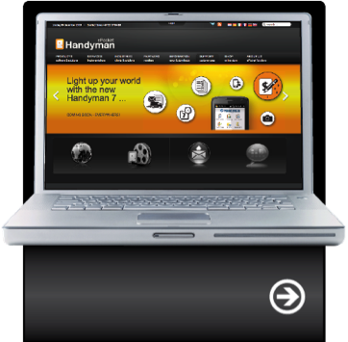

read more about us:

epockethandyman.com

