The Bäckman siblings competes in two different championships in 2022
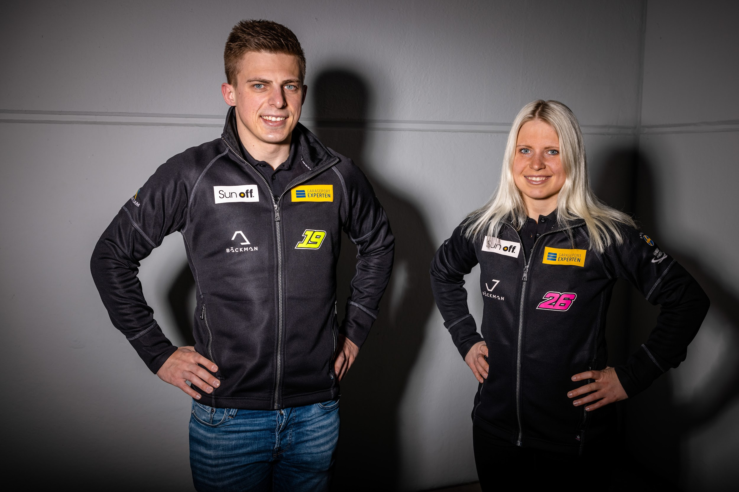
Andreas and Jessica Bäckman.
Photo: FIA WTCR (Free rights to use the image)
The siblings Andreas and Jessica Bäckman from Sweden today announced that in 2022 they will be racing in two different championships, STCC and TCR Germany, for the first time.
- Last time I raced in TCR Germany I was 2nd at the Hockenheimring and close to my first win. My goal for this season is to fight for the top positions in the championship and to take my first win in TCR, Jessica Bäckman says.
Andreas and Jessica Bäckman have, despite their young age, already achieved great success in karting, rallycross and racing. In 2018, they both competed in STCC and the British counterpart TCR UK, where Andreas, among other things, took his very first racing victory and finished in third place in the championship. Jessica managed to grab a podium place at Brands Hatch and therefore became the first woman in TCR UK to take a podium place and also finished fourth in the championship. In 2019, the siblings took the step up in the European championship “TCR Europe” and competed there in 2020 as well. Over the years, Andreas has taken several wins and pole positions in the European Championship, while Jessica has managed to take podium places in 4 different TCR championships, while making history as the first woman ever to finish on the podium in TCR Europe.
The goal towards the championship titles in Sweden and Germany
Last year's adventure in the World Cup for TCR cars, FIA WTCR, was a tough year for the siblings where the team had difficulties adapting to the new car, and the siblings could not show their potential as a driver. For season 2022, the siblings have instead gone a completely different path. For the past four years, Jessica and Andreas have driven in the same championship, but now it is official that this year they will not compete against each other but in two different countries and championships. Andreas makes a comeback in the Swedish Championship STCC (Scandinavian Touring Car Championship), where he last did a full season in 2018. Jessica makes her first full season in the German Championship ADAC TCR Germany, where she made several successful races before and also took a podium place.
Andreas will compete for the championship-winning team Lestrup Racing Team, and together with the team he has high goals for 2022:
- It feels exciting to be back in STCC and Swedish racing again. After a one-off appearance last autumn in STCC at Mantorp, I got to show what I can do in a competitive car, which aroused interest in several teams during the winter. It will be an exciting venture where I aim to take home the championship title in STCC 2022 together with Lestrup Racing Team, Andreas Bäckman says.
Jessica will compete in a Hyundai TCR car for ROJA Motorsport in ADAC TCR Germany and is looking for her first TCR win in 2022:
- It will be fun to compete in TCR Germany again, I like both the race format and the german circuits. Last time I drove in TCR Germany I was 2nd at Hockenheimring and close to my first win. My goal for the 2022 season is to fight for the top places in the championship and take my first win in TCR, Jessica Bäckman says.
The structure of the ADAC TCR Germany series
The 2022 season in ADAC TCR Germany will consist of five races in Germany and two races in Austria. The series is one of the toughest TCR series in the world and competitive drivers. The start of the season will be on the Oschersleben track in Germany and will finish on the well-known Formula 1 track Hockenheimring in Germany. In addition to the Hockenheimring, the world-famous Formula 1 tracks Nürburingring and Red Bull Ring will also be on the calendar in 2022. Each race weekend consists of two free practice sessions, two timed qualifyings and two races. Points are awarded to the top 10 in the timed qualifyings and to the top 15 in each race. The driver with the most points after the final race at the Hockenheimring at the end of October will take home the drivers title in the ADAC TCR Germany series and become the ADAC TCR Germany champion.
The structure of the STCC championship
STCC (Scandinavian Touring Car Championship), also called TCR Scandinavia, is Sweden's and Scandinavia's most prestigious racing championship and is today the leading class for touring car racing in Sweden. The cars are built according to the global TCR regulations, which means that, for example, the same cars and tires are being used in the other TCR championships around the world. The series consists of six races that are run on the best tracks in Sweden, everything from well-known tracks such as Mantorp Park, and the series is run on tracks from Ring Knutstorp down in the South of Sweden to Drivecenter Arena in Skellefteå up in the North of Sweden. Each event is built on two free-practice sessions, a qualifying consisting of two rounds and three races, where the third race has a reverse starting order for the top 8 from the second race. Points are awarded to the top 5 in the qualifying and to the top 15 in each race. The driver with the most points after the last race at Mantorp will take home the driver's title in the STCC championship and also the Swedish Championship gold medal.
The co-owner of Lestrup Racing Team is happy to have Andreas on board
- I think that the entire STCC paddock was impressed by Andreas' performance at Mantorp Park last year and we are happy to have him on board in our goal to regain the STCC titles this year. We have been keeping an eye on Andreas for a while now and he has taken great strides forward in recent seasons. We have a lot of work ahead of us to get ready for what is to come and I have no doubt that he can deliver, Fredrik Lestrup says, co-owner of Lestrup Racing Team.
The team manager of ROJA Motorsport welcomes Jessica to the team
- We are very proud to welcome Jessica to our team for the ADAC TCR Germany 2022 season. I know and have followed Jessica´s career for quite a while and she already did a guest start in 2019 for my former team Engstler Motorsport in ADAC TCR Germany at Most. I am totally convinced of her both very strong driving skills and her fighting spirit and I am sure that Jessica will achieve stunning results in her first full season entry in ADAC TCR Germany series, Andreas Klinge says, Team Manager of ROJA Motorsport.
Andreas and Jessica Bäckman look forward to competing in two different championships in 2022, which they think they can benefit from by helping each other succeed. It will be a tough season where the siblings will give everything they have and continue to develop as drivers. The season starts for Jessica on April 22nd-24th on Oschersleben track in Germany and for Andreas on June 3rd-4th on the Ljungbyhed track in Sweden.
ADAC TCR Germany 2022 Calendar:
April 22nd-24th - Oschersleben, Germany
May 20th-22nd - Red Bull Ring, Austria
June 17th-19th - Salzburgring, Austria
August 5th-7th - Nürburgring, Germany
August 19th-21st - Lausitzring, Germany
September 23rd-25th - Sachsenring, Germany
October 21st-23rd - Hockenheim, Germany

STCC 2022 Calendar:
June 3rd-4th - Ljungbyhed, Sweden
June 17th-18th - Skellefteå, Sweden
July 22nd-23rd - Knutstorp, Sweden
August 19th-20th - Gelleråsen, Sweden
September 10th-11th - Anderstorp, Sweden
September 30th- October 1st - Mantorp, Sweden

Free rights to use the images.
Download press-photos here:
http://bit.ly/jabaeckman-photos
https://www.mynewsdesk.com/se/ja-backman/images

