|  |
| --- |
| PRESS RELEASE |
| København, 15. juli 2019 |
|  |
|  |

**DS TECHEETAH OG JEAN-ÉRIC VERGNE KAN KALDE SIG DOBBELT VERDENSMESTRE**

DS TECHEETAH har investeret stort i den nye elektriske motorsport – og i går, på den franske nationaldag, kom belønningen i form af en dobbelt VM-titel. Det blev til en flot sejr i team-mesterskabet og samtidig kunne Jean-Éric Vergne, som den første kører nogensinde, hæve mesterskabspokalen for andet år i træk.

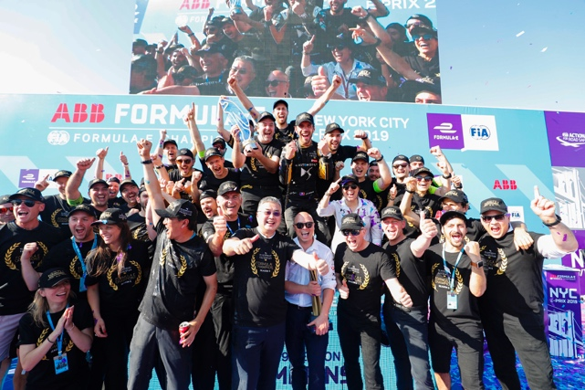Det unge brand, der satser stort på elektriske motorer, måtte se 2 nervepirrende løb i Brooklyn før Jean-Éric kunne køre over målstregen som 2018/2019 ABB FIA Formula E verdensmester, og teamet ligeledes kunne fejre team-titlen. Som Mark Preston, DS TECHEETAH Team Principal siger: ”Denne finale weekend kunne ikke starte dårligere og slutte bedre, hvilket cementerer vores styrke i mesterskabet. Og viser, at motorsport er teamwork.

Den nykårede verdensmester, Jean-Éric Vergne, siger selv: ”I dag har været en helt utrolig dag. Weekenden startede på ingen måde som forventet, og i dag, søndag, var heller ikke ideel, men på grund at en god sæson og et fantastisk team, kunne vi alligevel tage begge mesterskabstitler. Det er stadig lidt uvirkeligt, at være den første kører, der bliver dobbelt verdensmester. Og jeg kan kun takke teamet for det.”

Team-kollegaen, André Lotterer siger. ”Det allerstørste tillykke til JEV og teamet. Jeg har aldrig oplevet et team som dette i hele min motorsports karriere. Alle har fortjent at vinde de 2 titler i dag. Jeg ville selv ønske, at jeg kunne have bidraget bedre til den samlede stilling i ABB FIA Formula E 2018/2019 mesterskabet, men det var ikke min weekend, og det vigtigste er, at vi vandt.

Se mere på: <https://www.fiaformulae.com/>

Se resultaterne fra kørernes mesterskab på: <https://www.fiaformulae.com/en/results/standings/driver>

Se resultaterne fra team mesterskabet på:

<https://www.fiaformulae.com/en/results/standings/team>

## ABOUT DS TECHEETAH

DS TECHEETAH Formula-E team is a Chinese racing team in the all-electric street racing series, ABB FIA Formula E. The team is owned by SECA (Shanghai) Limited.

The team won the 2017/2018 Drivers' Championship title with Jean-Éric Vergne and together with André Lotterer, the team secured second place in the Teams' Championship in the 2017/2018 season of Formula E.

Heading into the 2018/2019 season e of the all-electric championship, TECHEETAH has partnered with DS Automobiles to become DS TECHEETAH.

## ABOUT CHINA MEDIA CAPITAL (CMC)

China Media Capital ("CMC"), founded and chaired by Ruigang Li, is one of the most prestigious names in media and entertainment investment and operation in China and global markets. CMC has created and grown a number of champions and emerging leaders in the sectors of media and entertainment, Internet and mobile, and life style, covering film, television, music, sports, location-based entertainment, financial media, financial data service, online-video, smart TV, advertising, social network, game, online-education, e-commerce, O2O and etc.

## ABOUT SECA

Headquartered in Shanghai, SECA is a leading Chinese sports marketing and management company specializing in sports talent representation, event management and content/IP development. The company's investors include China Media Capital (CMC) Holdings and member of NBA Hall of Fame, Yao Ming.

## ABOUT DS AUTOMOBILES

Driven by the avant-garde spirit and backed by an exceptional heritage of the 1955 DS, DS Automobiles, launched in 2015, aims to embody French luxury savoir-faire in the automotive industry. DS Automobiles is the PSA Group's Premium brand.

Designed for customers seeking personal expression and eager for the latest technologies, the second-generation DS models combine refinement and advanced technology. With the SUVs DS 7 CROSSBACK and DS 3 CROSSBACK, the DS brand is launching a range of six worldwide vehicles, all offered in electrified versions under the E-TENSE signature.

For its demanding customers, DS Automobiles has created "ONLY YOU, the DS experience", its exclusive service program for a unique brand experience.

Present in 32 countries, the DS brand has created and is developing an exclusive distribution network that includes 400 DS STORES and DS SALONS throughout the world in early 2019.

|  |
| --- |
| logo.png |