

**PRESS RELEASE**

For immediate release: Friday 27 February 2015

**ID Medical remains stalwart placed yet again in The Sunday Times 100 Best Companies to Work for 2015**

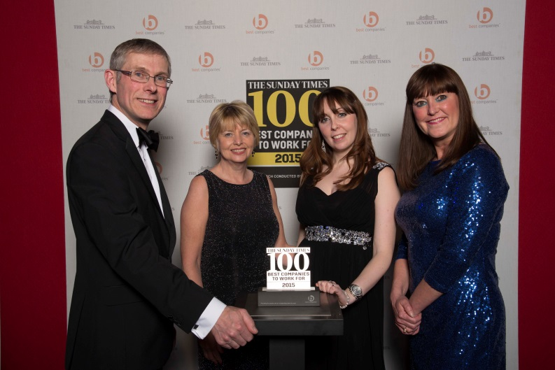

Two years running, ID Medical beats global organisations into The Sunday Times Best Companies to Work For league table as announced at the awards celebration on Thursday 26 February.  The UK’s leading multi-discipline healthcare recruiter is rewarded a position in the top 3rd quartile of [The Sunday Times 100 Best Companies to Work for 2015](http://features.thesundaytimes.co.uk/public/best100companies/live/template).

Being the third consecutive year ID Medical has earned its 2 star accreditation signalling an ‘Outstanding’ organisation, ID Medical has yet again been recognised for its commitment to employee satisfaction and wellbeing. 2014 saw the company grow by a significant 33%, fuelled by its strong continuous industry-leading workforce solutions to the NHS and private sector. And to accommodate this phenomenal rate of growth expanded its corporate headquarters, employing further talent across all business functions to exceed increasing demand for its recognised recruitment services.

Deenu Patel, managing director of multi-discipline healthcare recruiter ID Medical reflects upon the achievement.

“Being named as one of The Sunday Times 100 Best Companies to Work for 2015 is always a colossal achievement for ID Medical. We continually invest in training and staff development in order to make ID Medical a stimulating and enjoyable place to work. I am delighted that this investment is paying off in terms of attracting and retaining a highly talented force, and we are constantly looking for new aspiring professionals to join our company.

“It fills me with great pride to know that our employees feel valued and are passionate about where the company is headed, as well as being confident in their own careers at ID Medical. Being recognised by The Sunday Times once again is something the ID Medical team as a whole can be proud of.

Following the awards ceremony, the official Sunday Times Best Companies to Work for 2015 list will be published in The Sunday Times newspaper this coming Sunday 1st March.

## ENDS

**About The Sunday Times**

The Sunday Times Best Companies has been producing and publishing the ‘Best Companies to Work for’ lists since 2001 to measure and acknowledge excellence in workplace engagement. In 2015, 1055 companies applied to participate in the employee engagement survey, 428,719 employees were surveyed and 707 of those companies gained accreditation. Only organisations with the highest level of overall employee engagement qualify for the 100 Best Companies to Work for list.

**About ID Medical**

Award-winning, multi-discipline healthcare recruiter ID Medical was formed in 2002 and is a superior quality supplier of locum doctors, nurses, allied health professionals and clerical staff to over 90% of NHS hospitals and private medical sector organisations.

From its headquarters in Milton Keynes as well as its Central London office, ID Medical provides practical, cost-effective and **innovative workforce solutions**, supplying over 3 million hours to the NHS per annum. Crown Commercial Service (CCS), HealthTrust Europe (HTE) and London Procurement Partnership (LPP) framework approved, ID Medical receives over 38,000 available shifts per month in hospitals nationwide.

Since its foundation, the company has earned itself industry-wide accreditation and success with an amounting collection of accolades. These include the Recruiter FAST 50, Real Business Hot 100, Recruitment International Top 250 and The Sunday Times Virgin Fast Track 100. Most notably, through an abiding focus on employee satisfaction, ID Medical was crowned Recruitment International’s ‘Best Recruitment Company to Work for 2013’ and made its debut in The Sunday Times Best Companies to Work for 2014 at list position 33.

For more information please visit our website at [www.id-medical.com](http://www.id-medical.com), view our [Facebook](https://www.facebook.com/IDMedical) page or follow us on Twitter [@IDMedical](https://twitter.com/IDMedical). You can also contact ID Medical’s head of marketing Caryn Cooper direct on:

**Caryn Cooper**

head of marketing

Description: markdes

ID MEDICAL - ID House - 1 Mill Square - Wolverton Mill South - Milton Keynes - MK12 5ZD

**t:** +44 (0) 1908 555 498 **f:** +44 (0)1908 552 825

**w:** id-medical.com   **e:** [caryn.cooper@id-medical.com](mailto:caryn.cooper@id-medical.com)

[cid:image002.png@01CF5FCD.A84FA500](http://www.facebook.com/IDMedical)  [cid:image003.png@01CF5FCD.A84FA500](http://www.twitter.com/idmedical)  [cid:image004.png@01CF5FCD.A84FA500](https://plus.google.com/104338735298043774830/posts)  [cid:image005.png@01CF5FCD.A84FA500](http://www.youtube.com/user/IDMedical2012/videos)