Press Release
Stockholm, August 22, 2017

Six pieces of furniture, four different interior styles

When Svenskt Tenn’s Interior Design Studio takes on a new assignment, there are often some existing furniture or interior details which should be preserved. Coupled with the needs and personality of each client, such legacy becomes the foundation for an interior that is like no other. Now Svenskt Tenn showcases four interior styles, using six selected pieces of furniture in different versions and combinations.
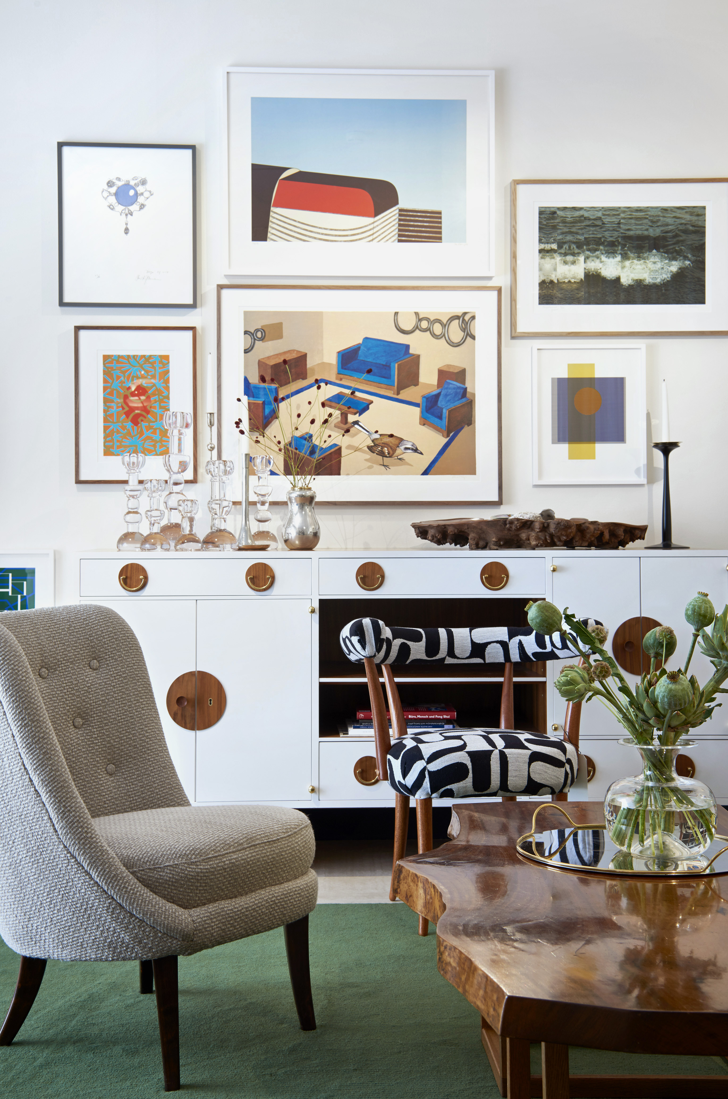
“Our intention is to illustrate how details such as colour, choice of materials and pattern combinations can elicit different expressions from an interior. One piece of furniture can be perceived either as classic, contemporary, Scandinavian or international, just depending on how you elect to present it,” says Emelie Gadmar, manager of Svenskt Tenn’s interior and textile designers, whose studio is located in the store at Strandvägen in Stockholm.

In each of the four exhibition rooms, six furniture items from Svenskt Tenn’s range are placed: one stool, two armchairs, a coffee table, a cupboard and a floor lamp.

The first room is stylish and elegant, with dark, earthy tones and sophisticated materials. Another room may be described as Scandinavian style, using pastel, marble, light wood and leather. One interior has a bright color scheme where white and sheer is blended with rough knit and weaved details. In the fourth and final interior, the expressive furniture, art objects and other things appear to have been placed by chance, an example of the style dubbed ‘Accidentism’ by Josef Frank.

”People are all different. We are attracted by different things and our personal belongings convey an individual history. We hope that visitors will identify with one or several of the interiors in the exhibition, and thus get closer to discovering their own interior style,” says Thommy Bindefeld, Marketing Director at Svenskt Tenn.

For the Interior Design Studio, each assignment begins with a discussion about the thoughts, vision and wishes that the client has for the space to be decorated. The exhibition where the four interiors are displayed is appropriately titled ”Who are you?” and is open through September 17, 2017.

For further information, please contact:

Vicky Nordh, Marketing Assistant: +46 8-670 16 23 or vicky.nordh@svenskttenn.se

Thommy Bindefeld, Marketing Director: +46 8 670 16 02 or thommy.bindefeld@svenskttenn.se

Images can be downloaded from svenskttennpress.se. Username: Press. Password: Tenn

Svenskt Tenn is an interior design company with retail stores at Strandvägen in Stockholm and online. Since 1975, Svenskt Tenn is owned by the Kjell and Märta Beijer Foundation, which provides research grants within ecology, medicine and the preservation of Swedish interior design tradition.

