**Mixed results but a promising season opener for the Bäckman siblings**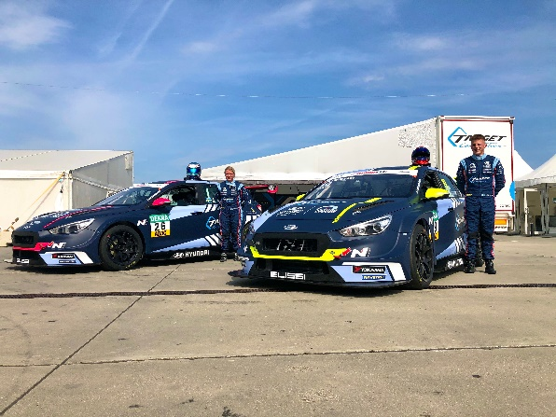Andreas and Jessica Bäckman are ready for the TCR Europe opener this weekend at Paul Ricard, France.   
Photo: Private (Free rights to use the images)

**Andreas and Jessica Bäckman had a guest appearance last weekend in the German TCR championship ADAC TCR Germany, to prepare for next weekends season opener of the TCR Europe Championship. Andreas got his first podium finish of the year with his second position.**

**- It was fun to climb up on the podium straight away in my first race of the year, Andreas Bäckman says.**

Last weekend, August 14-16, the second round of ADAC TCR Germany was held at the Nürburgring track in Germany. It was the Bäckman siblings first race of the year and almost 10 months since they last time raced.

The weekend started promising with good qualifying speed for both siblings on Friday, where Andreas qualified 4th and Jessica 7th for Race 1.

In Race 1 on Saturday, Andreas had a consistent race and finished 2nd behind the 2019 WTCR World Champion Norbert Michelisz, who also was a guest driver of the German TCR championship during the weekend.

- It was fun to climb up on the podium straightaway in my first race of the year. It’s nice to have this result with me when we now recharge for next weekend, August 21-23, when we head to France for the TCR Europe season, Andreas Bäckman says.

Jessica had a tough start in Race 1, when she was involved in a crash directly in the start and had to retire from the race already on the first lap.  
  
Then in Race 2 on Sunday Andreas and Jessica was starting 3rd and 7th respectively (due to a 5-place grid penalty). In the start, Andreas made a jump-start and got a Drive-Through penalty, which meant that he had to drive through the pit-lane after a hard battle with Michelisz for 3rd place during the beginning of the race. Andreas finished the race in 10th after the penalty.

Jessica had some more luck during Race 2 and made a good start. After that she made her way up to 6th place, after a spectacular overtake.

- My weekend had a lot of up-and-downs. I had good speed in both the Qualifying and in the second race, but I had some bad luck in the Qualifying and the first race. But the speed is there, so now we recharge for next weekend, Jessica Bäckman says.

**Timetable for this weekend’s race (TCR Europe round 1):**All times is local time (French time)

**Friday August 21:**09:00 Free Practice 1 14:19 Free Practice 2

**Saturday August 22:**09:00 Qualifying12:50 Race 1 (LIVE at [JA Bäckman's Facebook page](https://www.facebook.com/jabaeckman/) and at [TCR TV on YouTube](https://www.youtube.com/channel/UCoSlmLSprEnTz7HjmMb7HBw))

**Sunday August 23:**12:15 Race 2 (LIVE at [JA Bäckman's Facebook page](https://www.facebook.com/jabaeckman/) and at [TCR TV on YouTube](https://www.youtube.com/channel/UCoSlmLSprEnTz7HjmMb7HBw)) **Live-streaming**Both races are live-streamed at [JA Bäckman's Facebook page](https://www.facebook.com/jabaeckman/), as well as at [TCR TV on YouTube](https://www.youtube.com/channel/UCoSlmLSprEnTz7HjmMb7HBw). **Live-timing**All practice sessions, qualifying and races can be followed via live-timing [HERE](https://europe.tcr-series.com/).

**About the track:**

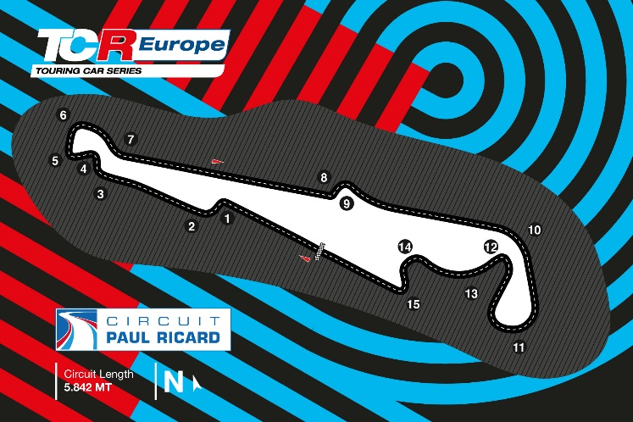

**Located in:** Le Castellet, France

**Length:** 5,842 km

**Corners:** 15

**Race duration:** 10 laps (55 km)

**Lap record (TCR):** 2:13.668 / average speed 157.34 kph, Nicola Baldan (Hyundai i30 N TCR) 2018

​***Free rights to use the images.***