KONGSBERG’s new EM 304 MKII multibeam echo sounder offers major range and swath improvements
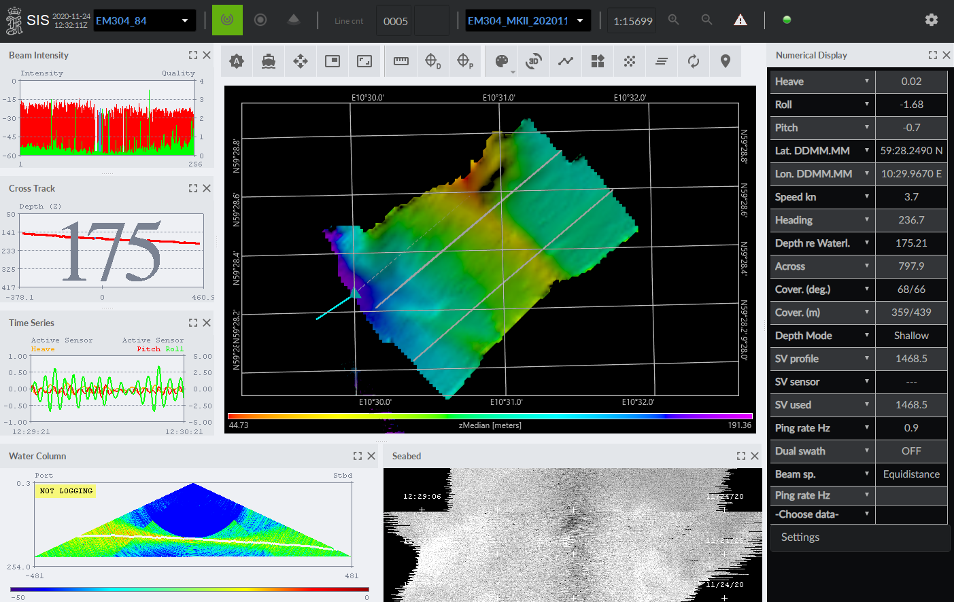
The new EM 304 MKII echo sounder from KONGSBERG boasts long range precision with a wide swath
Kongsberg, Norway, 1st December 2020 – Kongsberg Maritime is pleased to announce the launch of the EM 304 MKII, the newest addition to its portfolio of deep-water multibeam echo sounders. Underpinned by a brand new KONGSBERG-designed wideband transmitter working in the 20-32kHz band with a nominal frequency of 26kHz, the new mapping system significantly improves upon the performance of the MKI model, boosting range from a previous maximum of 8,000m to full ocean depth, and increasing swath performance by up to 75%.
In addition, the EM 304 MKII delivers an unprecedented 0.3° x 0.5° resolution – the highest achieved by a deep-water multibeam echo sounder – yielding optimal performance and precision. Meanwhile, the system’s modular construction and flexible transducer design make installation easy and enable it to be adapted to fit almost any size of vessel.
As part of a new EM technology platform designed to anticipate and address future challenges, the EM 304 MKII is compatible with a novel KONGSBERG-developed datagram format. This supports several innovative features such as extended backscatter calibration, and more features are already in development. The new format is supported by Kognifai, KONGSBERG’s open digital ecosystem, which provides operators with the potential to transform their survey operations via digitalisation as well as hosting all major post-processing software on the market.
“I am very excited to introduce the EM 304 MKII,” says Kjetil Jensen, Product Manager EM Multibeam, Kongsberg Maritime. “As the global effort to map the world’s oceans escalates, we find that our customers are looking for an echo sounder that will not only maintain its resolution in medium depths, but which will also be able to reach well beyond 7,000m while also providing a substantial swath width. Our engineers have done some remarkable work to enable me to proudly introduce the solution to the age-old conundrum – resolution or range? I give you both, courtesy of the EM 304 MKII and KONGSBERG.”
Ends

For further information, please contact:
Gunvor Hatling Midtbø, VP Communication
Kongsberg Maritime
Tel: +47 9921 4209
gunvor.hatling.midtbo@km.kongsberg.com
David Pugh
Saltwater Stone
Tel: +44 (0)1202 669244
d.pugh@saltwater-stone.com

About Kongsberg Maritime
Kongsberg Maritime is a global marine technology company providing innovative and reliable ‘Full Picture’ technology solutions for all marine industry sectors including merchant, offshore, cruise, subsea and naval. Headquartered in Kongsberg, Norway, Kongsberg Maritime has manufacturing, sales and service facilities in 34 countries.
Kongsberg Maritime solutions cover all aspects of marine automation, safety, manoeuvring, navigation, and dynamic positioning as well as energy management, deck handling and propulsion systems, and ship design services. Subsea solutions include single and multibeam echo sounders, sonars, AUV and USV, underwater navigation and communication systems.
Training courses at locations globally, LNG solutions, information management, position reference systems and technology for seismic and drilling operations are also part of the company’s diverse technology portfolio. Additionally, Kongsberg Maritime provides services within EIT (Electro, Instrument & Telecom) engineering and system integration, on an EPC (Engineering, Procurement & Construction) basis.
Kongsberg Maritime is part of Kongsberg Gruppen (KONGSBERG), an international, knowledge-based group that celebrated 200 years in business during 2014. KONGSBERG supplies high-technology systems and solutions to customers in the oil and gas industry, the merchant marine, and the defence and aerospace industries.
Web: Kongsberg Gruppen | Kongsberg Maritime
Social media: LinkedIn | Twitter | Facebook

