Communication is the key nowadays! It refers to both the communication with your clients (external) as well as the communication within your enterprise (internal). In order to have a strong image as a company, remember to have a unified behavior within your firm. Integrated communication will help you to accomplish that!

What is integrated communication?
It is the coordination of brand communication measures in form and content with the goal to unify and strengthen the impressions of your company.
The measures should all work together and support each other. For example, if you have the same pattern in your email and on your website, clients will recognize your company faster. There are five easy steps to shape your communication into an integrated communication. It is a process of analyzing, planning, organizing, carrying out and evaluating the way you communicate.
Let’s see how you can take your communication to the next level!

1. STEP: ANALYSIS
Before we start to change anything about your communication strategy we need to look into what methods you are currently using.
EXTERNAL COMMUNICATION
First, you need to investigate the whole company and the outgoing communication.
- How do you reach your customers? What channels do you use?
- How well do the channels perform?
- What can be done better?
Easier said than done. Finding communication mistakes in your strategies is always hard. Recognizing them, though, is a good way to learn and avoid them in the future.
INTERNAL COMMUNICATION
The same analysis should be applied to the internal communication:
- Is the communication within the company transparent?
- Do you provide employees with feedback and purpose?
- Do you use online tools for internal communication?
POSITIONING
The final step of the analysis is to look at the positioning of your company. This step is needed to decide which communication tools you are going to use later to execute your new communication strategy. A command method to do that is doing a SWOT-analysis.
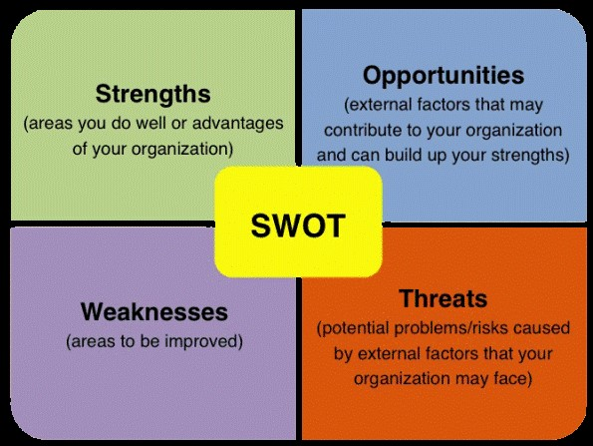
SWOT stands for strengths and weaknesses you have internally and opportunities and threats for external parties. Influencing factors could be your customers, the market, competition and the environment your company is working in.

2. STEP: PLANNING
The planning of the integrated communication is about the desired state. The target group you want to reach is what really matters here. At this stage it is important to specify who your target group is. Are they the customers who want to buy your products, investors or journalists you want to advertise with?
Depending on your target audience you should adjust your tone and the channels you are going to use. If you want to build a more friend-like relationship with your target group, your communication should reflect that as well. You could use a less formal style in your emails or use social networks where people are more likely to get in contact with you.
Determine your goals. What do you want to accomplish? Do you want to engage more with your clients or would you rather build trust? Once you specify this it is easier to find the right message and the main idea.
3. STEP: ORGANIZATION
Organization means the methods you want to use to execute your planned steps. Your new communication strategy should make your work more efficient. To ensure that the new communication strategy is used correctly internally it is helpful that you actually feel in charge. Then you can stimulate creativity and motivate the whole team to stick to the newly established strategy.
4. STEP: EXECUTION
There is not much to explain regarding the execution. You implement the measures we just talked about. Remember to identify new internal communication tools and make sure that all employees are informed about the changes and understand new techniques and ideas. And last but not least, provide everyone with a solid reason for new communication methods and their purpose.

5. STEP: EVALUATION
The final step is to see how effective your integrated communication is. You can make an anonymous survey to see how people adapted to the new methods and to check if they still have the right image in mind.
Review if you accomplished the goals you set. Have you noticed any difference in the way your clients respond to your communication? Is it the change you were hoping for? Evaluate what went right and wrong with the process. Remember to always optimize what you are doing to get the best results possible.

