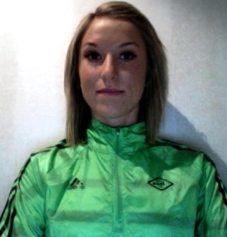 | Name | Date of birth | PB
 | Karoline Bjerkeli Grøvdal | 1990 | 5000m : 15.25 (2010)  Steeple : 9.33.34 (2009)  10 k road : 31.29 (2009)  IAAF-biography  Ranked 29th in the World 2010 on 3000m steeple. Three times EC jr champion in 2009

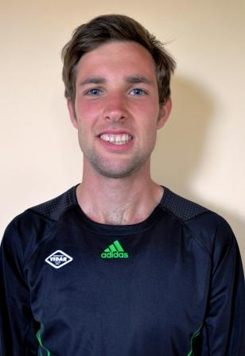 | Name | Date of birth | PB
 | Sindre Buraas | 1989 | 10K road : 28.41 (2011)  3000m : 8.07 (2009)  5000m : 13.41 (2010)  IAAF-biography  Ranked 2th in Europe U23 2010 on the 5000m  World Junior Champion Uphill Running 2008

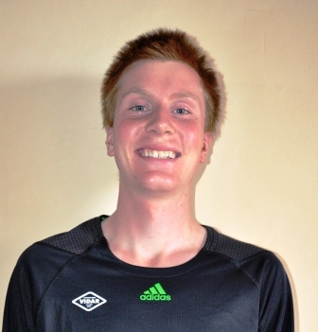 | Name | Date of birth | PB
 | Sondre Nordstad Moen | 1991 | 10K road : 28.50 (2009)  3000m : 8.01 (2010)  5000m : 13.44 (2010, NJR)  IAAF-biography  Ranked 1th in Europe U20 2010 on the 5000m and 10 000m

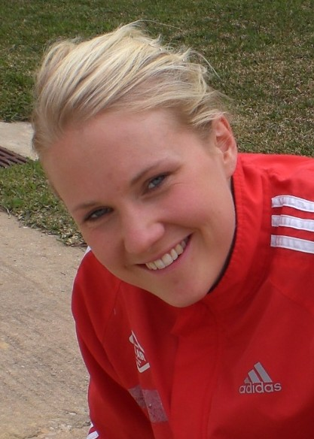 | Name | Date of birth | PB
 | Ragnhild Kvarberg | 1981 | 1500m : 4.07.14 (2006)  3000m : 9.09.59 (2010)  5000m : 15.46.99 (2010)  IAAF-biography  Finished 15th on the 5000m in the EC Barcelona 2010

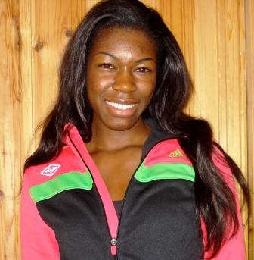 | Name | Date of birth | PB
 | Folake Akinyemi | 1990 | 100m : 11.47 (2009)  200m : 23.61 (2010)  IAAF-biography  Finished 2th on the 100 m in the EC Jr Novi Sad 2009. Reached semifinals in the WC indoor in Doha 2010 on the 60m.

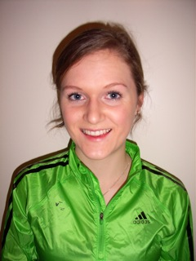 | Name | Date of borth | PB
 | Ingeborg Løvnes | 1992 | 1500m : 4.22 (2010)  2000m steeple : 6.36.75 (2010)  IAAF-biography  Ranked 5th in the World on 2000m steeple U20  Ranked 22th in Europe on the 1500m U20

 | Name | Date of Birth | PB
 | Silje Fjørtoft | 1987 | 3000m : 9.16.88 (2009)  3000m Steeple : 9.37.97 (2009)  IAAF-biography

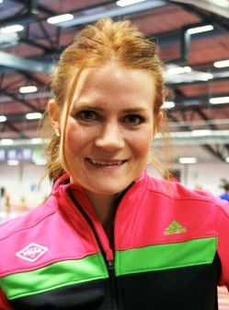 | Name | Date of birth | PB
 | Stine Tomb | 1986 | 400m : 53.49 (2009)  400m hurdles : 57.10 (2010)  IAAF-biography  World record holder on the 300m hurdles indoor -40.09, Tampere 2011

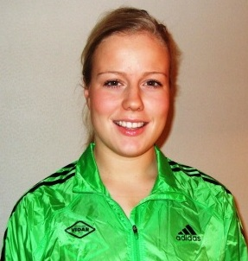 | Name | Date of birth | PB
 | Katja Vangsnes | 1991 | Hammer throw : 61.08 (2010)  IAAF-biography  Finished 9th in the Jr. WC in Moncton 2010

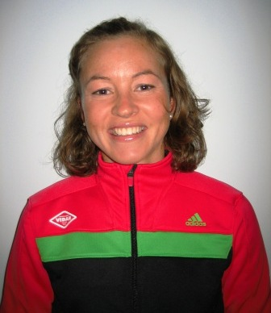 | Name | Date of birth | PB
 | Christina Bus Holth | 1980 | Half marathon : 1.14.54 (2010)  10 km road : 33.58 (2010)  Marathon : 2.37.13 (2010)  IAAF-biography  EC Barcelona 2010 : finished 29th on the marathon

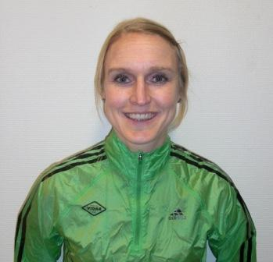 | Name | Date of birth | PB
 | Kjersti Karoline Danielsen | 1979 | Half marathon : 1.14.25 (2011)  Marathon : 2.37.23 (debut) (2009)  IAAF-biography  EC Barcelona 2010 : finished 25th on the marathon

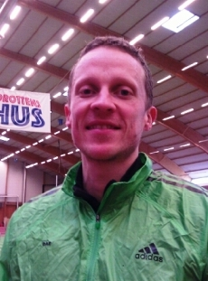 | Name | Date of birth | PB
 | Andreas Totsås | 1981 | 400m hurdles : 50.86 (2008)  IAAF-biography  Norwegian Champion four years in a row.  Part of the Norwegian EC Barcelona team 2010

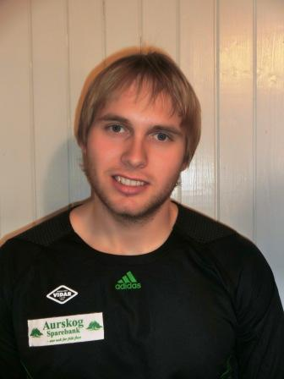 | Name | Date of birth | PB
 | Magnus R. Berntsen | 1989 | Discus : 57.07 (2010)  IAAF-biography  Ranked 18th in Europe (U23) 2010

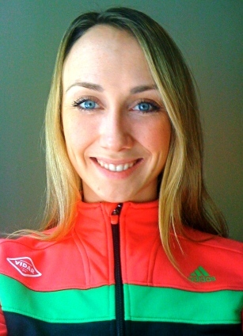 | Name | Date of birth | PB
 | Siri Eritsland | 1985 | 100m : 11.86 (2009)  IAAF-biography  Norwegian Record Holder 4x100m, part of Norwegian relay team EC Barcelona 2010

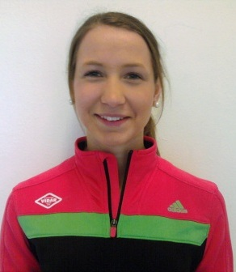 | Name | Date of birth | PB
 | Astrid Mangen Cederkvist | 1994 | 100m : 12.07 (2011, indoor)  60m indoor : 7.65 (2011)  Two times Norwegian Jr Champion (2010)  Second place 60m&200m NC indoor 2011

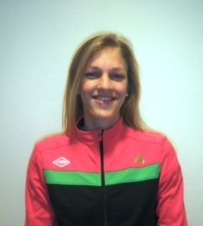 | Name | Date of birth | PB
 | Line Kloster | 1990 | 400m indoor : 54.46 (2011)  Second in the Nordic U23 Championchips 2010  Norwegian recordholder 300m U23 (2010) and 400m U23 indoor (2011)

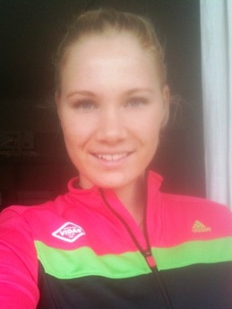 | Name | Date of birth | PB
 | Tine Teigene Dalen | 1990 | 100m hurdles : 13.76 (2008)  400m hurdles : 60.03 (2009)  IAAF-biography  Jr WC, Bygdoszcz, 2008, semifinals  Part of the Norwegian 4x100m relay team that finished 5th at the Jr EC in Novi Sad 2009

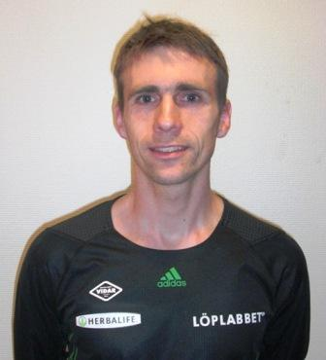 | Name | Date of birth | PB
 | Øystein Sylta | 1978 | Steeple : 8.31.52 (2009)  Maraton : 2.17.42 (2009)  IAAF-biography  Part of the Norwegian EC team Barcelona 2010, Nordic Cross Champion 2008

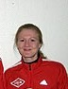 | Name | Date of birth | PB
 | Fride Vullum-Bruer | 1976 | Maraton : 2.45.34 (debut) (2010)  IAAF-biography  Norwegian Champion Marathon 2010

 | Name | Date of birth | PB
 | Vibecke Brun | 1986 | 400m : 54.41 (2009)  400m hurdles : 60.85 (2009)  Three times Norwegian Champion 2009&2010

