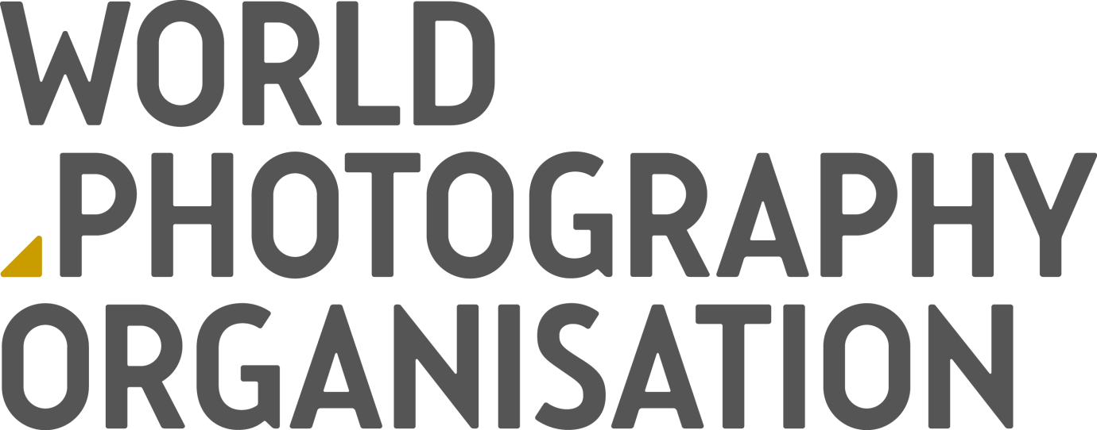

IMAGE USE TERMS AND CONDITIONS

The World Photography Organisation supports the Artists’ Bill of Rights and respects the copyright of our photographers at all times. By publishing the images supplied by the World Photography Organisation for you agree to the Terms and Conditions of this agreement as outlined below.

Image credit
∙ Each image must be credited as per the information downloaded with the file.

Copyright
∙ Ownership and copyright of the image remains with the photographer at all times
∙ The permission granted in this agreement is personal to you and your downloaded image may not be used by any third party
∙ If you are supplied with a website username and password by the World Photography Organisation you must not disclose these details to any third party

Image use
∙ Images are offered on a non-exclusive basis for single use only (i.e. for one edition of a single publication)
∙ Images can be used in an editorial context only and must specifically refer to the event the image is connected with – for example, the Sony World Photography Awards
∙ Images shall not be altered or manipulated, added to, or have any part deleted without our prior written consent
∙ Images must not be used for advertising, commercial, promotional, merchandising or endorsement purposes
∙ Images may not be used in any way that is or might be deemed defamatory, libelous, pornographic, obscene or immoral
∙ Images must not be printed any larger than ½ page without prior written permission

Social media

- When using on social media all images must have the photographer credit overlaid
Coverage
∙ Upon publication, please provide the World Photography Organisation with at least one complimentary copy of any publication in which image appears.
∙ All publications should be sent to Press Department, World Photography Organisation, 9 Manchester Square, London, W1U 3PL

For all inquiries please contact Jill Cotton, PR Director, World Photography Organisation press@worldphoto.org / +44 (0) 20 7886 3043

