MEDIA RELEASE

Pan Pacific Hotels Group pledges to remove single-use plastics by 2019
All properties worldwide will offer more environmentally-sustainable alternatives

23 October 2018, Singapore — Guided by its core values and brand philosophy to conduct business with sincerity and integrity, Pan Pacific Hotels Group has pledged to eliminate all single-use plastics by 2019 to do its part for the environment.

As part of the Group’s eco-conscious initiatives, several efforts are in place, with others underway:
- Removed all plastic straws across all properties globally since July 2018
- Adopting environmentally-friendly options for pens, stirrers, takeaway coffee cups/boxes
- Removing plastic wraps for in-room slippers and plastic laundry wraps;
- Exploring environmentally-friendly options for in-room amenities; and
- Expanding recycling efforts from used soap to non-disposable plastics.

Mr Neo Soon Hup, Senior Vice-President, Operations, Pan Pacific Hotels Group, says, “We pride ourselves as a world citizen with a heart towards our environment. Guided by our core values and brand philosophy, we believe in conducting business with sincerity and integrity. We respect our environment and demonstrate our commitment through initiatives such as the phasing out the use of disposable plastics at our hotels, all with a view for the future and our next generation. We are taking sustainability to the next level by looking at the traceability of food produce and ways to minimise food waste generated at our properties in the near-term.”
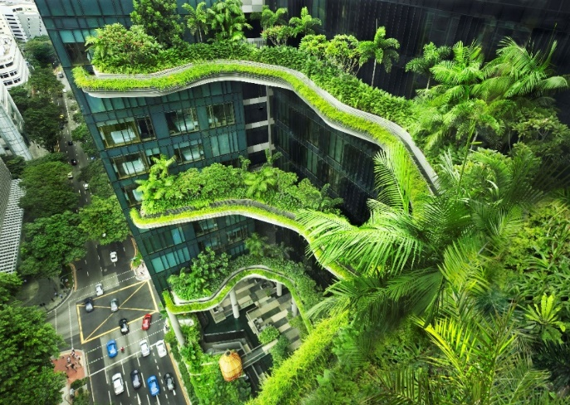
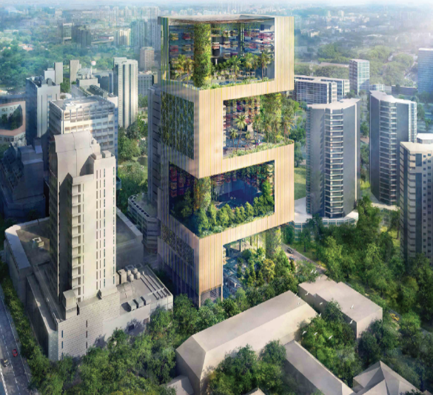
More importantly, Pan Pacific Hotels Group is an industry leader which has taken significant steps beyond adopting environmentally-friendly practices to designing and building hotels that are sustainable. Its first success is PARKROYAL on Pickering, a highly-awarded hotel-in-a-garden which is four-time winner of World Travel Awards’ Asia’s Leading Green Hotel, and World Luxury Hotel Awards’ Best Luxury Green Hotel.

Joining soon will be Pan Pacific Orchard in Singapore, another architectural icon along Orchard Road. Designed and built to be zero-impact and zero-waste, the hotel will be a showcase of environmental sustainability when it is completed in 2021. Pan Pacific Orchard will feature, amongst other innovative elements, a rainwater harvesting system, a recyclable water system, and a compactor which turns food waste into compost. The public spaces, meeting spaces and guestrooms are designed to optimise natural daylight.

Compared to five years ago, Pan Pacific Hotels Group’s properties in Singapore have collectively achieved a 24.8 per cent reduction of energy and water intensity per guest night. Besides PARKROYAL on Pickering, PARKROYAL on Kitchener Road is also Green Mark Platinum-certified for its environmentally-sustainable practices, an accolade it has retained in the last few years, while the 790-room Pan Pacific Singapore is Green Mark-certified.

Outside of Asia-Pacific, Pan Pacific Vancouver has achieved a “Four Key” rating from Green Key Global for its efforts in environmental conservation, which includes recycling programmes and sustainable F&B practices. Meanwhile, Green Globe-certified Pan Pacific Seattle, which is known for its focus on the community, is an active donor of food and toiletries to local shelters and regularly sends soap for recycling, which is then distributed to at-risk communities in the U.S. and developing countries.

-ENDS-

Media Contact
Cuili NG
Brand & Corporate Comms Manager
Pan Pacific Hotels Group
DID: +65 6808 1269
Mobile: +65 9634 4425
Email: ng.cuili@pphg.com

About Pan Pacific Hotels Group
Pan Pacific Hotels Group is a wholly-owned hotel subsidiary of Singapore-listed UOL Group Limited, one of Asia’s most established hotel and property companies with an outstanding portfolio of investment and development properties.

Based in Singapore, Pan Pacific Hotels Group owns and/or manages more than 40 hotels, resorts and serviced suites including those under development in 24 cities across Asia, Oceania, North America and Europe.

Voted “Best Regional Hotel Chain” by readers in Asia-Pacific in 2017 and 2018, Pan Pacific Hotels Group comprises two acclaimed brands: its signature brand, Pan Pacific and its deluxe brand, PARKROYAL.

Sincerity is the hallmark of Pan Pacific Hotels Group. The Group is known to its guests, partners, associates and owners for its sincerity in people and the sense of confidence which alleviates the stresses of today’s complex world.

Visit us at www.panpacific.com.

