Press release
Düsseldorf, 14/06/2023
The role of storage systems in the face of disrupted supply chains
The disrupted supply chains due to the effects of the Corona pandemic and the Ukraine war have led to product scarcity, rising costs, and extended delivery times. Increasing storage capacities is one possible solution. However, obtaining storage technology is currently also challenging and comes with high investment costs. Buying used equipment offers an alternative.
The worldwide spread of the Corona virus and the ongoing Ukraine war have led to significant disruptions in global supply chains. The effects of these crises are felt in almost all sectors of the economy. Products are scarce, becoming more expensive and experiencing longer delivery times.
One way to overcome disrupted deliveries is through the establishment of local supply chains and promoting regional production. Relocation is the keyword. However, this is accompanied by an increasing demand for logistics properties.
Another important approach is to increase one’s own storage capacities in order to ensure the supply security of production. A survey conducted by the German ifo Institute at the end of last year shows the trend in Germany: almost 70% of the companies surveyed have expanded their warehouses due to the disrupted supply chains. However, there are differences depending on the company size. SMEs in particular increased their capacities (73% compared to 64% for large companies), while large companies are increasingly looking for new suppliers (72% compared to 55% for smaller companies).
Storing is expensive
One potential disadvantage of increased storage capacity lies the associated costs. Setting up and operating a warehouse requires investment in infrastructure, staff, Storage systems and security measures. These costs can impact both the financial and operational efficiency of a company. In addition, there is a the risk of inventory loss with prolonged storage, such as spoilage, theft or obsolescence, which can lead to financial losses. Careful planning and monitoring are necessary to ensure optimal management of inventory and minimise these risks.
Full automation can be a solution to overcome some of these drawbacks. By employing automated storage systems and technologies, warehouse processes can be made more efficient. Automated warehousing systems, for example, utilise robots, stacker cranes, automated guided vehicles and computer-controlled systems to store, organise and transport goods. Additionally, full automation enables the use of vertical storage space, maximising storage capacity. It should be noted, however, that full automation again involves high investment costs for the acquisition.
Storage technology is also difficult to supply
The production of storage systems is also hindered by disrupted supply chains. Especially fully automated technology requires specialised components. In view of the current bottlenecks in the procurement of storage systems, buying used equipment is gaining in importance. Where companies go bankrupt, close down sites or restructure their production, operational equipment such as storage technology is also discarded.
Purchasing used storage systems
At the industrial auction house Surplex, there is currently a fully automatic, computer-controlled storage system from 2010 available for direct sale. The warehouse was previously used by the Slovenian furniture manufacturer ALPLES as well as GORENJE, a manufacturer of household appliances, and is located in Železniki (Slovenia). Surplex, known for its auctions of used machinery, not only offers more than 800 auctions per year, where up to 55,000 industrial goods change hands. Surplex.com also offers direct sales of individual machines or entire production lines – a total of around 3,000 per year. The machines sold directly are of particularly high quality or exceptional, just like the Alples/Gorenje storage system. In addition to the current sale, there are always auctions with items from storage technology and factory equipment.
The warehouse system on offer includes not only the computer-controlled technology, but also the associated building. The façade consists of 10 cm thick individual aluminium panels filled with glass wool insulation. With a capacity of 4,770 pallets, this storage system offers sufficient space for a variety of goods.
In the storage system’s auto mode, the pallets are automatically transported into empty compartments, and the storage location is then reported to the computer. The warehouse has six aisles along which the pallets are transported with two curved rack lifts.
Acquiring a complete warehouse system including a building is undoubtedly a challenging endeavour. However, Surplex has extensive experience and expertise in handling large projects. The company supports buyers throughout the entire process, including logistics and commissioning. With its expertise and international network, Surplex thus facilitates the purchase and integration of used equipment into companies.

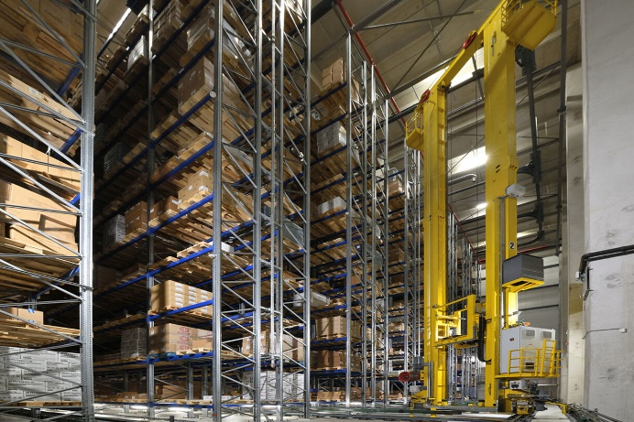 | Photo 1  Automated warehouses and storage system offer solutions to supply chain problems.  (© Surplex).
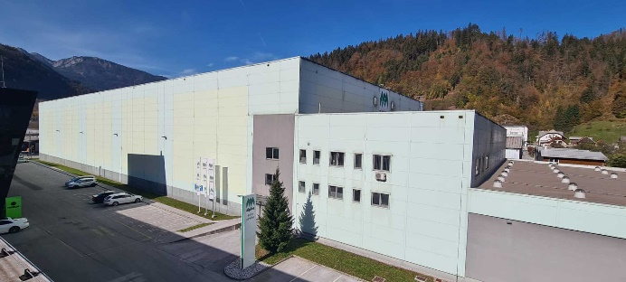 | Photo 2  Used storage systems are cheaper. The Alples/Gorenje warehouse is modern and fully automated. The storage system including the building is for sale.  (© Surplex).

