

PRESS RELEASE NOVEMBER 2013

RYUM - AS EASY AS IT CAN BE

Ryum broadens the Icebug collection, now there’s something for everybody

When you see Ryum BUGrip, surely you feel like it’s been missed. Of course there should be a shoe, safe and easy to use for everybody. So of course there should be a Ryum.

Icebug released Ryum BUGrip, a mid cut walking boot in water repellent suede, in the winter of 2012. It immediately became a success and was received with open arms by the many who have longed for this kind of shoe. The update of Ryum for winter 2013, with an improvment for larger and longer insteap measurements, will make it even more helpful.

On popular demand, this is to extend our traction offer to a wider group of people with specific demands. The mission was to create a classic looking boot that increases life quality to elderly people. RYUM BUGrip shall make people happy. The full leather upper also gives a dressy look which makes it possible to blend together perfectly with many different outfits and occasions.

Ryum BUGrip has velcro closing and it is, thanks to the generous last depth, very easy to get in and out of. The toe box is also extra roomy which makes it fit even for the most sensitive feet.

Perhaps the most important thing – it’s safe, as it should be. With 16 dynamic carbid tip studs, the winterwalk will not be a problem, no matter the conditions outside.

Ryum is warm and the BUGdri-membrane makes Ryum waterproof, something many people appreciate during walks in rain or wet snow.

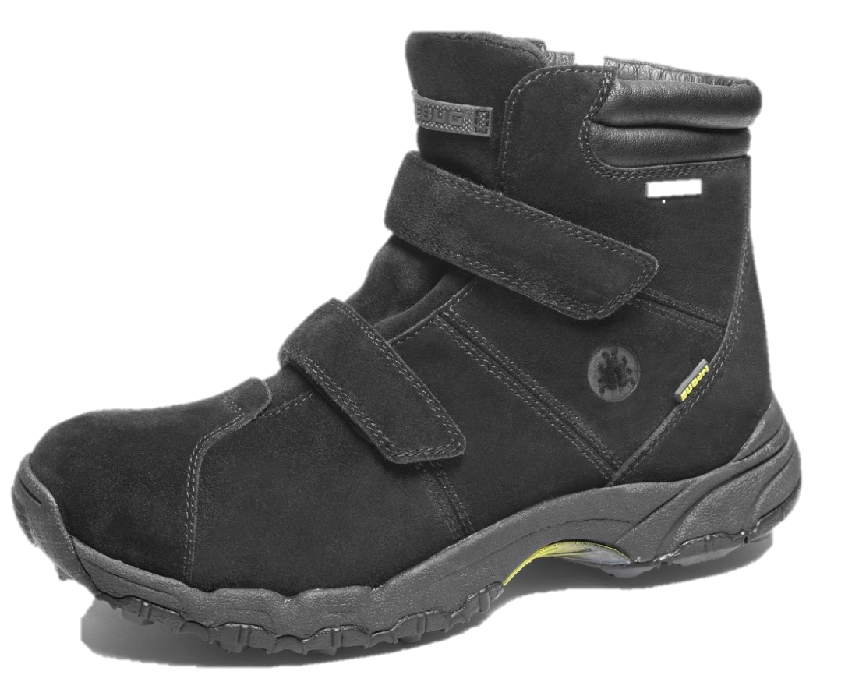The lining and the thick sole gives the shoe, despite its low weight, an insulating effect that is so good that Ryum’s comfort zone reaches down to -20 degrees. The sole provides anatomical support and has a good roll, which makes it easy to walk with. Carbide studded outsole gives confidence on ice but walks completely civilized on pavement and other surfaces. So, a shoe like Ryum dosen’t have to be missed anymore. It’s here and it can make the winter life so much better. For everybody.

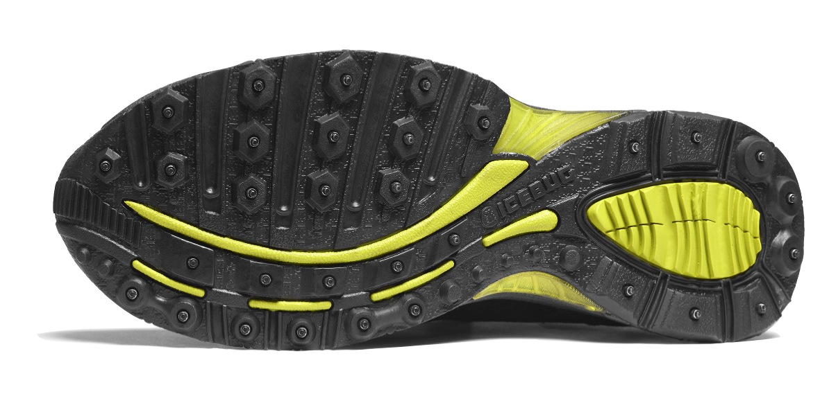Want to know more about Ryum?

Please contact: Marie Thomason,   
PR Manager at Icebug

mt@icebug.se +46 (0)72 246 11 46

