**Crash and first points in the WTCR premiere for the Bäckman siblings**

**The siblings Andreas and Jessica Bäckman made their debut this weekend in the WTCR - FIA World Touring Car Cup. Jessica picked up her first points in the World Cup series.  
- I did not expect points considering our circumstances, says Jessica Bäckman.**

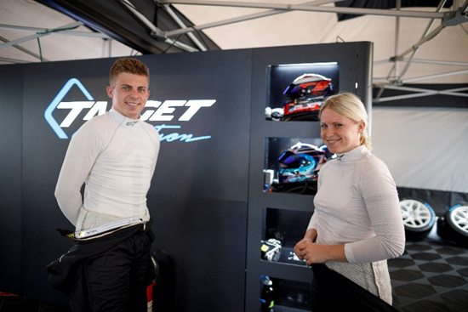Andreas and Jessica Bäckman. Photo: FIA WTCR (Free rights to use image)

The Nürburgring Nordschleife, also known as "The Green Hell", is one of the toughest tracks in the world. Formula 1 drove on this 25 km long track from 1927 until 1976 when world champion Niki Lauda was involved in a serious accident. Nowadays, Formula 1 runs on the Nürburgring GP track, which is about 4 km long. Since 2018, the FIA ​​WTCR has raced on this famous track the same weekend as the Nürburgring's 24-hour race.

This weekend, June 3-5, the season premiere was hosted by the WTCR, and the world's top elite drivers gathered to compete for new world cup points. The Swedish racing siblings Andreas and Jessica Bäckman took place in the starting field as debutants in the series, competing for the Italian team Target Competition. Their first race weekend offered mixed weather conditions and challenging races.

**Challenged track**It was the siblings' first race in their new Hyundai Elantra N TCR cars on the challenging track and they knew in advance that it would be a tough debut race in WTCR.

- The track is one of the toughest tracks in the world and we have not driven on the track as much as our competitors, so considering this, it was positive what progress we made during the weekend, **Andreas Bäckman says.**

- The unstable weather at the free practice sessions with changing conditions was also a big challenge and did not make it easier to learn the new car and track, **Jessica Bäckman says.**

**First World Cup points for Jessica**Jessica had a challenging qualifying when she suffered with some technical problems with the car. But for the race, she showed her true capacity and got her first World Cup points through her 14th place in Race 2.

- After the technical problems in the qualifying, I am very pleased that I managed to get my first World Cup points in the season premiere. I am also glad that I managed to improve my lap times so much, it shows that there is good capacity, it takes a while to learn the new car, tires, and this track as it is classified as the world's toughest track. So, considering the circumstances, the weekend went much better than I had expected, **Jessica Bäckman says.**

Andreas Bäckman in his new Hyundai Elantra N TCR car on the challenging Nürburgring Nordschleife. Photo: FIA WTCR (Free rights to use image)

**Start crash but promising speed for Andreas**It was a challenging weekend for Andreas too, but he showed good speed during both qualifying and races:

- I had a few misses on my qualifying lap but I still think it was above my expectations to qualify as 17th and beat several of the world's best drivers who also have more experience on this track, **Andreas Bäckman says.**

The raceday, on the other hand, became tougher for Andreas:

- In the first race I got a really bad start and was out at the back after the start. But I drove up a few places and the speed in the car felt good. For the second race, we made some adjustments to the car to make it even faster, but unfortunately, I got involved in a start crash already into the second corner on the first lap. I did not have time to avoid the car in front of me and the car got damaged which meant that I had to stop the race. So, it was a shame, but we will have to come back stronger again to the next race, **Andreas Bäckman says.**

*The second round of the WTCR series, will be held at the Estoril track in Portugal at June 25-27.*

**Andreas’ results**Free Practice 1: 16th placeFree Practice 2: 17th placeQualifying: 17th placeRace 1: 20th placeRace 2: DNF

**Jessica’s results**Free Practice 1: 18th placeFree Practice 2: 19th placeQualifying: 20th placeRace 1: 21st placeRace 2: 14th place

*Free rights to use the images.*