**Mixmo launch innovative solution for pick and mix confectionary with Candyking**

Mixmo have developed an innovative, automated and sealed solution for sales of pick and mix confectionary. A partnership with Candying is initiated to continue development and roll out on Candykings markets. The solution will be tested in approximately 20 stores during the summer of 2012. If results are in line with expectations roll out will be initiated during the fall and winter 2012.

We are very impressed by Mixmos solution and their technical knowledge says Daniel Juhlin CEO, Candyking Sweden. –Their solution has several advantages within hygiene and service that we hope will recruit new pick and mix consumers.

As the world leading player within pick and mix Candyking is the perfect partner for us says Fredrik Junkell CEO, Mixmo. -Candykings fast expansion in Europe and their strong home market in the Nordics and UK enables fast growth and distribution for our solution and I see big potential in this partnership.

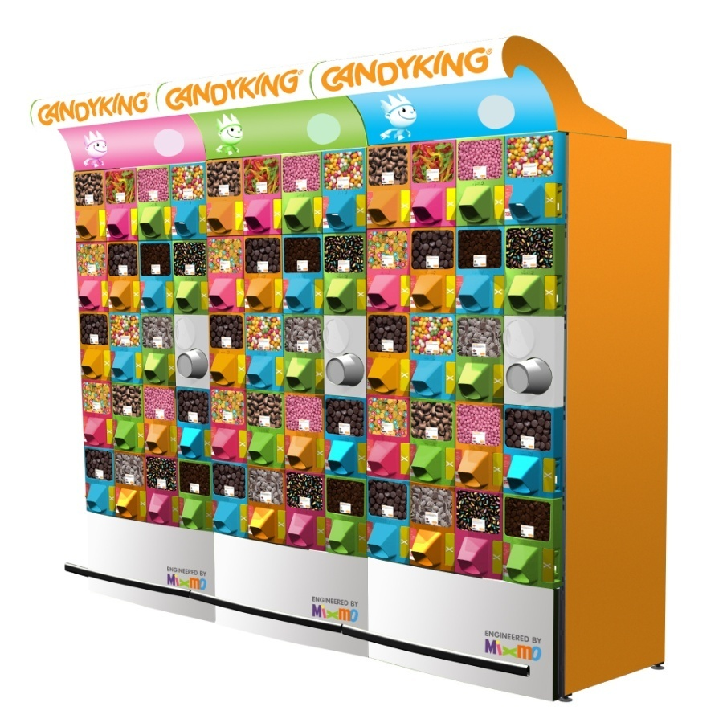

**Facts Candyking**

Candyking is the leading supplier and the strongest brand within confectionar pick and mix sales in Sweden, Norway, Finland and UK.We offer a complete shop-in-shop solution from high quality confectionary and in store sales solutions to marketing activities and full operations to our 8 500 customers within the retail and convenience trade. We are approximately 550 employees and hav a turnover of SEK 1,7 bn. The company was founded in 1984. Since 2008 Accent Equity Partners is the main owner. Candyking is based in Stockholm, Sweden. For more info see: [www.candyking.com](http://www.candyking.com/Candyking/templates/www.candyking.com)

**Facts Mixmo**

*Mixmo AB offers customized hygienic solutions for sales of pick and mix confectionary including cups, bags and service. For more if see:* [*www.mixmo.com*](http://www.mixmo.com)