FOR IMMEDIATE RELEASE

Intellian announces new brand identity

Intellian’s symbolic new branding signifies its evolution from an innovative antenna manufacturer to a global leader within the satellite communications industry
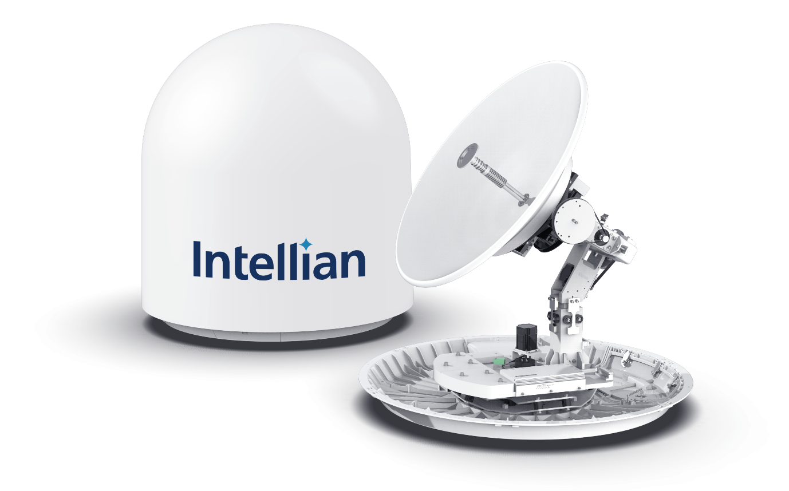Intellian’s innovative, future-proof v85NX antenna, with the new logo

29 September 2020 – Intellian is proud to announce the launch of its new corporate brand identity. This marks another significant milestone in the company’s evolution from an innovative antenna manufacturer to its position today as a leading technology and solutions provider.
Intellian empowers connectivity for its customers across multiple industry sectors, bringing high-speed data to remote locations and mission-critical environments, connecting people and the world. The company’s rapid growth is testament to its success in being first to market with innovative and reliable products, whilst building enduring partnerships based on trust.
The launch of its new brand is yet another example of how Intellian continues to lead the way. Far from being simply a visual change, it underlines a commitment to continue to evolve, and to explore fresh initiatives to improve both partner and customer experiences. The revitalized look includes a new logo and visual identity, with a strapline of ‘Empowering Connectivity’ encapsulating Intellian’s declared mission objectives. In addition, the company will launch a new website as a central resource for engaging with partners and customers, providing new support tools and more efficient ways of sharing information.
Fundamental to maintaining the great reputation and trust Intellian has built within the industry, an increased focus on the purpose and culture of the global team is a core tenet of Intellian’s clearly defined vision for the future. Culture has been key to the success of Intellian, with agility and creative thinking vital to its customer-centric approach. The new vision and branding paves the way to build on those strengths, as the team expands and engages with customers in new markets.
Eric Sung, CEO, Intellian Technologies, said: “We continue to invest in our business through multiple avenues, including research & development and infrastructure, with the purpose of delivering industry leading products and adding maximum value to our customer experience. Our brand identity launch is a further example of our continued pursuit of excellence in all that we do. Far from changing who we are, our new brand identity is about amplifying what we do best and what has contributed towards us becoming a trusted partner and a global leader. We are excited to enter this next chapter of growth and look to the future.”
The satellite communications industry continues to grow, and Intellian remains committed to being at the forefront of its evolution. Its advanced portfolio and key strategic partnerships are unparalleled within the industry, firmly focused on innovation that solves customer challenges and delivers outstanding value. The design of Intellian’s products ensures optimal performance today, with the agility and flexibility required to give customers the confidence they need to prepare for tomorrow.
The new brand will serve as a foundation for communicating Intellian’s vision with a wider audience, as the company continues to expand into new markets and builds on its success.
More information and the new website may be found at www.intelliantech.com.
-Ends-

For further enquiries, please contact:
Paul Comyns / VP of Marketing
Intellian Technologies USA
T + 1 949 727 4498 ext. 1301
Paul.Comyns@intelliantech.com

David Pugh
Saltwater Stone
T +44 1202 669 244
d.pugh@saltwater-stone.com
Sadie Brown / Marketing Manager
Intellian Ltd
T +44 2380 019 021 ext. 1612
Sadie.Brown@intelliantech.com

About Intellian Technologies
Intellian is a leading global technology and solutions provider for satellite communications, empowering connectivity for the maritime, government, military, energy, cruise and enterprise sectors. Founded in 2004, Intellian is renowned for its innovative design, future-proofed technologies and outstanding customer support, which combined with continued investment in its partners, logistics network, quality control and low environmental impact production facilities make it a trusted enabler within the satellite communications industry. Its bold, pioneering solutions include the award-winning v240MT – the world’s first tri-band, multi-orbit antenna system – and the future-proof NX series antennas, optimized for high performance and low cost of ownership.
Intellian has a global presence with over 400 employees, 12 regional facilities and five logistics centers on three continents. The Intellian 24/7 global support desk provides dedicated assistance to 550 service provider partners and their customers in mission-critical environments. Intellian Technologies Inc. is listed on the Korean Stock Exchange, KOSDAQ (189300:KS).

