MEDIA RELEASE

First PARKROYAL property to open in Bangkok
The 194-key serviced suites is also a first for Pan Pacific Hotels Group in Thailand

5 December 2018, Singapore — Pan Pacific Hotels Group signed its first PARKROYAL Serviced Suites in Bangkok, Thailand with Phachara Suites Co. Ltd today. PARKROYAL Suites Bangkok will be opening in Q2 2019 and will be the Group’s first property in the market.
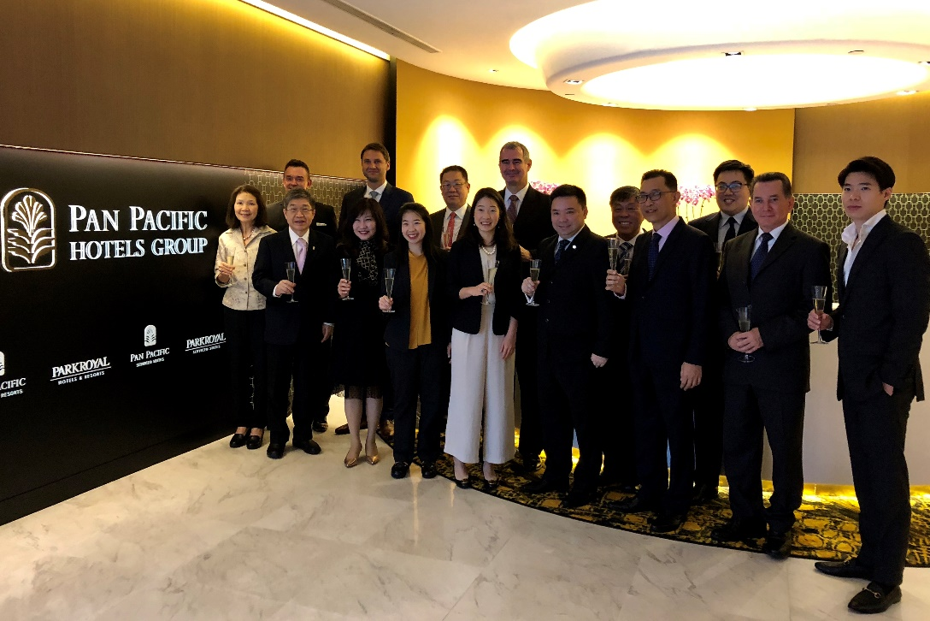
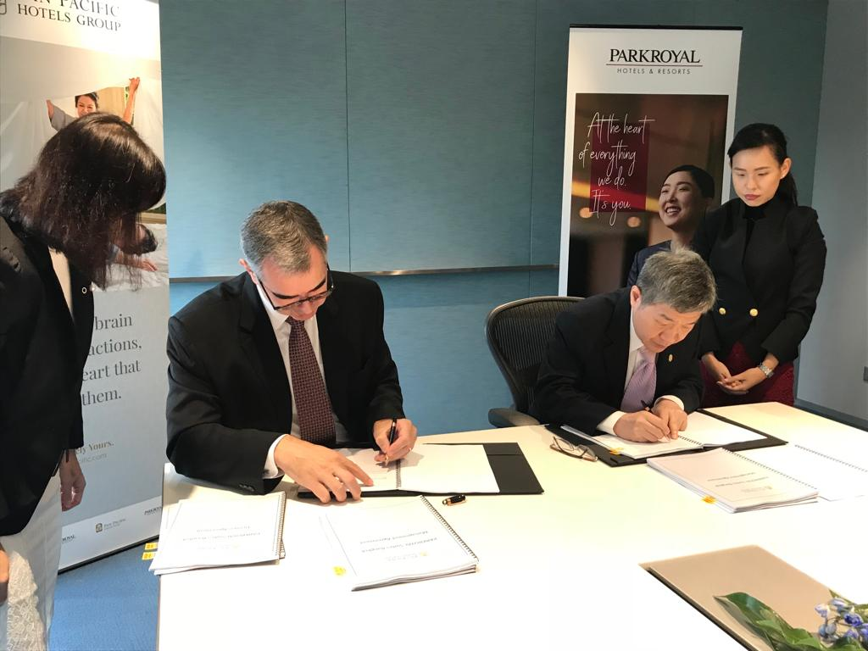
Pan Pacific Hotels Group’s CEO Mr Lothar Nessmann (left) and Phachara Suites Co. Ltd’s Mr Thanin Laohapiengsak (right) at the signing of PARKROYAL Suites Bangkok, followed by a group photo at Pan Pacific Hotels Group’s corporate office.

PARKROYAL Suites Bangkok will join Pan Pacific Hotels Group’s portfolio of serviced suites in Singapore, Kuala Lumpur, Ningbo and soon to open in Jakarta and Johor, strengthening the Group’s footprint and offerings in this accommodation category. Pan Pacific Hotels Group was recently named Top 5 Serviced Residences in the region by the readers of DestinAsian, a leading consumer travel publication.

The 194-unit PARKROYAL Suites Bangkok is located at Sukhumvit Soi 6, a prime location off Sukhumvit Road, the main artery of Bangkok running through its tourist, commercial and residential areas. The nearest station, Nana BTS skytrain station, is a 3 to 5-minute walk from the property, which is also within walking distance to some of the city’s newest shopping malls, including Central Embassy and Terminal 21 (both 1 km away).

Sharing the same Sukhumvit Line as Siam BTS – the largest and busiest station on the BTS, Nana BTS station is a 6-minute train ride to the retail heart of Bangkok. This is where one can find the widest selection of fashionable shops and restaurants in upscale malls such as Siam Paragon, Central World, EmQuartier and Emporium – all easily accessible by elevated walkways from Siam BTS.

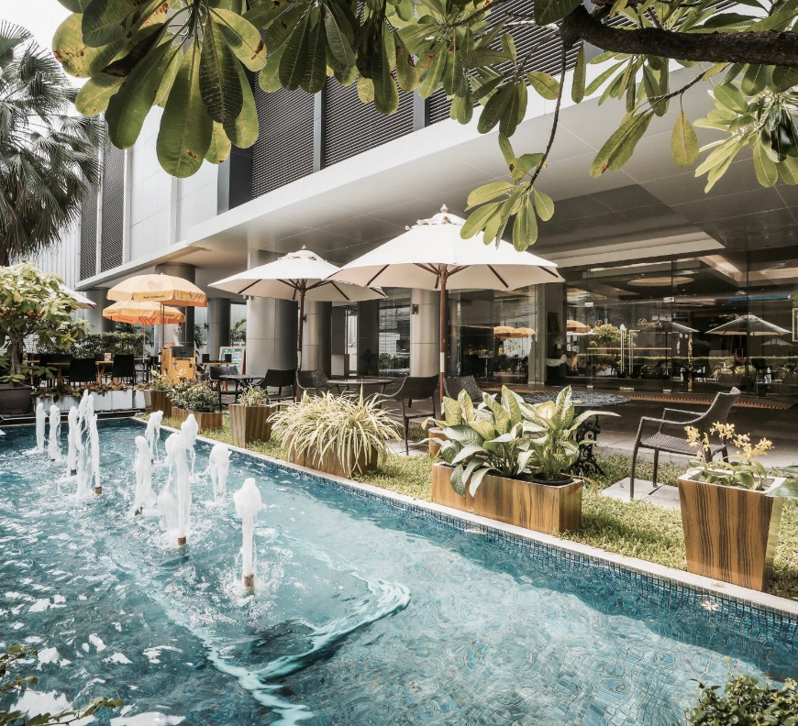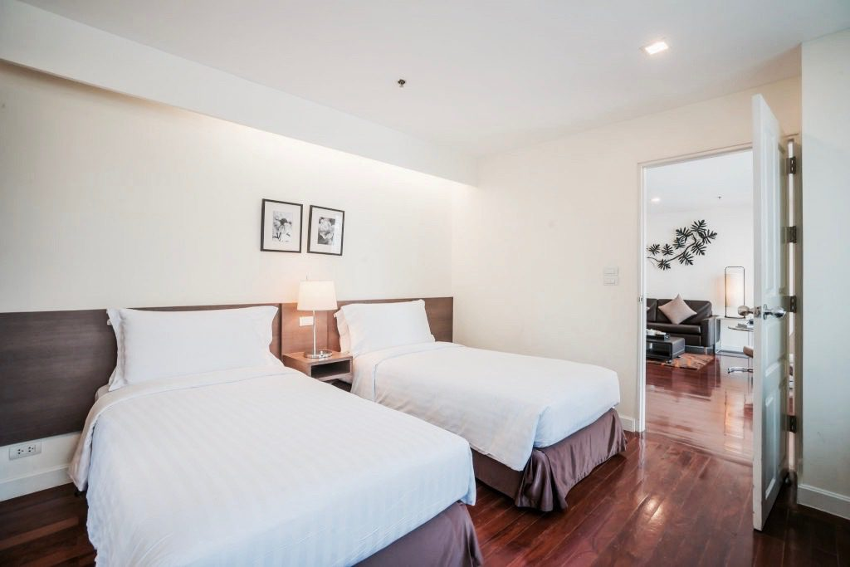

Current exterior and room at Phachara Suites, which will be rejuvenated with the refurbishment

PARKROYAL Suites Bangkok will be a conversion from the current Phachara Suites and will undergo a thorough refurbishment to meet the brand standards and offerings that PARKROYAL guests are familiar with. When it reopens, the property will offer 194 thoughtfully-designed and spacious suites, featuring Executive Studios (50 square metres) and Two-Bedroom Executive units (130 square metres), which are popular with both solo and family travellers.

With an all-day dining restaurant, meeting facilities, fitness facilities including a beautiful swimming pool, PARKROYAL Suites Bangkok is more than a serviced apartment or hotel. True to PARKROYAL’s service philosophy, every guest will be received warmly as an individual, even in a city which receives more visitors than any other city in the world. Guests are welcome to stay longer, whether for business or leisure, and truly enjoy the convenience and comfort of a home as all apartments equipped with a kitchenette, washer and dryer.

Thanin and Nuanswat Laohapiengsak, Principals, Phachara Suites Co Ltd, said, “We’re delighted to own the first PARKROYAL-branded property in Bangkok. We love the energy of the brand, which resonates with this city of a thousand smiles. The PARKROYAL brand is about warm and passionate people who genuinely care for others, and to us, this is key to helping our guests feel a sense of belonging. The rebranding to PARKROYAL will breathe new life into the property, and we’re excited to see PARKROYAL Suites Bangkok grow into one of the most people-centric places to stay in Bangkok.”

Mr Lothar Nessmann, Chief Executive Officer, Pan Pacific Hotels Group, said, “PARKROYAL is rapidly growing in Southeast Asia – besides Singapore, we operate properties in capital cities such as Kuala Lumpur, Yangon, and Ho Chi Minh, along with planned openings in Jakarta. We are excited to see the popularity of our brand, which is all about our people and the real connections they forge with our guests. It’s great to return to this city, where we once operated a hugely-successful Pan Pacific serviced suites product, and look forward to creating more joyful experiences for travellers to Bangkok.”

Scheduled for opening in 2019, the 205-unit Pan Pacific Serviced Suites Puteri Harbour will cater to the needs of short- and extended-stay professionals and expatriates working in the Iskandar region of Johor, Malaysia. The property is a 10-minute drive from Singapore via Tuas Second Link, with major attractions and developments, including the Ascendas Nusajaya Tech Park, Pinewood Studios, and Legoland in the vicinity. Pan Pacific Serviced Suites Jakarta, comprising 181 units, will open in 2020 in Indonesia 1, the tallest twin tower in the country. It is located along Jalan Thamrin, which runs through the city’s central business district. By 2022, PARKROYAL Hotel Jakarta and PARKROYAL Serviced Suites Jakarta will open as part of a new mixed-use development in Thamrin Nine, a prestigious address in central Jakarta.

-ENDS-

Media Contact
Cuili NG
Brand & Corporate Communications Manager
Pan Pacific Hotels Group
DID: +65 6808 1269
Mobile: +65 9634 4425
Email: ng.cuili@pphg.com

About Pan Pacific Hotels Group
Pan Pacific Hotels Group is a wholly-owned hotel subsidiary of Singapore-listed UOL Group Limited, one of Asia’s most established hotel and property companies with an outstanding portfolio of investment and development properties.

Based in Singapore, Pan Pacific Hotels Group owns and/or manages more than 40 hotels, resorts and serviced suites including those under development in 24 cities across Asia, Oceania, North America and Europe.

Voted “Best Regional Hotel Chain” by readers in Asia-Pacific in 2017 and 2018, Pan Pacific Hotels Group comprises two acclaimed brands: its signature brand, Pan Pacific and its deluxe brand, PARKROYAL.

Sincerity is the hallmark of Pan Pacific Hotels Group. The Group is known to its guests, partners, associates and owners for its sincerity in people and the sense of confidence which alleviates the stresses of today’s complex world.

Visit us at www.panpacific.com.

PARKROYAL Hotels & Resorts

A big city or cosy enclave – where there is a PARKROYAL hotel, resort or serviced suite, there is a celebration of people. Our passion for creating real connections and joyous moments can be felt when you enter any of our properties across Asia and Australia. After all, this is the place to bring out the best of you, by us.

