Haglöfs INTRODUCES helios & tight VX
– CLASSIC DAYPACKS IN HIGH-TECH PREMIUM MODELS

For the SS19 season Haglöfs has updated two of their classic backpacks – Tight and Helios – fusing the brand heritage with technical material and modern details. This has resulted in two new premium styles: Tight VX and Helios VX.

Tight VX and Helios VX are two new additions to the Haglöfs backpack range. Made from high-performance fabric and packed with smart, modern design touches and details, they are ideal for everyday use as well as fast-paced urban and outdoor pursuits.

Both the Tight VX and the Helios VX are made from a high-performance fabric called VX21 X-Pac, originally developed for the sails of ships in ocean races where rough weather conditions are a way of life. The backpacks are feature-heavy, and the technical material used in their construction is complemented by genuine leather details which will age beautifully and provide a unique, distinctive look.

Tight VX
This is a premium version of the iconic Haglöfs Tight. The VX version has the same construction and fit as the classic Tight, but now every detail has been considered and refined to give it a more premium look and feel. It’s been equipped with soft, ergonomic shoulder straps and a thermoformed back panel, all for extra comfort. Tight VX features a soft padded laptop compartment and an internal safety pocket. It has a volume of 25 L.

Helios VX
Helios VX is a contemporary roll-top backpack with a mountain attitude. It’s inspired by the classic Roc Helios mountain pack but designed with a more modern, everyday look. The Helios VX is constructed with a side opening to the main compartment, a roll-top, a side pocket with a waterproof zipper and 25 L of space. Like the Tight VX, it also features soft and ergonomic shoulder straps, a thermoformed back panel, an internal safety pocket and a padded laptop compartment.

The Tight VX and Helios VX backpacks comes in black and will be launched in February 2019. Estimated retail price is 200€.

For more information, please contact:
Lisa Grübb
Publishing Coordinator
+ 46 768 527 464
lisa.grubb@haglofs.se

tight vx & Helios VX – FACT SHEET

Tight VX – features
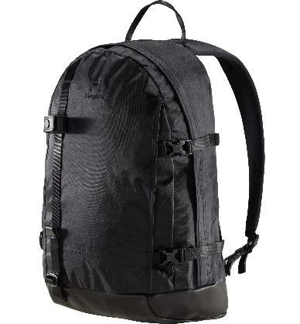
- VX21 Dimension Polyant X-Pac™ fabric provides high tenacity polyester/nylon lamination with superior tear strength and weather-shedding properties
- Base and details made with leather from Leather Working Group audited tanneries – ensuring a lower environmental impact
- Teardrop shaped front and side panels provide a low centre of gravity
- Fully padded laptop sleeve – fits laptops up to 15”
- Internal zip pocket with key holder
- Zippered front pocket
- Detachable ice axe loop
- Thermoformed back panel
- Fluorocarbon-free DWR-treated surfaces help repel water and dirt

Helios VX – features
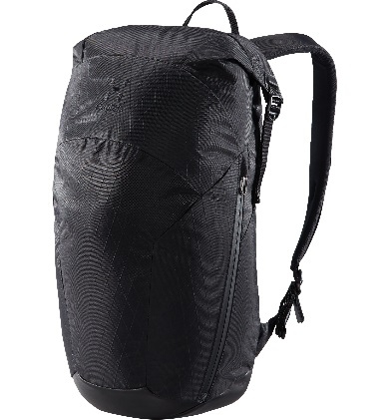
- VX21 Dimension Polyant X-Pac™ fabric provides high tenacity polyester/nylon lamination with superior tear strength and weather-shedding properties
- Base and details made with leather from Leather Working Group audited tanneries – ensuring a lower environmental impact
- Roll-top lid for quick access to contents
- Fully padded laptop sleeve – fits laptops up to 15”
- Internal zippered security pocket
- Water-resistant side zip pocket, with key holder
- Zippered side access to the main compartment, with a water-resistant zipper
- Thermoformed back panel
- Fluorocarbon-free DWR-treated surfaces help repel water and dirt

