Press Release 8 February 2019

**Self empowerment through creativity: an exhibition by homeless artists**

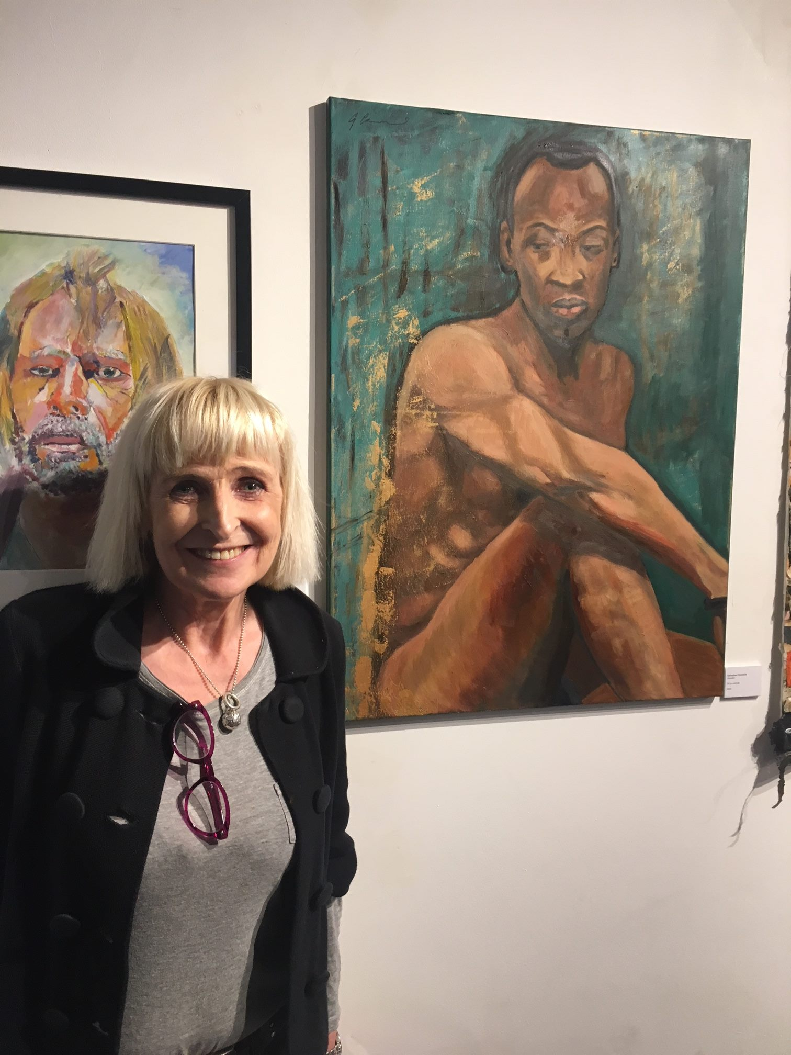

Eighty eight London artists affected by homelessness have participated in our unique annual art competition. A record number of more than 150 entries were received and the 20 finalists will be exhibited at the Hampstead School of Art on 5 March.

The exhibition features cash prizes for the artists who are affected by homelessness. A bespoke mentoring support package will also be given to the top three winners. The support is designed to give talented homeless artists a platform in both selling their art and connecting with the wider community. The exhibition also hopes to inspire other people affected by homelessness, empower our artists and show a different side to homelessness.

Sarah Caldwell Watson, Chief Operating Officer of Café Art says ‘we are excited that, with an increase in funding available to us this year, we are able to generate a far greater impact with the homeless art competition. This exhibition compliments our other activities which include our annual photography prize and calendar, our programme for exhibiting homeless art in cafes and our art rental scheme.’

Contact: sarah@cafeart.org.uk  Tel. 07535 807813.

Website: <https://www.cafeart.org.uk/>