October is Breast Cancer Awareness Month
With new non-toxic cancer treatments, women can keep their breasts
The new treatment regime is driven by highly motivated and skilled doctors, with focus on the patients well-being and non-toxic methods.
Red light that kills cancer cells, Sono-Photo Dynamic Therapy, an efficient non-toxic method.
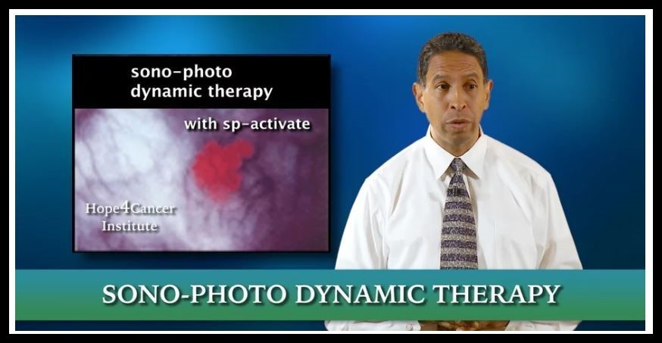
Benefits with non-toxic treatments are amazing. The patients experience no pain, no hair loss, no fear or stress. And the best thing is that the patients can keep their breasts. After the treatment patients are often full of energy and can do normal activities.
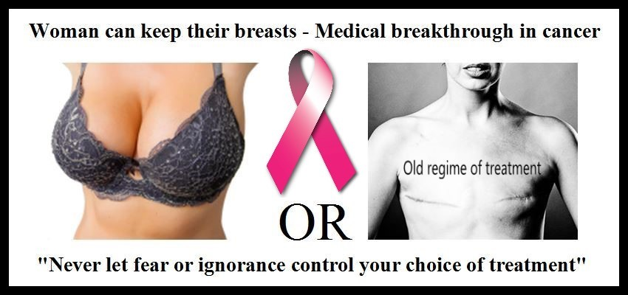
When we look at the old treatment regime, this was driven and developed mainly by fear and stress. No regard for the risks and damaging of the patient’s healthy inner organs and tissues.
Side effects from chemotherapy patients may experience, Ref: Directorate for E-Health:
Nausea and vomiting - Diarrhea - Blood Loss - Hair loss - Bleeding from the mucous membranes in the nose and mouth - Soreness in the mouth and throat - Reduced muscle strength - Damage heart permanently - Risk of heart disease - Reduced quality of life - Damage brain permanently (Chemo-brain) - Memory loss - Learning difficulties - Forgetfulness - Development of other cancer
Before any cancer patient undergo treatment using chemotherapy, they have to be informed by their doctor. Patients should always sign a contract showing they know and understand ALL the risks. Otherwise the doctor violates the patients’ rights, and put his/her health and life in danger without his/her consent.
Over 75% of woman unnecessarily go through removal of breasts.
According to a British independent group 3/4 women unnecessarily went through cancer treatment. This happened due to over diagnoses. An average growth in breast tumors are 10 millimeters in 1,7 years. The slow growth can in many cases give a cancer patient enough time to rethink the treatment options and save the breasts.
The leader of Cancer Management are happy to share this information. It is the most important breakthrough in breast cancer history.
When we see the numbers of people suffering or dying from this disease,
- More than 1.7 million new cases of breast cancer and 500 000 deaths each year (Ref. WHO)
and we know this information can help some of them, we encourage you to share this information. You can contribute to save lives!
For more information about non-toxic cancer treatments - cancerphone.com.

