Morten Hasås joins Kongsberg Digital as
SVP for Maritime Simulation

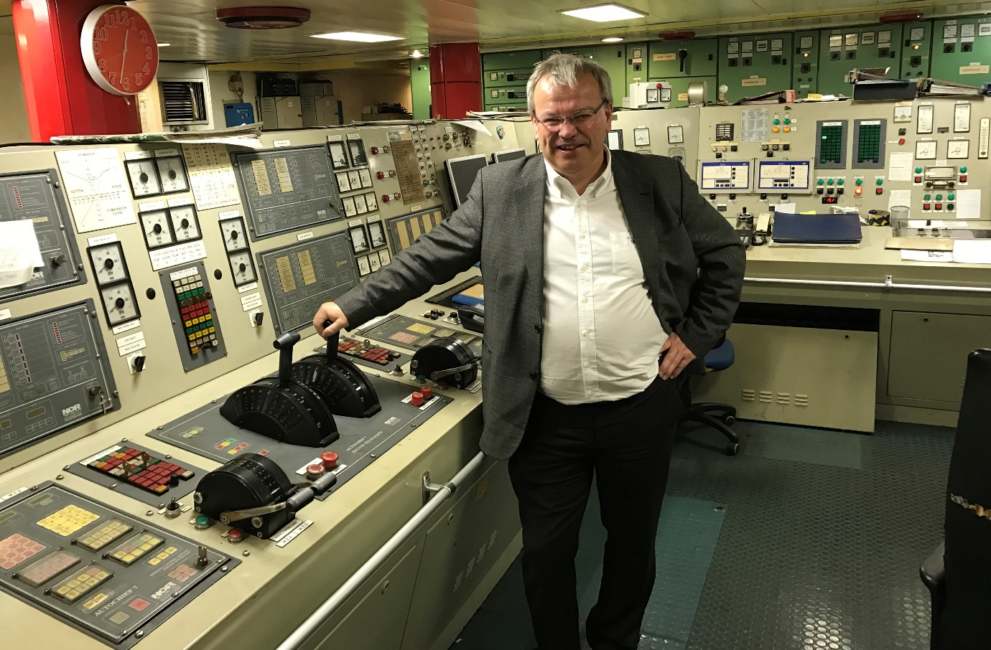
Morten Hasås, formerly of Scantech Industries, is to join the Digital Ocean team at
Kongsberg Digital as Senior Vice President for Maritime Simulation
Horten, Norway, December 15th, 2020 – On January 1st, 2021, Morten Hasås will join Kongsberg Digital as Senior Vice President for Maritime Simulation. Previously CEO of Scantech Industries, Morten has held top management positions at ScanSense, Scanmar and Kongsberg Maritime.
His extensive experience in the maritime industry extends over more than three decades, which teamed with his international background will serve to strengthen the Maritime Simulation branch of Kongsberg Digital’s operations.
“With Morten we are strengthening the already solid Maritime Simulation team at Kongsberg Digital,” says Andreas Jagtøyen, Executive Vice President of Digital Ocean, Kongsberg Digital. “Our maritime simulators are used by educational and research institutions worldwide, and we need to continue to deliver on the high expectations of our customers while working to modernize and digitalize our offering. The newly launched
K-Sim Connect eLearning platform is an example of this, but there are several other areas we are exploring, such as the development of maritime digital twins. I look forward to Morten joining the team.”
The benefits and necessity of digitalization are becoming increasingly apparent for the world’s industrial markets. KONGSBERG is spearheading the development of maritime digitalization solutions, and recently the company stated an ambition of developing maritime digital twins in their newly formed Digital Ocean hub. Maritime Simulation – which Hasås will now head up – is part of Digital Ocean, enabling the synergies required to address the need for holistic digital solutions in the market.
“I am proud, humble and happy to be joining Kongsberg Digital as SVP for Maritime Simulation,” says Hasås. “I know I will be working with a fantastic and agile team, and I will do my utmost to help bring Maritime Simulation to new heights. I am excited to get started and explore the enormous possibilities digitalization brings to the fantastic core of products brought to life by Norcontrol in the 1970s.”
Tone-Merete Hansen will assume new responsibilities within Kongsberg Digital as VP of Sales and Business Transformation of Maritime Simulation.
“Tone-Merete’s broad experience with Maritime Simulation will be of vital importance in the digitalization and modernization of the portfolio. We are very happy that she will head up these efforts,” Jagtøyen comments.
Morten Hasås and Tone-Merete Hansen will enter their new roles from 1st January 2021.
Ends

For further information, please contact:

Mathilde Vik Magnussen
VP Communications & Marketing
Kongsberg Digital
Tel: +47 4567 8255
mathilde.magnussen@kdi.kongsberg.com
David Pugh
Saltwater Stone
Tel: +44 (0)1202 669244
d.pugh@saltwater-stone.com

About Kongsberg Digital
Kongsberg Digital is a provider of next-generation software and digital solutions to customers within maritime, oil and gas, and renewables and utilities. The company consists of more than 500 software experts with leading competence within the internet of things, smart data, artificial intelligence, maritime simulation, automation and autonomous operations.
Kongsberg Digital is subsidiary of KONGSBERG (OSE-ticker: KOG), an international, knowledge-based group delivering high-technology systems and solutions to clients within the oil and gas industry, subsea, merchant marine, defence and aerospace. KONGSBERG has 11,000 employees located in more than 40 countries.
Web: Kongsberg Gruppen | Kongsberg Digital
Social media: LinkedIn | Twitter | Facebook

