Press release
Düsseldorf, 01/04/2024
The soundscapes of industry: Even machine noises can trigger ASMR
Surplex, the industrial auction house, is known for auctioning used machinery. But now, it is launching a new ASMR project featuring the sounds of the industrial machines sold. The distinctive sounds from the world of industry are now available on two platforms: YouTube and Alexa.
Rumbling: In an empty hall, a large ABUS double girder overhead crane with a capacity of over 150 tonnes moves through the space with a booming grumble noise. Heavy bundles of steel chains hang from its two trolleys. Pling, pling, pling – it sounds metallic. The crane is braked, and a strangely light, whistling air noise escapes from the hydraulics – ewyou. The starting of the trolleys is accompanied by a brief squeak, ieek. The movement causes the chains to swing. The clinking noise is a frequent pling, pling, pling. With a dull echoing noise (ruuummm), the trolleys are abruptly braked. It clicks and rattles as they lock into place. Rrrrrrrr: The chains are lowered down the steel cable with a whirring noise.
This is the first scene in Surplex’s new ASMR project. The industrial auction house for used machinery has an extensive archive of machine videos, particularly from the metal and woodworking sectors. Dennis Kottmann, Head of Online Marketing at Surplex, explains, “The great attention our YouTube channel has received, with over 7,000 followers, inspired us to share the machine noises in a new way.”
The characteristic sounds of the industry are made accessible across three different platforms: YouTube, Spotify and Alexa. On YouTube, there are two ASMR videos, each dedicated to the soundscapes of either woodworking or metalworking machines, including the overhead crane. Additionally, an Alexa skill allows users to call up the ASMR sounds with a simple ‘Hey Alexa, open Machine Sound Box’. In parallel, the audio tracks will soon be available on Spotify.
What is ASMR?
ASMR stands for Autonomous Sensory Meridian Response and describes a phenomenon where certain visual or acoustic stimuli trigger a pleasant tingling or relaxation sensation in people. This feeling usually starts at the head and can spread along the spine. Many people use ASMR content to reduce stress, relax, or alleviate sleep problems. However, the effect of ASMR is very individual and cannot be triggered in every person.
The ASMR-triggering stimuli can be very different. Examples of acoustic ASMR-triggering stimuli include whispering, typing on a keyboard, or flipping through a book. Visual stimuli might include the careful folding of paper, the precise preparation of food, or handicraft activities such as painting or modelling.

ASMR is not limited to traditional triggers like quiet noises. Even the humming and buzzing of machines used in metal and woodworking can trigger ASMR. The rhythmic, recurring noises of industrial plants, the harmonious operation of gears, or the sawing of wood can be just as relaxing to some people as conventional ASMR sounds.
On platforms like YouTube, there are numerous ASMR artists, the so-called ASMRtists, who create videos in various categories. “Of course, we don’t see ourselves as ASMRtists in the traditional sense. But what was originally intended as an April Fool’s joke has actually sparked interest and has therefore now been implemented by us,” Kottmann adds.

Photo 1
ASMR sounds from metal and woodworking machines on Alexa.
(© Surplex).
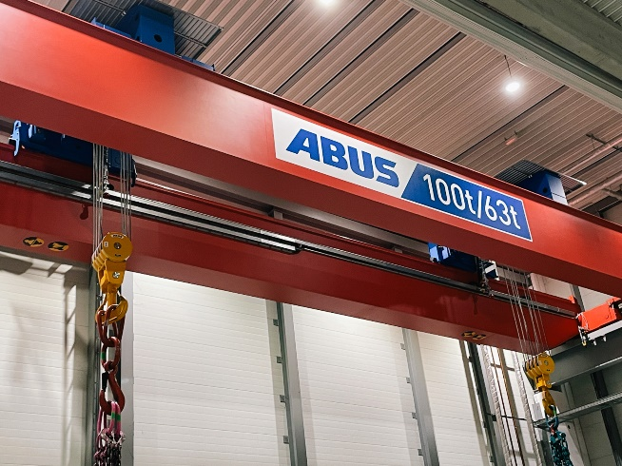 | Photo 2  What does an overhead crane actually sound like in action? It is a surprisingly soothing concert of the most diverse noises: the booming rumble of its movement, the metallic clink of heavy chains, and the soft whistle of the hydraulics when braking.  (© Surplex).

