“There’s old wave, there’s new wave,
and there’s David Bowie”

DAVID BOWIE
‘A NEW CAREER IN A NEW TOWN (1977 – 1982)’

The 3rd IN A SERIES OF DAVID BOWIE BOX SETS
RELEASED 29th SEPTEMBER 2017

CD, DIGITAL* AND AUDIOPHILE VINYL BOX SETS EXCLUSIVELY FEATURE ‘LODGER’ (TONY VISCONTI 2017 MIX)

‘BEAUTY AND THE BEAST’ (EXTENDED VERSION)
AVAILABLE NOW AS AN INSTANT GRAT TRACK
PREVOUSLY UNAVAILABLE ON DIGITAL / CD

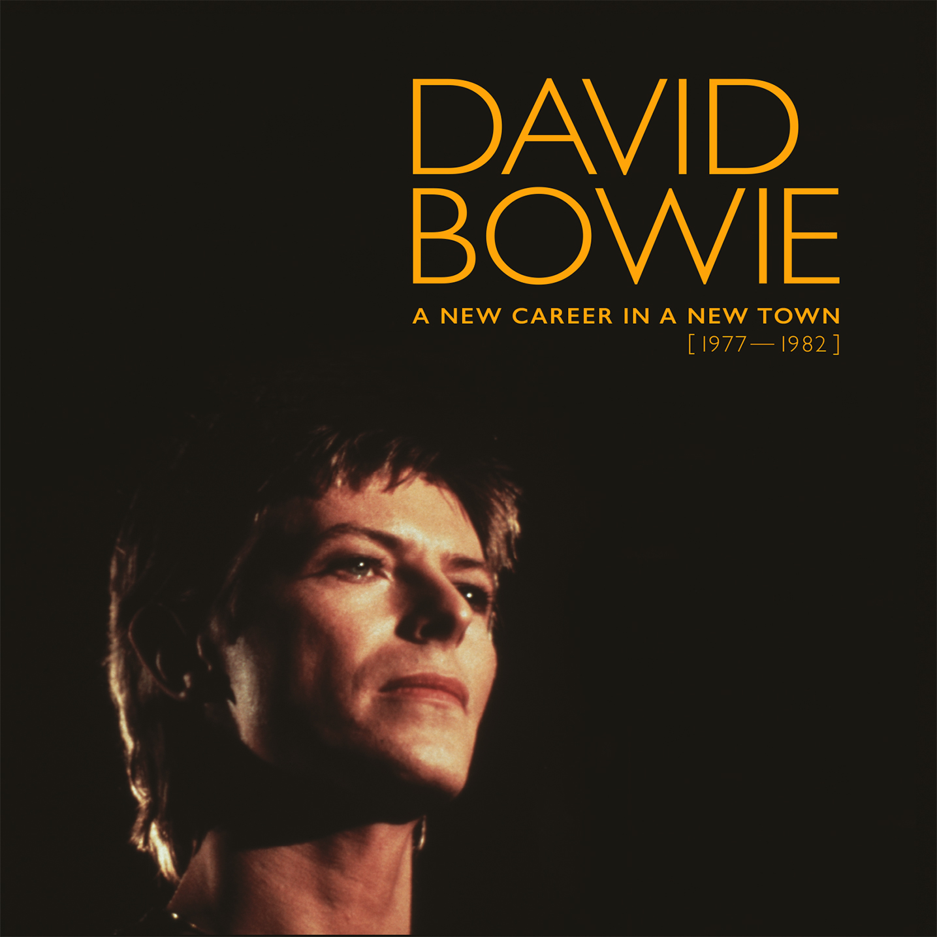

Parlophone Records are proud to announce DAVID BOWIE ‘A NEW CAREER IN A NEW TOWN (1977 – 1982)’ the third in a series of box sets spanning his career from 1969.

The follow-up to the awarding winning and critically acclaimed DAVID BOWIE ‘FIVE YEARS (1969 – 1973)’ and DAVID BOWIE ‘WHO CAN I BE NOW? (1974 – 1976)’ will be released on 29th September and will contain a brand new remix of the 1979 album ‘LODGER’ by long time Bowie producer/collaborator Tony Visconti.

The eleven CD box, thirteen-piece vinyl set and the Mastered For iTunes and standard digital download sets feature all of the material officially released by Bowie between 1977 and 1982. It includes the so-called ‘Berlin Trilogy’ of albums on which he collaborated with Visconti and Brian Eno as well as the ‘BAAL’ EP, appearing here for the very first time in its entirety on CD, and is closed by ‘SCARY MONSTERS (And Super Creeps)’.

The box set, named after a track from the first of the so-called ‘Berlin Trilogy’ LOW, includes ‘LOW’, ‘“HEROES”’, ‘STAGE (ORIGINAL and 2017 VERSIONS)’ the former in the vinyl box will be pressed on yellow vinyl, replicating its original limited edition U.K. release and the latter of which featuring two previously unreleased tracks, ‘LODGER’, ‘LODGER (Tony Visconti 2017 Mix)’, ‘SCARY MONSTERS (And Super Creeps)’, ‘RE:CALL 3’ (featuring contemporary single versions, non-album singles, b-sides and songs featured on soundtracks) and the ‘“HEROES”’ E.P., a compilation exclusive to the set celebrating the 40th anniversary of the song, which rounds up the German and French album and single versions of the track in one place for the first time.

Exclusive to each of the box sets is ‘LODGER (Tony Visconti 2017 Mix)’. The remix was started with David's blessing before his passing in January last year. Tony Visconti has revisited the original multi-tracks at Human Studios and remixed the album with the benefit of modern technology to better highlight the album's nuances. Always a personal favourite of David's, this version of the album will also feature newly 'remixed' artwork featuring unseen images from the original cover photographic session from the archive of the Estate of photographer Duffy, working closely with his son Chris.

Also exclusive to each box is ‘Re:Call 3’, a new compilation featuring remastered contemporary single versions, non-album singles and b-sides, and songs featured on soundtracks. The cover features a photo by Christian Simonpietri taken at Hansa Studios in Berlin during the ‘“Heroes”’ sessions in 1977. The ‘Baal’ E.P. in its entirety is making its CD debut while ‘Beauty And The Beast’ (extended version) and ‘Breaking Glass’ (Australian single version) are making their debuts on CD and digitally.

‘Beauty And The Beast’ (extended version) is available now as digital download upon pre-order of the box set. This version of the ‘“Heroes”’ album track is making its digital and CD debut having previously only been available on a rare US promo 12” and as a limited 12” release in Spain.

The physical box set’s accompanying book, 128 pages in the CD box and 84 in the vinyl set, will feature rarely seen and previously unpublished photos by photographers including Anton Corbijn, Helmut Newton, Andrew Kent, Steve Schapiro, Duffy and many others as well as historical press reviews and technical notes about the albums from producer Tony Visconti.

The CD box set will include faithfully reproduced mini-vinyl versions of the original albums, and the CDs will be gold coloured rather than the usual silver. The vinyl box set has the same content as the CD set and is pressed on audiophile quality 180g vinyl.

*A New Career In A New Town (1977-1982) will also be made available in High Definition audio digital formats (192kHZ/24bit and 96kHZ/24bit). Content varies from other formats due to the resolution of the available original source material.

“Tomorrow Belongs To Those Who Can Hear It Coming”

DAVID BOWIE ‘A NEW CAREER IN A NEW TOWN (1977-1982)’

LP Box Set:
84 Page hardback book
Low (remastered) (1LP)
"Heroes" (remastered) (1LP)
“Heroes” E.P. (remastered) (12” Single)*
Stage (remastered) (2LP Yellow Vinyl) *
Stage (2017) (remastered) (3LP)
Lodger (remastered) (1LP)
Lodger (Tony Visconti 2017 Mix) (1LP)*
Scary Monsters (And Super Creeps) (1LP)
Re:Call 3 (non-album singles, single versions and b-sides) (remastered) (2LP)*

* Exclusive to ‘A New Career In A New Town (1977-1982)’

CD Box Set:
128 Page hardback book
Low (remastered) (1CD)
"Heroes" (remastered) (1CD)
“Heroes” E.P. (remastered) (CD EP)*
Stage (remastered) (2CD)*
Stage (2017) (remastered) (2CD)
Lodger (remastered) (1CD)
Lodger (Tony Visconti 2017 Mix) (1CD)*
Scary Monsters (And Super Creeps) (1CD)
Re:Call 3 (non-album singles, single versions and b-sides) (remastered) (1CD)*

* Exclusive to ‘A New Career In A New Town (1977-1982)’

Digital download 192kHz/24bit box set:
Low (remaster)
“Heroes” (remaster)
“Heroes” E.P.*
Stage (original) (remaster) *
Stage (2017) (remaster)
Lodger (remaster)
Scary Monsters (And Super Creeps) (remaster)

NB Lodger (Tony Visconti 2017 mix) is not included in this digital box set.

Digital download 96kHz/24bit box set:
Low (remaster)
“Heroes” (remaster)
“Heroes” E.P.*
Stage (original) (remaster) *
Stage (2017) (remaster)
Lodger (remaster)
Lodger (Tony Visconti 2017 mix) *
Scary Monsters (And Super Creeps) (remaster)

Digital download standard/MFiT box set:
Low (remaster)
“Heroes” (remaster)
“Heroes” E.P.*
Stage (original) (remaster) *
Stage (2017) (remaster)
Lodger (remaster)
Lodger (Tony Visconti 2017 mix) *
Scary Monsters (And Super Creeps) (remaster)
Re:Call 3 (Single versions and non album B-sides) (non MFiT) *

* Set exclusives

‘A NEW CAREER IN A NEW TOWN (1977-1982)’ CD & Vinyl Tracklistings (showing Vinyl side breaks)

LOW
Released on RCA PL 12030 (U.K.) / CPL1-2030 (U.S.) on 14thJanuary, 1977.

Side 1
1. Speed Of Life
2. Breaking Glass
3. What In The World
4. Sound And Vision
5. Always Crashing In The Same Car
6. Be My Wife
7. A New Career In A New Town
Side 2
1. Warszawa
2. Art Decade
3. Weeping Wall
4. Subterraneans

"HEROES"
Released on RCA PL 12522 (U.K.) / AFL1-2522 (U.S.) on 14th October, 1977.
Side 1
1. Beauty And The Beast
2. Joe The Lion
3. "Heroes"
4. Sons Of The Silent Age
5. Blackout
Side 2
1. V-2 Schneider
2. Sense Of Doubt
3. Moss Garden
4. Neuköln
5. The Secret Life Of Arabia
"HEROES" E.P.
Side 1
1. "Heroes"/"Helden" (German album version)
2. "Helden" (German single version)
Side 2
1. "Heroes"/"Héros" (French album version)
2. "Héros" (French single version)

STAGE (Original)
Released on RCA PL 02913 (U.K.) / CPL2-2913 (U.S.) on 8thSeptember, 1978.
Side 1
1. Hang On To Yourself
2. Ziggy Stardust
3. Five Years
4. Soul Love
5. Star
Side 2
1. Station To Station
2. Fame
3. TVC 15
Side 3
1. Warszawa
2. Speed Of Life
3. Art Decade
4. Sense Of Doubt
5. Breaking Glass
Side 4
1. "Heroes"
2. What In The World
3. Blackout
4. Beauty And The Beast
STAGE (2017)
Side 1
1. Warszawa
2. "Heroes"
3. What In The World
Side 2
1. Be My Wife
2. The Jean Genie *
3. Blackout
4. Sense Of Doubt
Side 3
1. Speed Of Life
2. Breaking Glass
3. Beauty And The Beast
4. Fame
Side 4
1. Five Years
2. Soul Love
3. Star
4. Hang On To Yourself
5. Ziggy Stardust
6. Suffragette City *
Side 5
1. Art Decade
2. Alabama Song
3. Station To Station
Side 6
1. Stay
2. TVC 15

* Previously unreleased

LODGER
Released on RCA PL 13254 (U.K.) / APL1-3254 (U.S.) on 18th May, 1979.

LODGER (2017 Tony Visconti mix)
Side 1
1. Fantastic Voyage
2. African Night Flight
3. Move On
4. Yassassin (Turkish for: Long Live)
5. Red Sails
Side 2
1. D.J.
2. Look Back In Anger
3. Boys Keep Swinging
4. Repetition
5. Red Money
SCARY MONSTERS (AND SUPER CREEPS)
Released on RCA BOWLP 2 (PL 13647) (U.K.) / AQL1-3647 (U.S.) on 12th September, 1980.
Side 1
1. It's No Game (Part 1)
2. Up The Hill Backwards
3. Scary Monsters (And Super Creeps)
4. Ashes To Ashes
5. Fashion
Side 2
1. Teenage Wildlife
2. Scream Like A Baby
3. Kingdom Come
4. Because You're Young
5. It's No Game (Part 2)
RE:CALL 3
Side 1
1. "Heroes" (single version)
2. Beauty And The Beast (extended version)
3. Breaking Glass (Australian single version)
4. Yassassin (single version)
5. D.J. (single version)
Side 2
1. Alabama Song
2. Space Oddity (1979 version)
3. Ashes To Ashes (single version)
4. Fashion (single version)
5. Scary Monsters (And Super Creeps) (single version)
Side 3
1. Crystal Japan
2. Under Pressure (single version) - Queen and David Bowie
3. Cat People (Putting Out Fire) (soundtrack album version)
4. Peace On Earth/Little Drummer Boy * - David Bowie and Bing Crosby
* mono
Side 4
Bertolt Brecht's Baal
1. Baal's Hymn
2. Remembering Marie A.
3. Ballad Of The Adventurers
4. The Drowned Girl
5. The Dirty Song

The running order for Re:Call 3 CD differs from the vinyl version
1. "Heroes" (single version)
2. Beauty And The Beast (extended version)
3. Breaking Glass (Australian single version)
4. Yassassin (single version)
5. D.J. (single version)
6. Alabama Song
7. Space Oddity (1979 version)
8. Ashes To Ashes (single version)
9. Fashion (single version)
10.Scary Monsters (And Super Creeps) (single version)
11.Crystal Japan
12.Under Pressure (single version) - Queen and David Bowie
Bertolt Brecht's Baal
13.Baal's Hymn
14.Remembering Marie A.
15.Ballad Of The Adventurers
16.The Drowned Girl
17.The Dirty Song
18.Cat People (Putting Out Fire) (soundtrack album version)
19.Peace On Earth/Little Drummer Boy * - David Bowie and Bing Crosby
* mono

