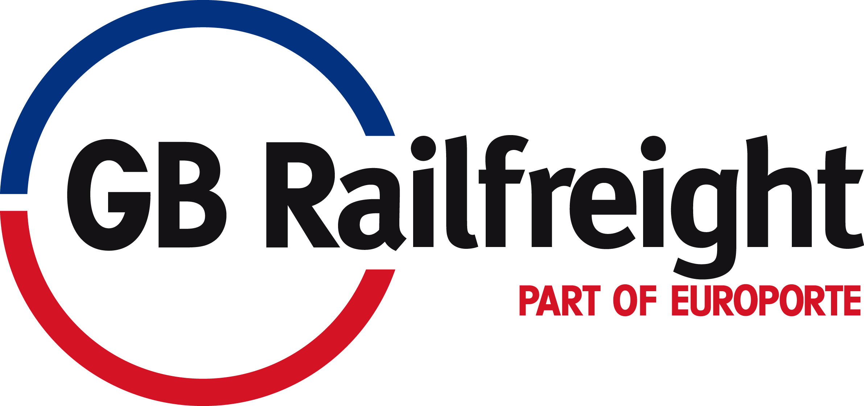

IMMEDIATE RELEASE

GB Railfreight celebrates relationship with Hitachi Rail Europe by naming Class 66 locomotive

Melton Mowbray, April 27th, 2015 – GB Railfreight today celebrated its relationship with Hitachi Rail Europe by naming one its Class 66 locomotives ‘Inspiration Delivered’ at Network Rail’s Rail Innovation Development Centre (RIDC, formerly known as Old Dalby).

Locomotive 66751 was named ‘Inspiration Delivered’ in collaboration with Hitachi Rail Europe and in recognition of the innovation and reliability of Hitachi Rail Europe’s business.

The naming plaque was unveiled by John Smith, Managing Director of GB Railfreight, and Andy Rogers, Projects Director at Hitachi Rail Europe, and was witnessed by representatives from the Department for Transport, Agility Trains, Network Rail, Virgin Trains East Coast and First Great Western.

Locomotive 66751 will be used as a dedicated resource to haul Hitachi Rail Europe’s Class 800 pre-series train for the InterCity Express Programme (IEP) between RIDC and the East Coast Main Line.

The naming ceremony also signifies the commitment GB Railfreight has to supporting Hitachi Rail Europe’s testing programme.

John Smith, Managing Director of GB Railfreight, said:

“We’re delighted to be supporting Hitachi Rail Europe with its testing programme for IEP. This ceremony highlights our commitment to the project, and the name “Inspiration Delivered” successfully reflects the wider innovation and reliability of Hitachi Rail Europe’s business. We aim to carry out the testing effectively and support Hitachi Rail Europe in its delivery of IEP.”

Andy Rogers, Projects Director from Hitachi Rail Europe, said:

“This is a proud moment for Hitachi Rail Europe to have this Class 66 locomotive named after Hitachi Rail Europe’s values, reflecting our expertise in innovation and on time delivery.”

Andy goes on to say;

“We would like to thank all our industry partners and key stakeholders for their support today and we look forward to inviting them all to the opening ceremony of the Hitachi Rail Europe Newton Aycliffe Rail Vehicle Manufacturing Facility very soon.”

--
For media enquires about GB Railfreight contact Lucy James on 020 3397 0105 or lucy.james@westbournecoms.com. For media enquiries about Hitachi Rail Europe contact John Higginson on john.higginson@westbournecoms.com or 020 3397 9943 / 07920 701 693.
--

Notes to Editor:

- The ‘Inspiration Delivered’ locomotive will be used to move the first InterCity Express trains whilst under test on the ECML & GWML
- The first InterCity Express train arrived into the UK at Southampton Dock on 12 March 2015
- The first IEP test train has been commissioned, initial approvals are in place and running testing has commenced at RIDC including: incremental speed tests, locomotive haul tests, running characteristics, brake and pantograph tests
- Testing is progressing well and on track to complete on schedule

-- Ends --

About GB Railfreight
GB Railfreight is one of the UK's leading rail freight companies. It operates over 1,000 trains a week in the UK and is the main transporter of coal on the rail network and one of only two rail freight companies with regular contracts to move biomass. For further information about GB Railfreight please go to http://www.gbrailfreight.com/welcome-first-gbrfhtml/p_1/.

About Hitachi, Ltd.
Hitachi, Ltd. (TSE: 6501), headquartered in Tokyo, Japan, delivers innovations that answer society’s challenges with our talented team and proven experience in global markets. The company’s consolidated revenues for fiscal 2013 (ended March 31, 2014) totaled 9,616 billion yen ($93.4 billion). Hitachi is focusing more than ever on the Social Innovation Business, which includes infrastructure systems, information & telecommunication systems, power systems, construction machinery, high functional materials & components, automotive systems, healthcare and others. For more information on Hitachi, please visit the company's website at http://www.hitachi.com.

About Hitachi Rail Europe Ltd.
Hitachi Rail Europe Ltd., is a wholly owned subsidiary of Hitachi Europe, Ltd. and is headquartered in London, UK.
Hitachi Rail Europe is a total railway system supplier offering rolling stock, traction equipment, signalling, traffic management systems, and maintenance depots.
Hitachi draws on many years of experience as a leading supplier of high-speed trains such as the Shinkansen (bullet train) for the Japanese and international markets. In Europe, Hitachi Rail Europe’s first rolling stock contract was to deliver a fleet of 29 Class 395 trains, the first domestic high-speed train in the UK, which are maintained at Hitachi’s state of the art depot in Ashford, Kent. As part of the British Department for Transport’s Intercity Express Programme, Hitachi Rail Europe will replace the UK’s ageing fleet of Intercity trains, and will establish a new rolling stock manufacturing facility in Newton Aycliffe, UK for this purpose. The trains will be maintained and serviced in a number of new maintenance depots along the Great Western Main Line and the East Coast Main Line.
For more information about the company, please visit: www.Hitachirail-eu.com .

# # #

