Andreas Bäckman joins STCC at Mantorp Park for Brink Motorsport
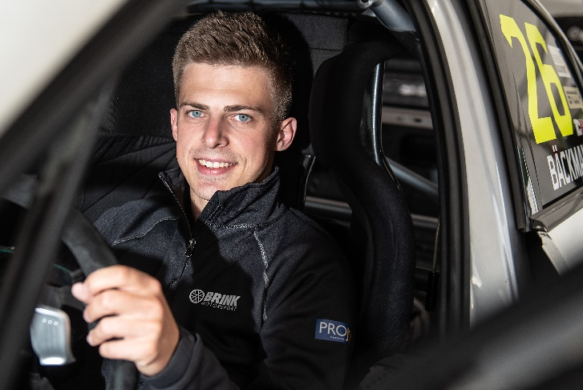
Andreas Bäckman, here in his Audi RS 3 LMS TCR car, which he will be racing for the first time in the 5th round of STCC at Mantorp Park on October 2nd-3rd, together with team Brink Motorsport.
Photo: Anders Helgesson (Free rights to use the image)
Andreas Bäckman will make a one-off appearance in STCC (Scandinavian Touring Car Championship) at Mantorp Park on October 2nd-3rd, together with Brink Motorsport. It will be both a new team and a new car for Andreas, as he will compete for the first time with an Audi RS 3 LMS-car.
- It will be great fun to come back to racing in Sweden again, Andreas Bäckman says.
STCC is Sweden's most prestigious motorsport championship and is today the leading class for Touring Car Racing. The cars are built according to the global TCR regulations, which means that the cars used in STCC are the same as those in the other TCR series around the world. The series consists of six race weekends held on different Swedish tracks and in two weeks, on October 2nd-3rd, the fifth round of the championship will be held at Mantorp Park, which is located near Linköping, Sweden. Mantorp Park is one of Sweden's top motorsport facilities and a large number of motor events are arranged here every year, some of which are among the largest in Sweden and Europe.
It is now official that the FIA WTCR driver Andreas Bäckman will make a one-off appearance in the championship, while there is a gap in the World Cup calendar. He will compete for Brink Motorsport with an Audi RS 3 LMS TCR car for the first time.
A new car and a new team
Andreas Bäckman made his competition debut in go-karting in 2006 as a 10-year-old and has since competed around the world with many national and international successes in go-karting. In 2018, Andreas made his debut in car racing after many years in go-karting and one year in rallycross.
Since his debut in car racing in 2018, he has over the years taken wins, pole positions and podiums in several TCR championships. In 2018, he got a win, a pole position and several podium places towards a 3rd place overall in the TCR UK Championship, which is the British counterpart of STCC.
In 2019, he took the step up to the European Series TCR Europe and finished in 4th place overall with one victory, two pole positions and two podium places during the season. In 2020, he also competed in TCR Europe and took home a win in Barcelona.
In 2021, Andreas are competing in the World Cup series WTCR - FIA World Touring Car Cup for Target Competition in a Hyundai Elantra N TCR car. Now he enters STCC at Mantorp Park in two weeks and this time for Brink Motorsport in an Audi RS 3 LMS TCR car.
- It will be great fun to come back to Sweden again after having only competed internationally for the past three years, Andreas Bäckman says.
- Really fun to welcome another WTCR driver to the team and to this year's STCC championship. He has really shown his forefoots in Europe, which has made him end up on our radar, Ted Brink, Team Manager for Brink Motorsport, says.
– We will of course be humble, as it will be the first race for him in an Audi and the first race with the team. But we aim high, we think there is potential to fight at the top.

It will be an intense STCC weekend at Mantorp Park for the Brink Motorsport driver, who has never competed with an Audi RS 3 LMS before. The last time he drove at Mantorp Park was in 2018 when he competed in STCC.
– Mantorp Park is a track that I have enjoyed driving at before, so it will be fun to race there again, Andreas Bäckman says.
– Considering that it will be the first competition for me in both the team and in the car, it will be a tough challenge and I will have a lot to learn. But I look forward to the challenge and I will do my best to deliver as good of a result as possible for the team.

The event are broadcasted LIVE at STCC+
The STCC weekend at Mantorp Park are broadcasted LIVE at: plus.stcc.se
Live-timing: raceresults.se
More information about STCC can be found here: stcc.se

About the track (Mantorp Park):
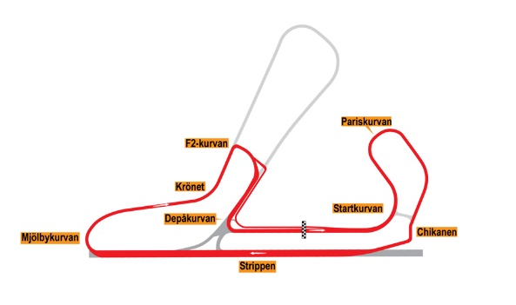
Location: Mantorp, Sweden
Length: 3,106 km
Corners: 8
Race length: 14 laps (43,48 km)
Track record (TCR): 1:19.260 / average speed 141.07 kph, Tobias Brink (Audi RS3 LMS TCR) 2020

Free rights to use the images.

Download press-photos here:
http://bit.ly/jabaeckman-photos
https://www.mynewsdesk.com/se/ja-backman/images

