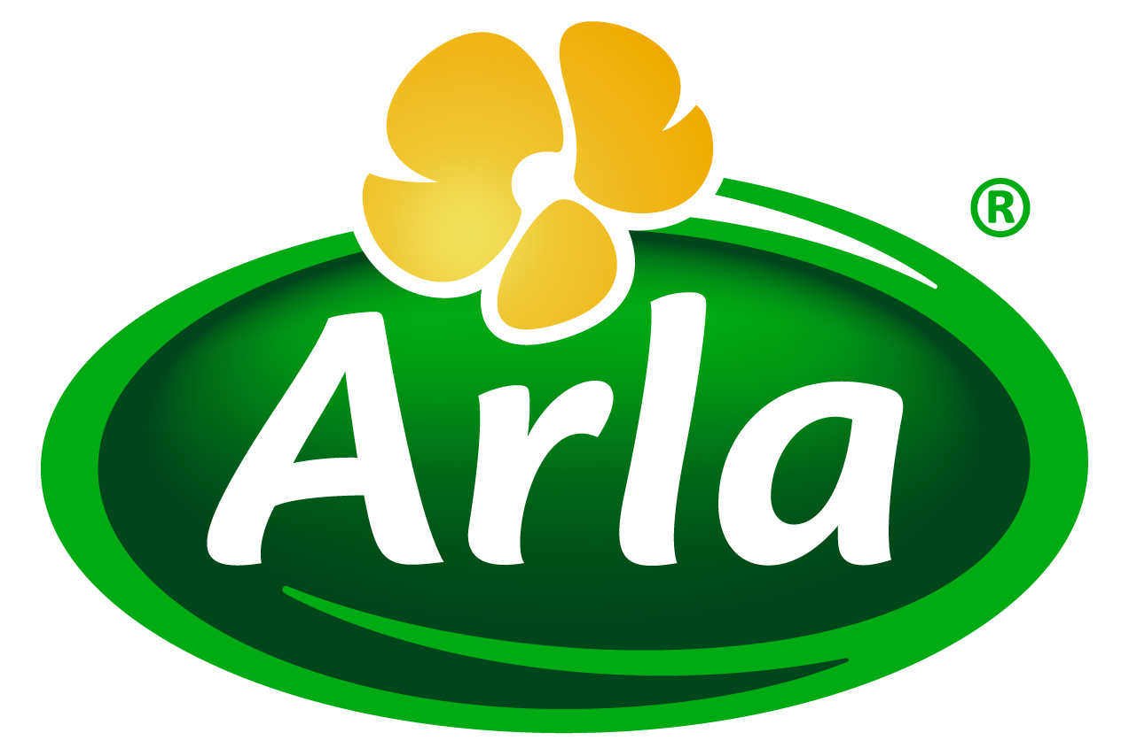
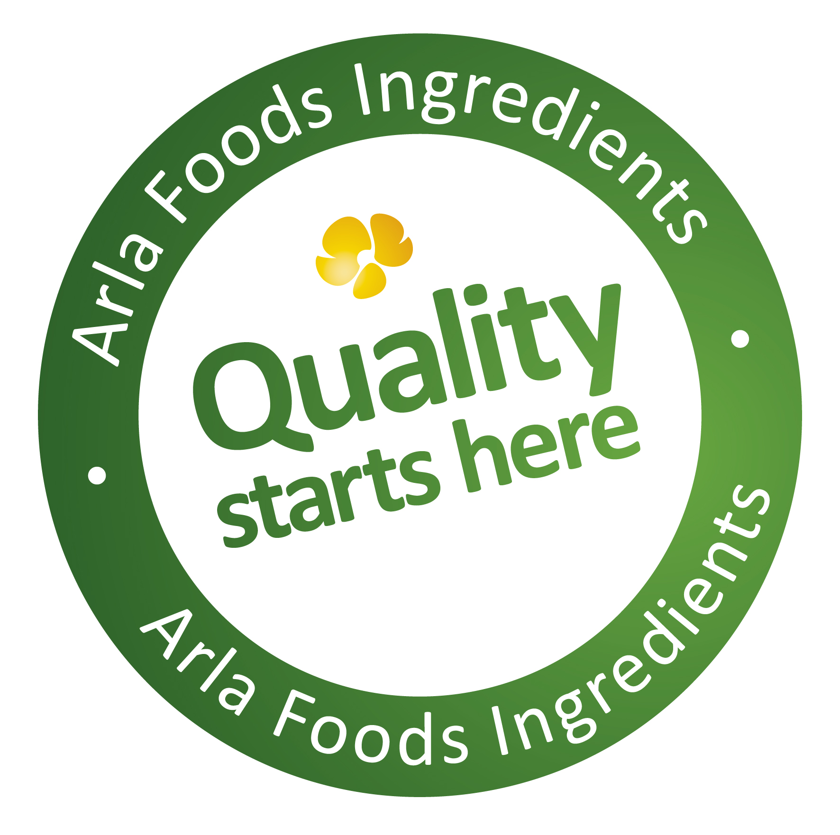

22 June 2016
PRESS RELEASE
Doors open on Arla Foods Ingredients’
€40 million hydrolysates factory

Arla Foods Ingredients has strengthened its position of leadership in the global dairy protein hydrolysates sector with the opening of new, dedicated factory located in Nr. Vium, Denmark.

The €40 million facility can produce approximately 4,000 tonnes of high quality whey and casein hydrolysates a year, creating ingredient solutions for applications in the infant, clinical and sports nutrition categories. Existing production of hydrolysates by Arla Foods Ingredients elsewhere will now be transferred over to the new site at Nr. Vium.

The factory features state-of-the-art manufacturing technology as well as pilot plants, analytical laboratories and R&D facilities. It complies with the strictest quality and safety standards and includes a dedicated packing line for filtered products.

Anders Steen Jørgensen, Business Unit Director Pediatric at Arla Foods Ingredients, said: “Our new factory has been built from the ground up, with the single aim of producing the best dairy protein hydrolysate ingredients available anywhere in the world. Our solutions offer scientifically documented health benefits, excellent solubility, superb microbiology and uniform quality. Now we can also offer them in much greater volumes with complete security of supply.”

Milk protein hydrolysates are proteins that have been through a natural enzymatic process, during which the intact protein is cut into small peptide fragments. Compared with intact proteins, they offer reduced allergenic potential, easier digestion and faster absorption. These attributes mean they provide excellent functional health properties in clinical and infant nutrition, where they deliver the benefits of the protein more quickly and effectively to those who need it most.

ENDS

For more information, please contact:
Richard Clarke Ingredient Communications
Tel: +44 7766 256176
Email: richard@ingredientcommunications.com
Twitter: @ingredientcomms

About Arla Foods Ingredients
Quality starts here: Arla Foods Ingredients is a global leader in natural whey ingredients for products in a range of categories – from sports, clinical and infant nutrition to beverages, bakery, dairy and ice cream.
The cornerstones of our business are innovative ingredients, world-class facilities and a staff of dedicated experts. Drawing on our portfolio of functional and nutritional whey proteins, milk minerals, lactose and permeate, our expert team delivers solutions that bring new food products quickly and efficiently to market. Our application centres run hundreds of customer product trials every week. All ingredients are produced using state-of-the-art processing technology at our plant in Denmark, or by one of our joint ventures in Argentina, Germany and the UK.
Arla Foods Ingredients Group P/S is a 100% owned subsidiary of Arla Foods, a global dairy company and cooperative owned by dairy farmers in Denmark, Sweden, the UK, Germany, the Netherlands, Belgium and Luxemburg.

RSS Feed
Visit our website at http://www.mynewsdesk.com/arla-foods-ingredients and sign up to our News RSS feed for all the latest developments – updated regularly.

Twitter
Follow us on twitter for all the latest updates @ArlaIngredients

LinkedIn
http://www.linkedin.com/company/arla-foods-ingredients

Facebook
https://www.facebook.com/arlaingredients

