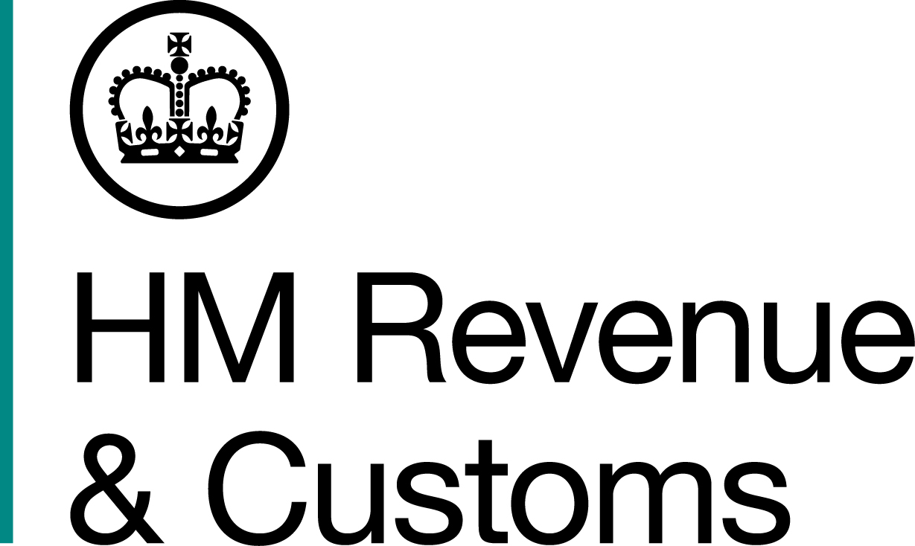
News Briefing

 | For the attention of News Desks |  | No. of pages: 2
 | Date: | 13 March 2017 | Ref: | LON 2 2017

Adventure ends for day-trip tobacco smugglers

Three men from Essex, who masqueraded as day-trippers on coaches to the continent to smuggle alcohol and cigarettes back into the UK, have been sentenced.

Richard Bartholomew Cheeseman, 73, Donald Francis McCudden, 67, and Ian Paul Irwin, 56, admitted evading nearly £80,000, the amount of duty due on the tobacco and alcohol purchased on their day trips to France and Belgium.

HM Revenue and Customs (HMRC) investigations revealed that, between December 2013 and March 2014, McCudden and Irwin took it in turns to travel up to four times a week, smuggling alcohol and cigarettes to meet customer orders, including off licences and shops. While Cheeseman travelled less frequently he had a controlling role in the scam organising the purchase of alcohol and tobacco from warehouses in France and Belgium.

In an attempt to avoid detection the men used a variety of coach companies and boarded from different pick up points, including Thurrock Services. They also recruited other day trippers, making sure that each passenger kept within personal use guide levels, in case any of them were stopped at border controls.

At the end of each trip, the three men would travel to shops in the Southend, Maldon and Frinton areas, delivering their illegal contraband. HMRC officers caught Cheeseman and McCuddon red-handed, outside an off licence in Southend, in March 2014 with over 460 litres of wine and five and a half kilogrammes of tobacco.

Cheeseman will now be subject to confiscation proceedings.

Notes for Editors

- Richard Bartholomew Cheeseman (DOB 7/12/43) of Holmbrook, Frinton-on-Sea, pleaded guilty to the fraudulent evasion of duty contrary to section 170 (2) (a) of the Customs and Excise Management Act of 1979 and was sentenced to 15 months imprisonment at Maidstone Crown Court today.

- Ian Paul Irwin (DOB 25/03/60) of Old Road, Frinton-on-Sea, pleaded guilty to the fraudulent evasion of duty contrary to section 170 (2) (a) of the Customs and Excise Management Act of 1979 and was sentenced to seven months imprisonment, suspended for 18 months and ordered to carry out 180 hours of unpaid work at Maidstone Crown Court on 28 November 2016.

- Donald Francis McCudden (DOB 17/02/50) of Connaught Avenue, Frinton-on-Sea, pleaded guilty to the fraudulent evasion of duty contrary to section 170 (2) (a) of the Customs and Excise Management Act of 1979 and was sentenced to six months imprisonment, suspended for 18 months and ordered to carry out 140 hours of unpaid work at Maidstone Crown Court on 28 November 2016.

- Follow HMRC Press Office on Twitter @HMRCpressoffice

- HMRC's Flickr channel www.flickr.com/hmrc.gov.uk

Issued by HM Revenue & Customs Press Office

Press enquiries only please contact:

Natalie Brown
Tel: 03000 519123
E-mail: Natalie.brown@hmrc.gsi.gov.uk

Or
Nikki Sanders
Tel: 03000 524936
E-mail: Nikki.sanders@hmrc.gsi.gov.uk

Out of hours
Tel: 07860 359544

Website www.gov.uk/hmrc

