

For immediate release

OCTAPAS, A SPANISH TAPAS BAR AT CLARKE QUAY,

BUBBLES WITH THE LAUNCH OF A NEW MENU

Singapore, April 18- OCTAPAS, a Spanish tapas bar at Clarke Quay will blossom on Monday the 18th of April due to the launch of a new menu. The new menu consists of improved classic recipes with more than 15 items of vegetarian dishes as well as Gluten Free dishes (50% of the items on the new menu are gluten free).

To add to the mouth-watering and fantastic dishes offered at Octapas, is the ambience of the restaurant. Guests at the magnificent restaurant will be exposed to the enjoyment of two dazzling and tantalizing experiences- to sit at fresco by the riverside and watch the world sail by the river while leisurely picking on a plethora of tapas or escape to the inner sanctuary of Octapas.

The interior of the exquisite restaurant is another attractive and fascinating feature as it showcases custom high tables with mosaic-like marbled tops and wrought-iron legs, customers are bathed in warm light bouncing off the burnt orange walls and ceiling, characteristic of a great chill-out spot. In the evenings, this is the place to capture the upbeat vibe of live entertainment, which includes music featuring modern Spanish hits and contemporary numbers by the resident band.

Few highlights of the new menu includes:

|  |  |
| --- | --- |
| Macintosh HD:Users:Octapas:Desktop:NEW FOOD PICS - OCT - MAR 16:AD1-7.jpg | Tapas Frias (Cold Tapas) section:  Item: Gambas en Salsa $14++  Shrimps tossed in shallots, tomatoes and bell peppers salsa |
| Macintosh HD:Users:Octapas:Desktop:NEW FOOD PICS - OCT - MAR 16:AD1-43.jpg | Ensaladas / Salad Section:  Verduras Grilladas $14++  Artichokes, zuchinni, aubergine, piquillo with wild rocket leaves |
| Macintosh HD:Users:Octapas:Desktop:NEW FOOD PICS - OCT - MAR 16:AD1-28.jpg | Tostadas / Toasted bread section:  Carne con picada $13++  Minced beef with a basket of grilled baguette |
| Macintosh HD:Users:Octapas:Desktop:NEW FOOD PICS - OCT - MAR 16:AD1-18.jpg | Tapas Calientes / Hot Tapas section:  Pulpo con salsa picaada caatalana $18++  Grilled Octopus with Catalan Picada sauce |
| Macintosh HD:Users:Octapas:Desktop:NEW FOOD PICS - OCT - MAR 16:AD1-22.jpg | Tapas Calientes / Hot Tapas section:  Classic dish – chef’s favourite hangover cure  Huevos Rotos $18++  Spanish Broken egg with potatoes and jamon iberico |
| Macintosh HD:Users:Octapas:Desktop:NEW FOOD PICS - OCT - MAR 16:AD1-21.jpg | Tapas Calientes / Hot Tapas section:  Zarzuela de Mariscos $19++  Catalan style seafood stew with saffron and tomato sauce |
| Macintosh HD:Users:Octapas:Desktop:NEW FOOD PICS - OCT - MAR 16:AD1-26.jpg | Tapas Calientes / Hot Tapas section:  Panceta con chimichuri $15++  Grilled marinated pork belly with chimichurri sauce |
| Macintosh HD:Users:Octapas:Desktop:NEW FOOD PICS - OCT - MAR 16:AD1-37.jpg | Fiduea $36++ for 2 persons, $56++ for 4 persons  Chicken, mussles, squids, prawns and fish with angel hair pasta in saffron and tomato sauce |
| Macintosh HD:Users:Octapas:Desktop:NEW FOOD PICS - OCT - MAR 16:AD1-51.jpg | Posters / Dessert section:  Trio de Helado $17++  Jamon iberico, parama and chorizo on olive focaccia with vanilla ice cream |

There is also happy hour which is available every day from 12-8pm. 1-for-1 – draft beers, wine by the glass, sangria, cocktails and house-pour spirits (not valid on major event nights).

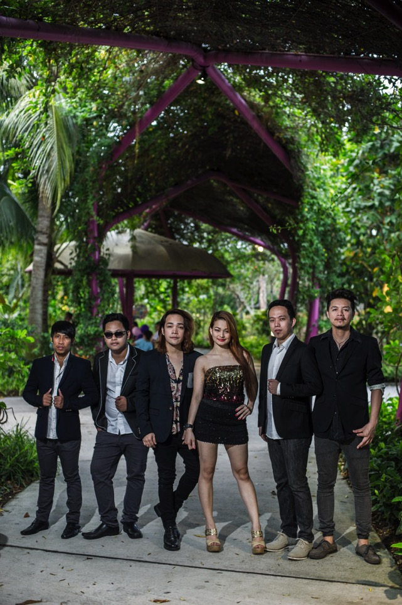

‘We are pleased to announce that Antidote will be coming on board in April to spice up the restaurant. Antidote is a great top 40’s band that has played all over South East Asia and greater part of Philippines, so we’re very fortunate to have them. We wanted to find a band that will meet the eclectic style of the restaurant so perfectly and that’s Antidote. Antidote consists of singers Annmarie Richel, Jay-Ar, Johann Cornelia, Kim Clark, Ferdinand Nilo, and guitarist Israel Antipas. The band has played most recently as a headliner at Flare Bar bringing their renditions of popular hits. Their smooth, soulful covers of songs like Enrique Iglesias’s Bailamos have brought patrons to the floor and made them one of the most popular cover bands in Manila’; said the General Manager, Rahidi Hamzah. Antidote performs on Friday, Saturday & Eve of Ph from 10pm & Tuesday to Thursday, Sunday from 9.30pm. Octapas operates from Monday to Thursday by 12pm to 1:00am; Friday, Saturday, Sunday & Eve of Public Holiday: 12:00 noon to 2:00am.

Why not treat yourself to a dazzling and fantastic menu at Octapas. Do not wait to be told. This may be the most memorable experience in your life.

**Fact Sheets**

**OCTAPAS**

BLK D, Clarke Quay, #01-08. River Valley Road. Singapore 179023

Telephone: 6837 2938

Email: [enquiries@octapasasia.com](mailto:enquiries@octapasasia.com)

Website: http://www.octapasasia.com/

Facebook: <https://www.facebook.com/Octapasasia>

Operating hours: Monday to Thursday: 12pm to 1:00am

Friday, Saturday, Sunday & Eve of Public Holiday: 12:00 noon to 2:00am

-End-

For more information and photographs in high resolution, please contact: jayden@tembusuprojects.com