KONGSBERG to supply Finnish Navy corvettes with Anti-Submarine Warfare and diver detection sonars
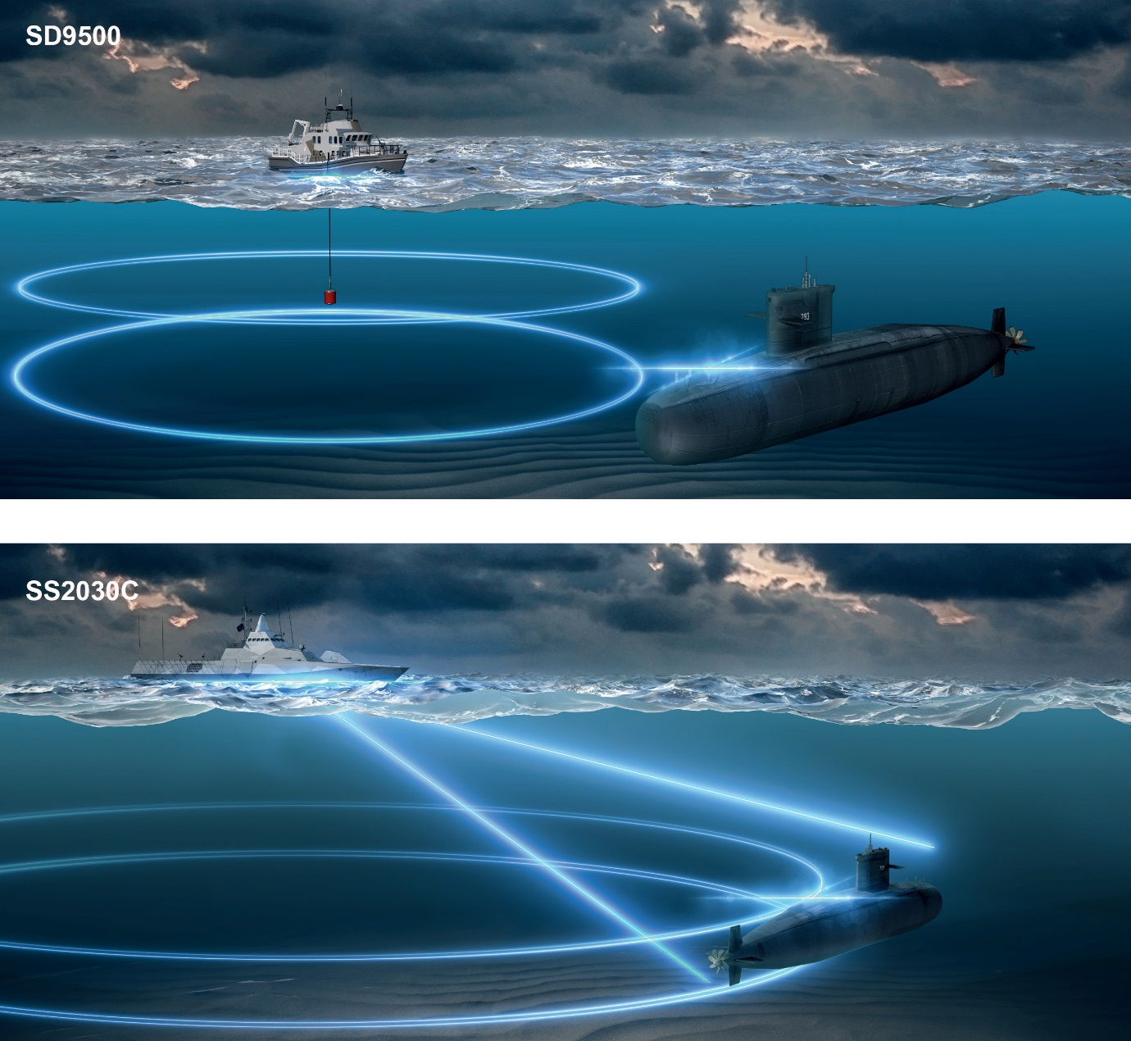

Kongsberg, Norway, 15th April 2020 – Kongsberg Maritime AS, Sensor & Robotics is celebrating the signing of a contract with Saab that will see KONGSBERG delivering its market-leading Anti-Submarine Warfare (ASW) and diver detection sonars for the Pohjanmaa-class corvettes currently being developed by the Finnish Navy under its Squadron 2020 project.
Under the terms of the contract, which equates to approximately 100MNOK, KONGSBERG will equip the vessels with its SS2030 and SD9500 sonars, both of which boast acoustic properties which make them ideally suited for deployment in shallow-water environments.
The SS2030, principally devised for ASW operations and capable of detecting torpedoes or other small objects in the water column, is an active hull-mounted sonar which utilises sophisticated tracking algorithms. Its electronically-stabilised transmitting and receiving beams can be tilted to adjust to challenging sound speed profiles, with its integrated Sound Propagation Model determining the optimal tilt settings and enhancing the Probability of Detection (PoD) ratio. The SS2030 sonars will be delivered to the Finnish Navy complete with hoistable hull units and ice protection to ensure safe and efficient operation in the often harsh conditions of the Baltic Sea.
The SD9500, meanwhile, is a light and compact over-the-side dipping sonar with outstanding horizontal and vertical positioning capabilities for diver detection, ASW duties and volumetric survey assignments in shallow, reverberation-limited waters.
“We are very pleased to have been selected for another sonar program for the Finnish Navy and to further strengthen our position as a principal supplier of shallow-water ASW, diver detection and mine-hunting equipment,” says Thomas H Dahle, Director of Sales at KONGSBERG. “The armed forces, as with all defence industries, have to rely upon the most advanced technology available in order to fulfil their responsibilities effectively, and this new naval contract is another resounding testimony to the deep level of trust the KONGSBERG brand has accumulated over our many successful years of trading.”
Ends
For further information, please contact:
Gunvor Hatling Midtbø, VP Communication
Kongsberg Maritime
Tel: +47 9921 4209
gunvor.hatling.midtbo@km.kongsberg.com

David Pugh
Saltwater Stone
Tel: +44 (0)1202 669244
d.pugh@saltwater-stone.com

About Kongsberg Maritime
Kongsberg Maritime is a global marine technology company providing innovative and reliable ‘Full Picture’ technology solutions for all marine industry sectors including merchant, offshore, cruise, subsea and naval. Headquartered in Kongsberg, Norway, Kongsberg Maritime has manufacturing, sales and service facilities in 34 countries.
Kongsberg Maritime solutions cover all aspects of marine automation, safety, manoeuvring, navigation, and dynamic positioning as well as energy management, deck handling and propulsion systems, and ship design services. Subsea solutions include single and multibeam echo sounders, sonars, AUV and USV, underwater navigation and communication systems.
Training courses at locations globally, LNG solutions, information management, position reference systems and technology for seismic and drilling operations are also part of the company’s diverse technology portfolio. Additionally, Kongsberg Maritime provides services within EIT (Electro, Instrument & Telecom) engineering and system integration, on an EPC (Engineering, Procurement & Construction) basis.
Kongsberg Maritime is part of Kongsberg Gruppen (KONGSBERG), an international, knowledge-based group that celebrated 200 years in business during 2014. KONGSBERG supplies high-technology systems and solutions to customers in the oil and gas industry, the merchant marine, and the defence and aerospace industries.
Web: Kongsberg Gruppen | Kongsberg Maritime
Social media: LinkedIn | Twitter | Facebook

