www.thehappinesseffect.com

Press release

The Happiness Effect gets the world smiling.

SINGAPORE, 20 March 2013 – Today, The Happiness Effect movement is launched from Singapore, in conjunction with the International Day of Happiness. The movement kicks off with a day of smiles, where people globally are invited to smile, make others smile, thank others for making them smile, and to share their photos, videos, tweets and comments online.

THE movement is launched on 20th March 2013, in support of the United Nation’s International Day of Happiness. However, instead of celebrating just one day of happiness, this global movement is designed to last 100 days because habits generally take at least 21 days to forge. THE movement aims to positively touch at least a million people over the 100 days.

Although the movement is only launched today, it has already reached 20 countries online. Over 100 days from 20 March to 27 June 2013, The Happiness Effect (THE) movement will invite the world to take 1 action a day to make someone happy, and to spread these acts of happiness through videos, photos, tweets, and stories.

The first activity chosen for its launch today is smiling. Studies have reported that smiling releases good chemicals in the body, such as endorphins, which are natural pain relievers, and serotonin, which is associated with feel-good properties. These chemicals are only released by “genuine” smiles that engage the muscles in the mouth, cheeks, and eyes.
‘We chose to kick off the movement with smiling, as it is such a simple thing to do. Yet, when you smile at people and they return the smile, you are creating physiological changes that benefit everyone. It is one of the best actions to start spreading happiness,’ said Ms Angela Lam, founder of THE movement.
After the first day of smiles, THE team will be highlighting other actions to spread happiness. These actions are selected from the free Happiness Manifesto or public suggestions. Supporters are encouraged to share their happiness ideas and actions through THE website or social media platforms. Happiness Angels are also nominated and voted by the public, to recognize the joy, happiness and positive contributions that they make to others.

Here’s how you can participate and be a part of the movement:

- ‘Like’ and share the website and Facebook page at www.thehappinesseffect.com and www.facebook.com/thehappinesseffect.

- Follow the movement on Twitter at www.twitter.com/thehappinessef1.

- Download the free Happiness Manifesto at http://thehappinesseffect.com/book-videos, and offer your suggested ideas on actions that the world can take together to spread happiness.

- Tune in daily from 20 March 2013 to 27 June 2013, do the selected happiness actions and upload your pictures, videos, ideas and comments on THE Facebook or twitter pages. Start your tweets with the #TheHappinessEffect.

For more information, please visit www.thehappinesseffect.com.

END www.thehappinesseffect.com

MEDIA CONTACTS
Angela Lam angela.lam@thehappinesseffect.com, +65 9843 6993
Gareth Poh gareth.poh@thehappinesseffect.com, +65 8228 0302

THE MOVEMENT AND FOUNDERS
The Happiness Effect (THE) movement is a 100 day movement from 20 March to 27 June 2013. Over 100 days, THE unites the world in 1 action each day, focused at making someone happy. Actions are selected from the free Happiness Manifesto and public suggestions. Happiness Angels are also nominated and voted by you, to recognize the joy, happiness and positive contributions that they make to others.
THE aims touch 1 million people worldwide over 100 days and inspire positive action.
Here’s how you can participate and be a part of the movement:
1. ‘Like’ and share the website and Facebook page at www.thehappinesseffect.com and www.facebook.com/thehappinesseffect.
2. Follow the movement on Twitter at www.twitter.com/thehappinessef1.
3. Download the free Happiness Manifesto at http://thehappinesseffect.com/book-videos, and offer your suggested ideas on actions that the world can take together to spread happiness.
4. Tune in daily from 20 March 2013 to 27 June 2013, do the selected happiness actions and upload your pictures, videos, ideas and comments on THE Facebook or twitter pages. Start your tweets with the #TheHappinessEffect.
THE movement is a not-for-profit movement started as a personal initiative by Ms Angela Lam, Chief Happiness Officer of Skool of Happiness and several social entrepreneurs in Singapore. Skool of Happiness™ (SoH) betters lives by helping individuals to unlock their personal potential and live successful and fulfilled lives. SoH was founded by Ms Angela Lam. Angela started out with a high-flying corporate career in aviation, tourism and the hospitality industries. After more than 10 years in the corporate world, she gave up her title of Vice President with a multinational corporation to pursue her dreams and passions in bettering lives. Angela is known for her positive energy, bubbly nature, and “can-do” attitude. She loves music, dance, books, nature, and an occasional burst of spontaneity and madness. For more information, please visit www.skoolofhappiness.com.

PHOTOS

The following photos and captions may be used for visuals. The photos can be downloaded at this link: http://www.mynewsdesk.com/sg/pressroom/the-happiness-effect
 | A group of friends from different countries touching typhoon-hit villages in the Philippines with small gifts but big hearts.
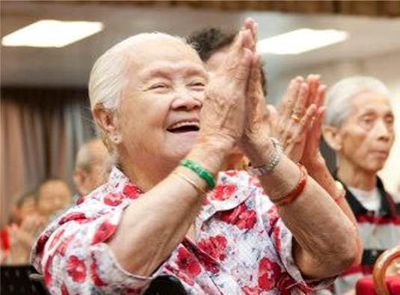 | Simple personal connections and great company can make the day for old folks. Sharing and giving at a charity event, Project 100 Smiles.
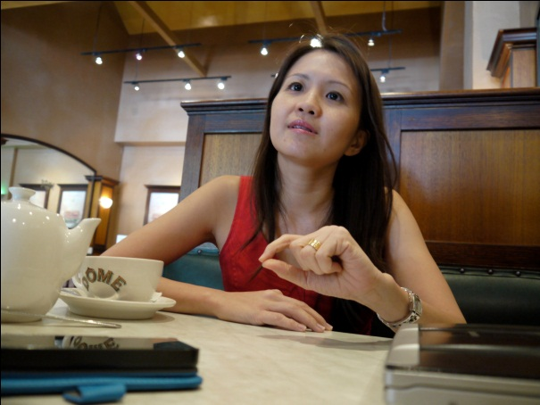 | Ms Angela Lam, founder of The Happiness Effect (THE) movement, speaking about her vision and objectives for THE movement.

