Meet the maritime digitalization experts with
Kongsberg Digital’s Power Hours
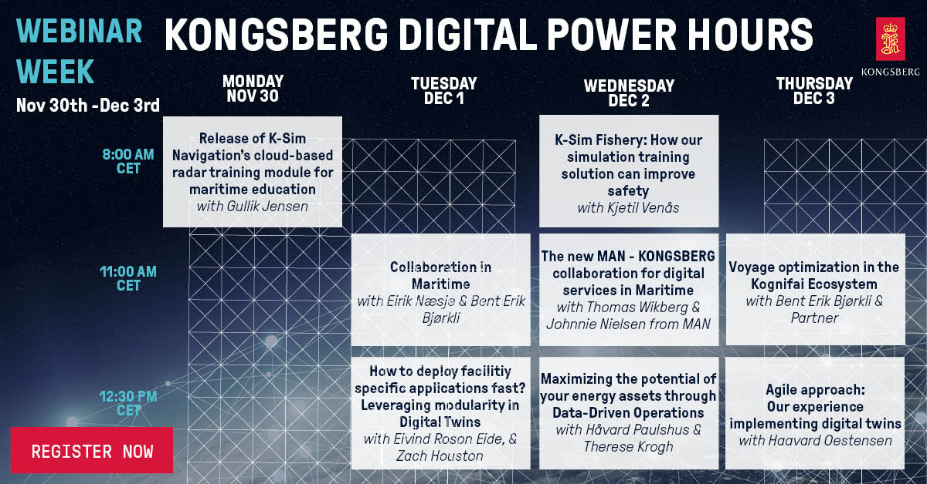
Kongsberg Digital will host a webinar week, with a series of Power Hours on digital maritime technologies

Kongsberg, Norway, November 30th, 2020 – Kongsberg Digital are delighted to announce a new Webinar Week: a series of live webinars taking the form of ‘Power Hours’. Hosted by leading experts from within Kongsberg Digital and the maritime industry, these sessions offer a valuable, time-efficient way for professionals across all market sectors to stay informed and learn of the latest developments in maritime digitalization.
The webinars will run from Monday 30th November to Thursday 3rd December. A Q&A session is included within each webinar, providing a key opportunity for interaction with the hosts and to obtain the latest information about Kongsberg Digital’s wide range of digital solutions.
Kicking off this morning with the release of K-Sim Navigation’s cloud-based radar training module for maritime education (click here for more information), the week continues with webinars addressing a range of topics, including:
- Collaboration in Maritime
- Eirik Næsje, SVP Vessel Insight, Kongsberg Digital
- Bent Erik Bjørkli, VP Partner Program, Kongsberg Digital
- How to deploy facility specific applications fast? Leveraging modularity in Digital Twins
- Eivind Roson Eide, Senior Engineer, Kongsberg Digital
- Zach Houston, Senior Product Champion, Kongsberg Digital

- K-Sim Fishery: How simulation training improves safety, efficiency and sustainability
- Kjetil Venås, Project Manager, Kongsberg Digital

- The new MAN – KONGSBERG collaboration for digital services in Maritime
- Thomas Wikberg, Manager Strategic Partnerships, Kongsberg Digital
- Johnnie Nielsen, Sales Manager, MAN
- Maximizing the potential of your energy assets through Data-Driven Operations
- Håvard Paulsus, Director of Solutions, Kongsberg Digital
- Therese Krogh, Customer Success Manager, Kongsberg Digital
- Voyage optimization in the Kognifai Ecosystem
- Bent Erik Bjørkli, VP Partner Program, Kongsberg Digital
- New partner – to be announced
- Agile approach: Our experience implementing Digital Twins
- Haavard Oestensen, Head of Growth, Kongsberg Digital
The webinars are open to all, and there are no restrictions on how many you can attend. For those unable to join the live sessions, recordings will be made available.
For more information and to register, click here.
Ends

For further information, please contact:

Mathilde Vik Magnussen
VP Communications & Marketing
Kongsberg Digital
Tel: +47 4567 8255
mathilde.magnussen@kdi.kongsberg.com

David Pugh
Saltwater Stone
Tel: +44 (0)1202 669244
d.pugh@saltwater-stone.com

About Kongsberg Digital
Kongsberg Digital is a provider of next-generation software and digital solutions to customers within maritime, oil and gas, and renewables and utilities. The company consists of more than 500 software experts with leading competence within the internet of things, smart data, artificial intelligence, maritime simulation, automation and autonomous operations.
Kongsberg Digital is subsidiary of KONGSBERG (OSE-ticker: KOG), an international, knowledge-based group delivering high-technology systems and solutions to clients within the oil and gas industry, subsea, merchant marine, defence and aerospace. KONGSBERG has 11.000 employees located in more than 40 countries.
Web: Kongsberg Gruppen | Kongsberg Digital
Social media: LinkedIn | Twitter | Facebook

