**Bäckman ready for GT4 European Series season finale**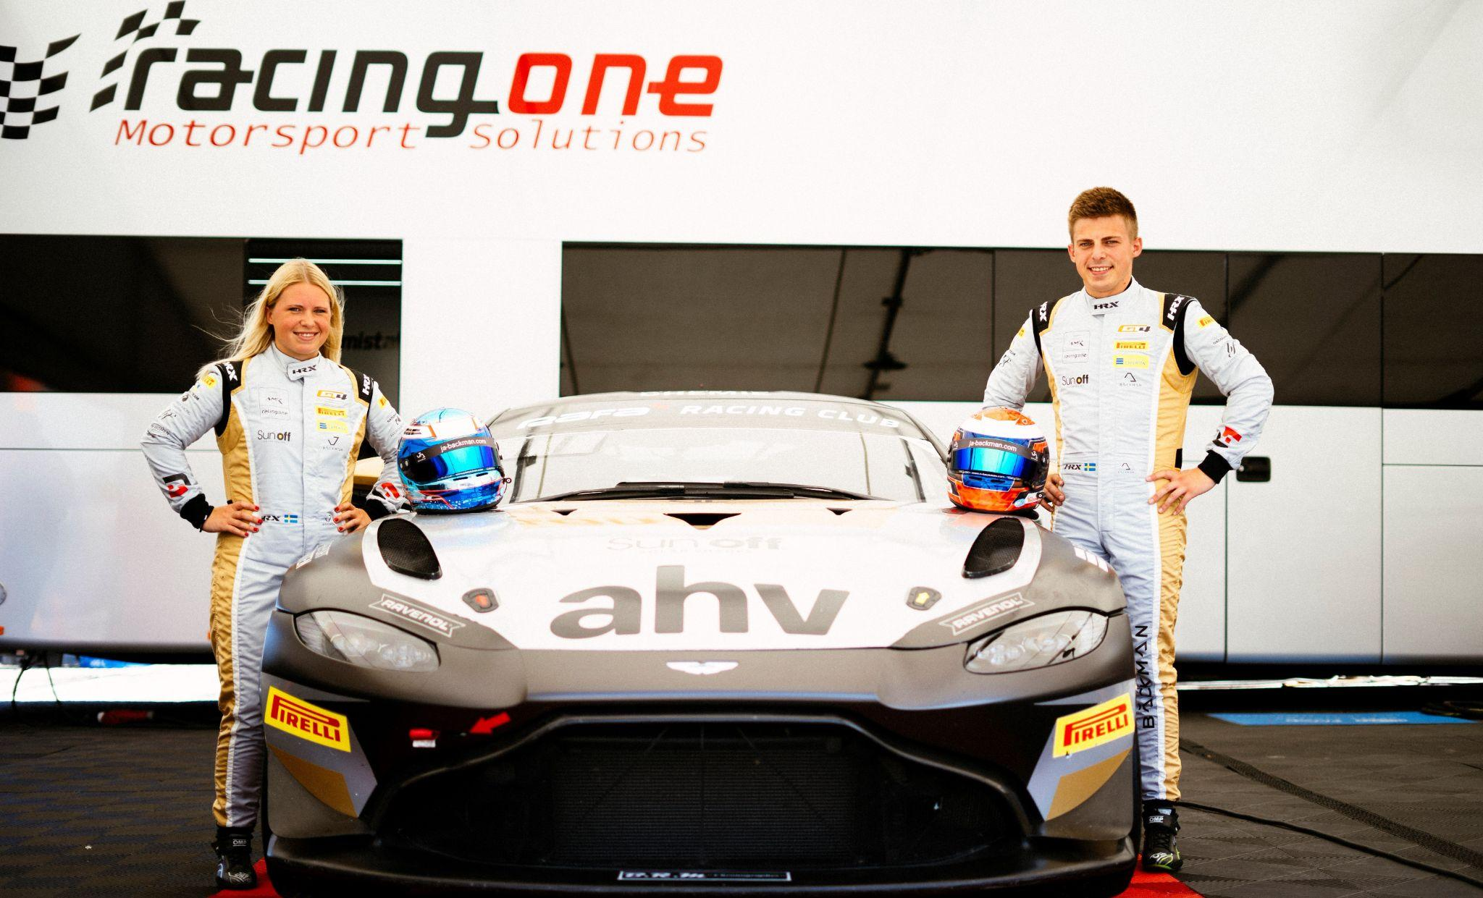Andreas and Jessica Bäckman are ready for the final round of the GT4 European Series in Barcelona, Spain in their Aston Martin AMR Vantage GT4.  
Photo: Linus Benz & Maximilian Bauer (Free rights to use the image) **Upcoming weekend, September 29th-October 1st, it's time for Andreas and Jessica Bäckman to take on the Barcelona track in Spain which is the season finale of the GT4 European Series 2023. The Sweden National Team drivers are excited and want to end the season on a high.  
- Barcelona is one of my favourite tracks and I have many good memories from there. I won the last two races I drove there in TCR so I hope it can bring us some luck for the season finale, Andreas Bäckman says.**

This weekend, it's time for the sixth and final round of the GT4 European Series at the Barcelona track in Spain, which will be the siblings seventh race together in GT4.

- It will be exciting to race again, and we are hungry for revenge and hope we can finish the year in a positive way. Last races haven't been what we wanted but it gives us extra motivation for the season finale to show some strong results against the 43- car strong grid, **Jessica Bäckman** says.

**The structure of the GT4 European Series**The GT4 European Series consists of six races around Europe. The series is considered one of the toughest GT4 series in the world and has a high status among the drivers who come from several different countries around Europe. The start of the season went on the well-known Monza circuit in Italy, which is also called "The Temple of Speed" and will end on the well-known Formula 1 circuit Barcelona in Spain where the siblings will race this weekend. In addition to Barcelona and Monza, the world-famous Formula 1 tracks Spa, Paul Ricard and Hockenheim have been on the 2023 calendar.

Each competition consists of two free practice sessions, two timed qualifying’s and two races of 60 minutes each where drivers are changed halfway through the race. Points are awarded to the fastest cars in the time qualifying’s and the top 10 in each race. The drivers in the car with the most points after the final race at Barcelona will take home the driver's title together "GT4 European Series Drivers Title" in the GT4 European Series.

**Time schedule for this weekend’s races (GT4 European Series Round 6):**(all times in CEST)  
  
**Friday September 29th:**11:20 Free Practice 1 (60 min) – [LIVETIMING](https://www.gt4europeanseries.com/watch-live#live-timing)  
15:40 Free Practice 2 (60 min) – [LIVETIMING](https://www.gt4europeanseries.com/watch-live#live-timing)  
 **Saturday September 30th:**  
11:25 Q1/Q2 – Qualifying 1 & 2 (2 x 20 min) - [LIVE TV QUALIFYING](https://youtube.com/@GTWorld)   
16:50 Race 1 (60 min) – driver change in the middle of the race - [LIVE TV RACE 1](https://youtube.com/@GTWorld)  
  
**Sunday October 1st:**  
11:20 Race 2 (60 min) – driver change in the middle of the race - [LIVE TV RACE 2](https://youtube.com/@GTWorld)

**About the track (Circuit de Catalunya-Barcelona):**  
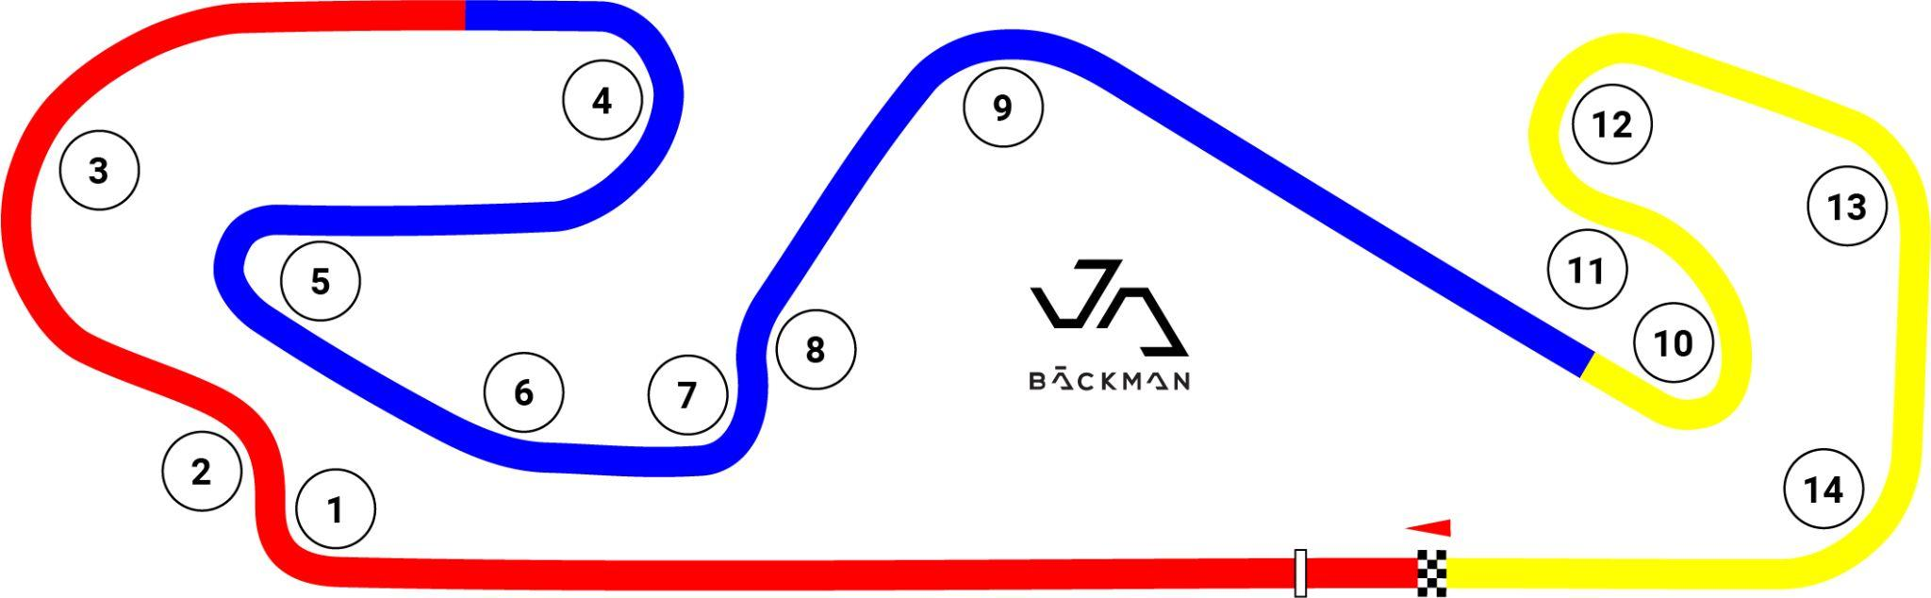  
  
**Location:** Barcelona, Spain  
**Length**: 4,655 km  
**Corners:** 14

**GT4 Europe Calendar 2023:  
*April 22nd-23rd*** - Monza, Italy ***June 2nd-4th*** - Paul Ricard, France  
***June 29th-July 2nd*** - Spa, Belgium ***July 14th-16th*** - Misano, Italy ***September 1st-3rd*** - Hockenheim, Germany ***September 29th-October 1st*** - Barcelona, Spain

***Free rights to use the images.***

***Download press-photos here:***[***http://bit.ly/jabaeckman-photos***](http://bit.ly/jabaeckman-photos)[***https://www.mynewsdesk.com/se/ja-backman/images***](https://www.mynewsdesk.com/se/ja-backman/images)

