Kongsberg Maritime offer remote training, e-Learning and assessment, with vessel-specific software
Video conferencing and virtual machines allow in-depth, hands-on training to be
safely delivered, maintaining skills and continuing development

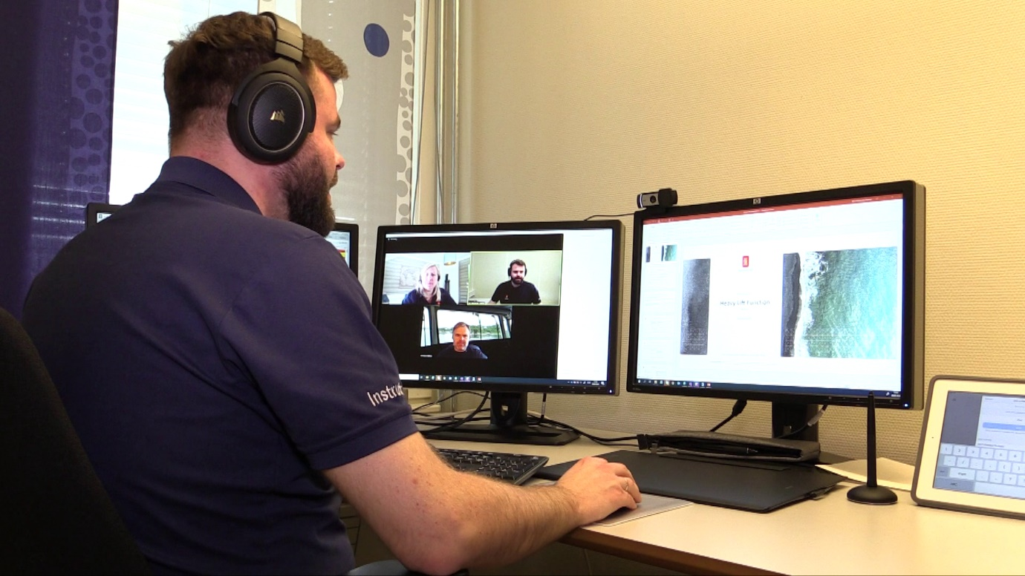
Kongsberg Maritime instructors will conduct courses in real time in virtual classrooms

Kongsberg, Norway, 30th March 2020 – Kongsberg Maritime is delighted to announce an integrated strategy to deliver remote, targeted training for its customers. Providing this service through digital platforms reduces travel, cost, time away from home and climate footprint. Three products – Remote Training, e-Learning and K-CAT (KONGSBERG Competence Assessment Tool) – combine to ensure that vessel crews can fully benefit from KONGSBERG’s expertise from the convenience and safety of their homes or offices.
Remote Training is delivered through established virtual classrooms and online training tools. The virtual/digital training environment allows remote students to learn using their own vessel’s software, assisted live by a qualified instructor. Many of KONGSBERG’s tried-and-tested classroom courses can be delivered in this way, using cloud-based virtual machines to provide each student with access to a Human-Machine Interface and allow them to operate real Dynamic Positioning (K-Pos), Automation (K-Chief 700) and Navigation (K-Bridge) software from any location. This ability to carry out practical tasks gives the participant hands-on experience as a basis for safe and sustainable operation. All that is required for students and instructors to take part is a PC or Mac, preferably with two monitors and a headset.
Remote Training can be delivered as a generic course or customised for each customer, with vessel-specific software. The virtual classroom includes tools to ensure learning objectives are understood by the participant, such as breakout rooms for one-to-one lessons or group work, facilitating discussions and helping contribute to the learning outcomes.
E-Learning – which is now available for K-Chief 600 in addition to KONGSBERG’s well-established ECDIS course – delivers an interactive learning experience without the instructor, allowing the student to complete the course at their convenience. E-Learning typically comprises a combination of theoretical lessons, practical tasks and summative tests after every topic, qualifying the student to sign up for a final online assessment.
Online assessment is carried out via the KONGSBERG Competence Assessment Tool (K-CAT). Usage includes verification of crews’ competence, pre-employment assessments and more – for example, to verify a potential employee’s knowledge of a subject prior to hiring them. K-CAT also offers a portfolio of competence assessments that measure key competencies from two perspectives: system understanding/utilisation of the DP system and practical skills of DP Operators. Compliant with the Continuous Professional Development layout from the IMCA M 117 and DNV-GL standards, K-CAT can be accessed from all smart devices and computers with internet connection, or used offline when suitably configured.
Aiming to help ship owners safeguard and verify the development and retention of their crews’ skills, K-CAT now offers competence assessments for key DP personnel, with additional offerings expected in the near future.
Click here for more details.
Ends
For further information, please contact:

Gunvor Hatling Midtbø, VP Communication
Kongsberg Maritime
Tel: +47 9921 4209
gunvor.hatling.midtbo@km.kongsberg.com

David Pugh
Saltwater Stone
Tel: +44 (0)1202 669244
d.pugh@saltwater-stone.com

About Kongsberg Maritime
Kongsberg Maritime is a global marine technology company providing innovative and reliable ‘Full Picture’ technology solutions for all marine industry sectors including merchant, offshore, cruise, subsea and naval. Headquartered in Kongsberg, Norway, Kongsberg Maritime has manufacturing, sales and service facilities in 34 countries.
Kongsberg Maritime solutions cover all aspects of marine automation, safety, manoeuvring, navigation, and dynamic positioning as well as energy management, deck handling and propulsion systems, and ship design services. Subsea solutions include single and multibeam echo sounders, sonars, AUV and USV, underwater navigation and communication systems.
Training courses at locations globally, LNG solutions, information management, position reference systems and technology for seismic and drilling operations are also part of the company’s diverse technology portfolio. Additionally, Kongsberg Maritime provides services within EIT (Electro, Instrument & Telecom) engineering and system integration, on an EPC (Engineering, Procurement & Construction) basis.
Kongsberg Maritime is part of Kongsberg Gruppen (KONGSBERG), an international, knowledge-based group that celebrated 200 years in business during 2014. KONGSBERG supplies high-technology systems and solutions to customers in the oil and gas industry, the merchant marine, and the defence and aerospace industries.
Web: Kongsberg Gruppen | Kongsberg Maritime
Social media: LinkedIn | Twitter | Facebook

