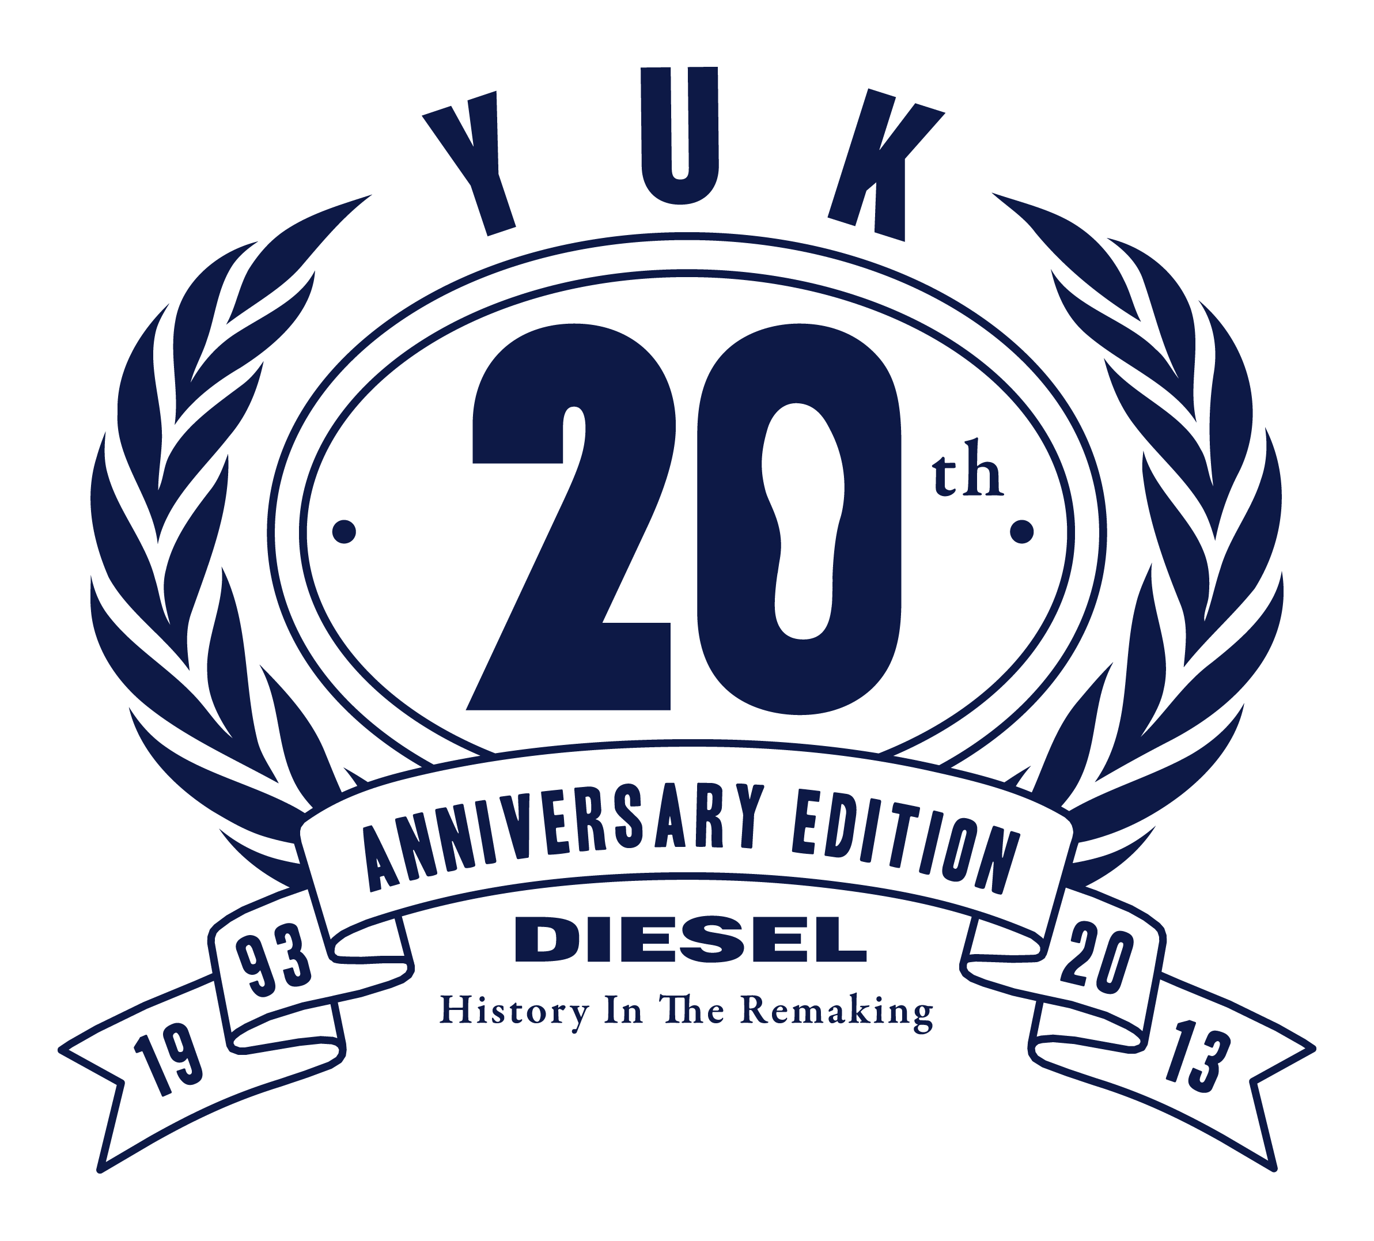

**20 YEARS AFTER, YUK IS BACK!**

*Diesel re-launching YUK 20 years after its first release: a pre-internet shoe, refreshingly stripped of all modern technology*

Breganze, November 19th 2012 – When YUK was first released 20 years ago it immediately became a huge success. Now Diesel is re-launching the shoe with this 20th anniversary edition: the world has changed but YUK is exactly like it was back in 1993.

Fully stocked with all the latest interactive technology from 1993 – *none!* – YUK is a genuine and brave shoe with heritage that takes you back to times when things were different. It doesn’t count calories, track where you go, or count your steps: a pre-internet shoe with no share button, connecting just to the floor.

Available in red and blue, it has an oversized vulcanized rubber sole that makes it definitely unmistakable. YUK is easily recognizable also from the “Only The Brave” rubber logo, embroidered tongue label and the metal seal of authenticity.

The shoe is re-launched with a dedicated campaign on Facebook focused on the Diesel pre-internet experience: a YUK app encouraging users to take a step back and go offline, rewarding those who stop sharing online for three days straight.

YUK will be available starting from late November in the Diesel stores and the Diesel online store.

More on the pre-internet shoe:

[www.diesel.com/yuk](http://www.diesel.com/yuk), [www.facebook.com/diesel](http://www.facebook.com/diesel), [www.youtube.com/dieselplanet](http://www.youtube.com/dieselplanet)

For further information:

www.diesel.com

Diesel HQ Press Office - Tel. + 39 0424 477555