Maran Gas adopts KONGSBERG’s K-IMS platform as basis for digitalisation strategy across its entire fleet
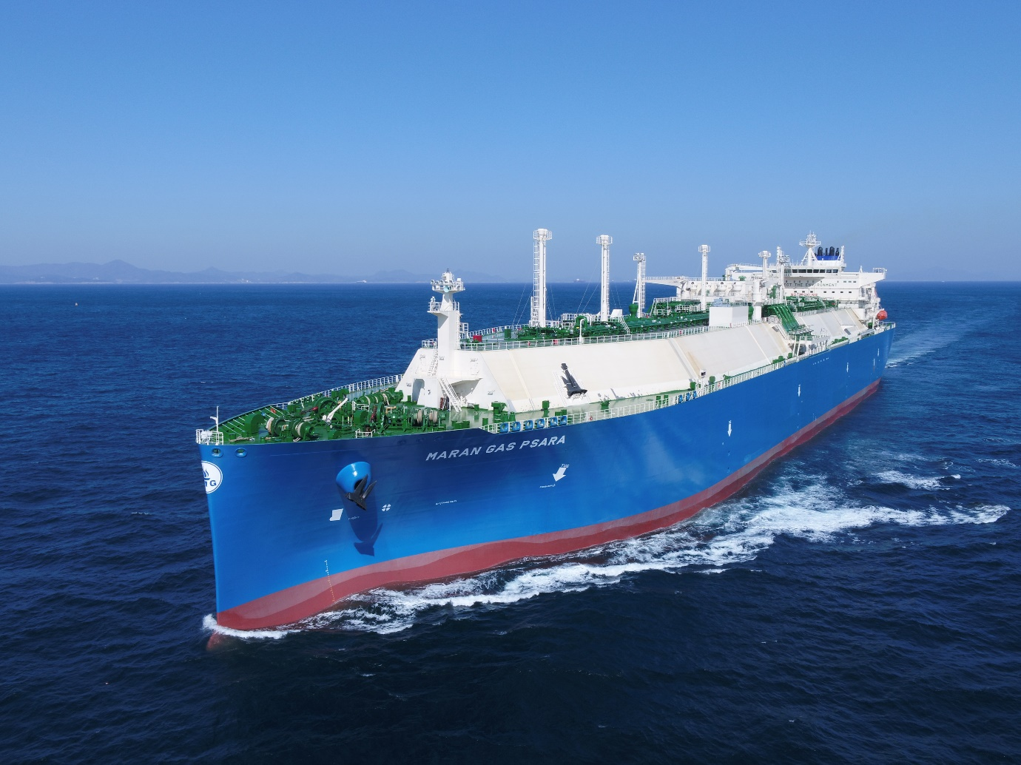
Maran Gas Maritime will deploy Kongsberg Maritime’s K-IMS Information Management System to its entire fleet

Kongsberg, Norway, 16th June 2021 – Kongsberg Maritime (KM) is pleased to announce that Maran Gas Maritime, one of the largest international ship-owning concerns, has signed a contract to roll out KM’s K-IMS Information Management System across its entire fleet. Already a long-term customer of KM, with this move Maran Gas are taking the relationship to a new level by integrating KM into its digitalisation strategy and cyber security.
“We feel very confident with the decision to implement the K-IMS project with KONGSBERG for the entire fleet,” says Andreas Spertos, EVP, Technical Director, Maran Gas Maritime. “By the end of 2021, K-IMS will be rolled-out to more than 20 LNG carriers of various propulsion types.
“Implementation of K-IMS will continue for existing and newbuild vessels until the entire fleet of 40+ LNG carriers is upgraded. K-IMS will replace the existing limited capability data transfer system and will provide us with unlimited opportunities to develop and advance further our in-house fleet monitoring and analysis systems that support the safe, efficient and environmentally friendly operation of the fleet.”
Anders Sjuls Fjeld, Sales Director LNG, Global Sales & Marketing, Kongsberg Maritime, adds: “All of us at KM are committed to growing our working partnership with Maran Gas, after spending approximately 15 fruitful years as the systems provider for its fleet.
By focusing on building strong customer relations and trust, and following an open, dialogue-driven partnership with Maran Gas, we have created a great foundation for rolling out K-IMS.”
Most ships in the Maran Gas fleet already have K-IMS-ready hardware in place: any outstanding vessels have been taken into consideration in the overall rollout plan. “Data replication is then enabled via software applications on our K-IMS Onboard and K-IMS Onshore solutions,” Fjeld concludes.
KM currently has secured more than 300 K-IMS contracts, with over 100 K-IMS agreements signed in the first half of 2021 alone and more in the pipeline. “The majority of the LNG segment’s largest international ship owners and charterers are currently reaping the benefits of K-IMS, which is perhaps the most advanced, tailor-made vessel information management system in the world. It has already proved to be well suited to the LNG sector, and many more LNG shipowners are lining up to get involved,” comments Bård Bjørløw, EVP Global Sales & Marketing, Kongsberg Maritime.
About K-IMS
The KONGSBERG Information Management System (K-IMS) is a suite of specialised applications hosted on the Kognifai open digital ecosystem. K-IMS is designed to allow continuous access to data, both on board and on shore, in an interactive, web-based solution, and to provide an efficient information flow. Applications, dashboards and tailor-made fleet and process automated viewing tools can subsequently be added to the K-IMS solution in each owner’s or third-party’s data replication and advisory cloud environment.
Ends

For further information, please contact:
Gunvor Hatling Midtbø, VP Communication
Kongsberg Maritime
Tel: +47 9921 4209
gunvor.hatling.midtbo@km.kongsberg.com
David Pugh
Saltwater Stone
Tel: +44 (0)1202 669244
d.pugh@saltwater-stone.com

About Kongsberg Maritime
Kongsberg Maritime is a global marine technology company providing innovative and reliable ‘Full Picture’ technology solutions for all marine industry sectors including merchant, offshore, cruise, subsea and naval. Headquartered in Kongsberg, Norway, Kongsberg Maritime has manufacturing, sales and service facilities in 34 countries.
Kongsberg Maritime solutions cover all aspects of marine automation, safety, manoeuvring, navigation, and dynamic positioning as well as energy management, deck handling and propulsion systems, and ship design services. Subsea solutions include single and multibeam echo sounders, sonars, AUV and USV, underwater navigation and communication systems.
Training courses at locations globally, LNG solutions, information management, position reference systems and technology for seismic and drilling operations are also part of the company’s diverse technology portfolio. Additionally, Kongsberg Maritime provides services within EIT (Electro, Instrument & Telecom) engineering and system integration, on an EPC (Engineering, Procurement & Construction) basis.
Kongsberg Maritime is part of Kongsberg Gruppen (KONGSBERG), an international, knowledge-based group that celebrated 200 years in business during 2014. KONGSBERG supplies high-technology systems and solutions to customers in the oil and gas industry, the merchant marine, and the defence and aerospace industries.
Web: Kongsberg Gruppen | Kongsberg Maritime
Social media: LinkedIn | Twitter | Facebook

About Maran Gas Maritime
Maran Gas Maritime (MGM) is the gas shipping unit of the Angelicoussis Shipping Group Limited (ASGL). MGM was set up in July 2003 to manage ASGL’s LNG and LPG carriers.
ASGL has a well-established track record in shipping, which dates back to 1947. ASGL’s fleet now comprises bulk carriers, tankers, LNG vessels and LPG vessels. Today, it employs a staff of approximately 300 shoreside professionals as well as over 3,700 officers and crew.
Web: Maran Gas Maritime

