Press Release

For immediate release

# geo launches new monitoring and control system for PV installations

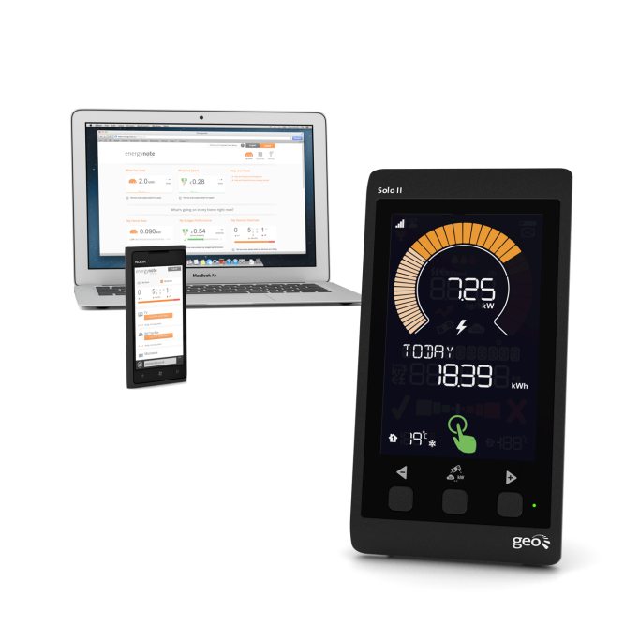

**(Cambridge, UK) In January, geo is releasing their second-generation PV monitoring system.**

**With falling installation rates and a reduced feed-in tariff, this new system comes with a comprehensive online & mobile service and Smart Plugs for appliance control – specifically developed to improve consumer engagement and help PV installers maintain a competitive advantage.**

Since the feed-in tariff was reduced, fewer panels have been installed. The figures are clear: installation rates plummeted to just 841 new installs (week ending 11 November 2012), a drop of nearly 73%. So how will the PV market survive this coming year?

**geo**’s Solo II PV bundle is key. It gives installers a unique offering in the marketplace and gives homeowners the chance to take control of their energy generation and consumption. One of the main selling points is the bundle offering, which gives online and mobile support for full flexibility and value-added functionality.

Crucially, with the new Solo II, homeowners can add Smart Plugs. Smart Plugs can be attached to home appliances to keep track of individual consumption. Adding a Smart Plug also means you can switch devices on/off remotely from a smartphone, through **geo**’s online energy management service: energy**note**. Homeowners can view, analyse and control their energy use at home, at work or on the move.

“Using the Solo II with energy**note** gives people a remote sense check of their energy use,” says Patrick Caiger-Smith, chief executive officer at **geo**. “From wherever they are, people can monitor levels and decide to use or sell the energy they are generating. This 24/7 energy flexibility means PV owners maximise efficiency and save money, powering high-load appliances when the sun shines and selling back to the grid when they’ve used all they need.”

--ENDS--

Notes for Editors

Interviews can be arranged with Patrick Caiger-Smith.

**About Green Energy Options**

GEO designs and produces in-home energy displays, online energy services and mobile applications that make energy engaging. They enable energy suppliers, meter manufacturers and installers to strengthen the relationship with their customers by putting end-users in control of their energy consumption, home appliances and energy budget in a visual, informative and engaging way. GEO’s products and services work together with pre-smart and smart meters and micro-generation to enable the energy-efficient home.

**Media Enquiries: Christine Rush, GEO, +44 1223 851 390,** [**christine@greenenergyoptions.co.uk**](mailto:christine@greenenergyoptions.co.uk)