Information

Yanmar Produces 10 millionth
vertical water-cooled engine
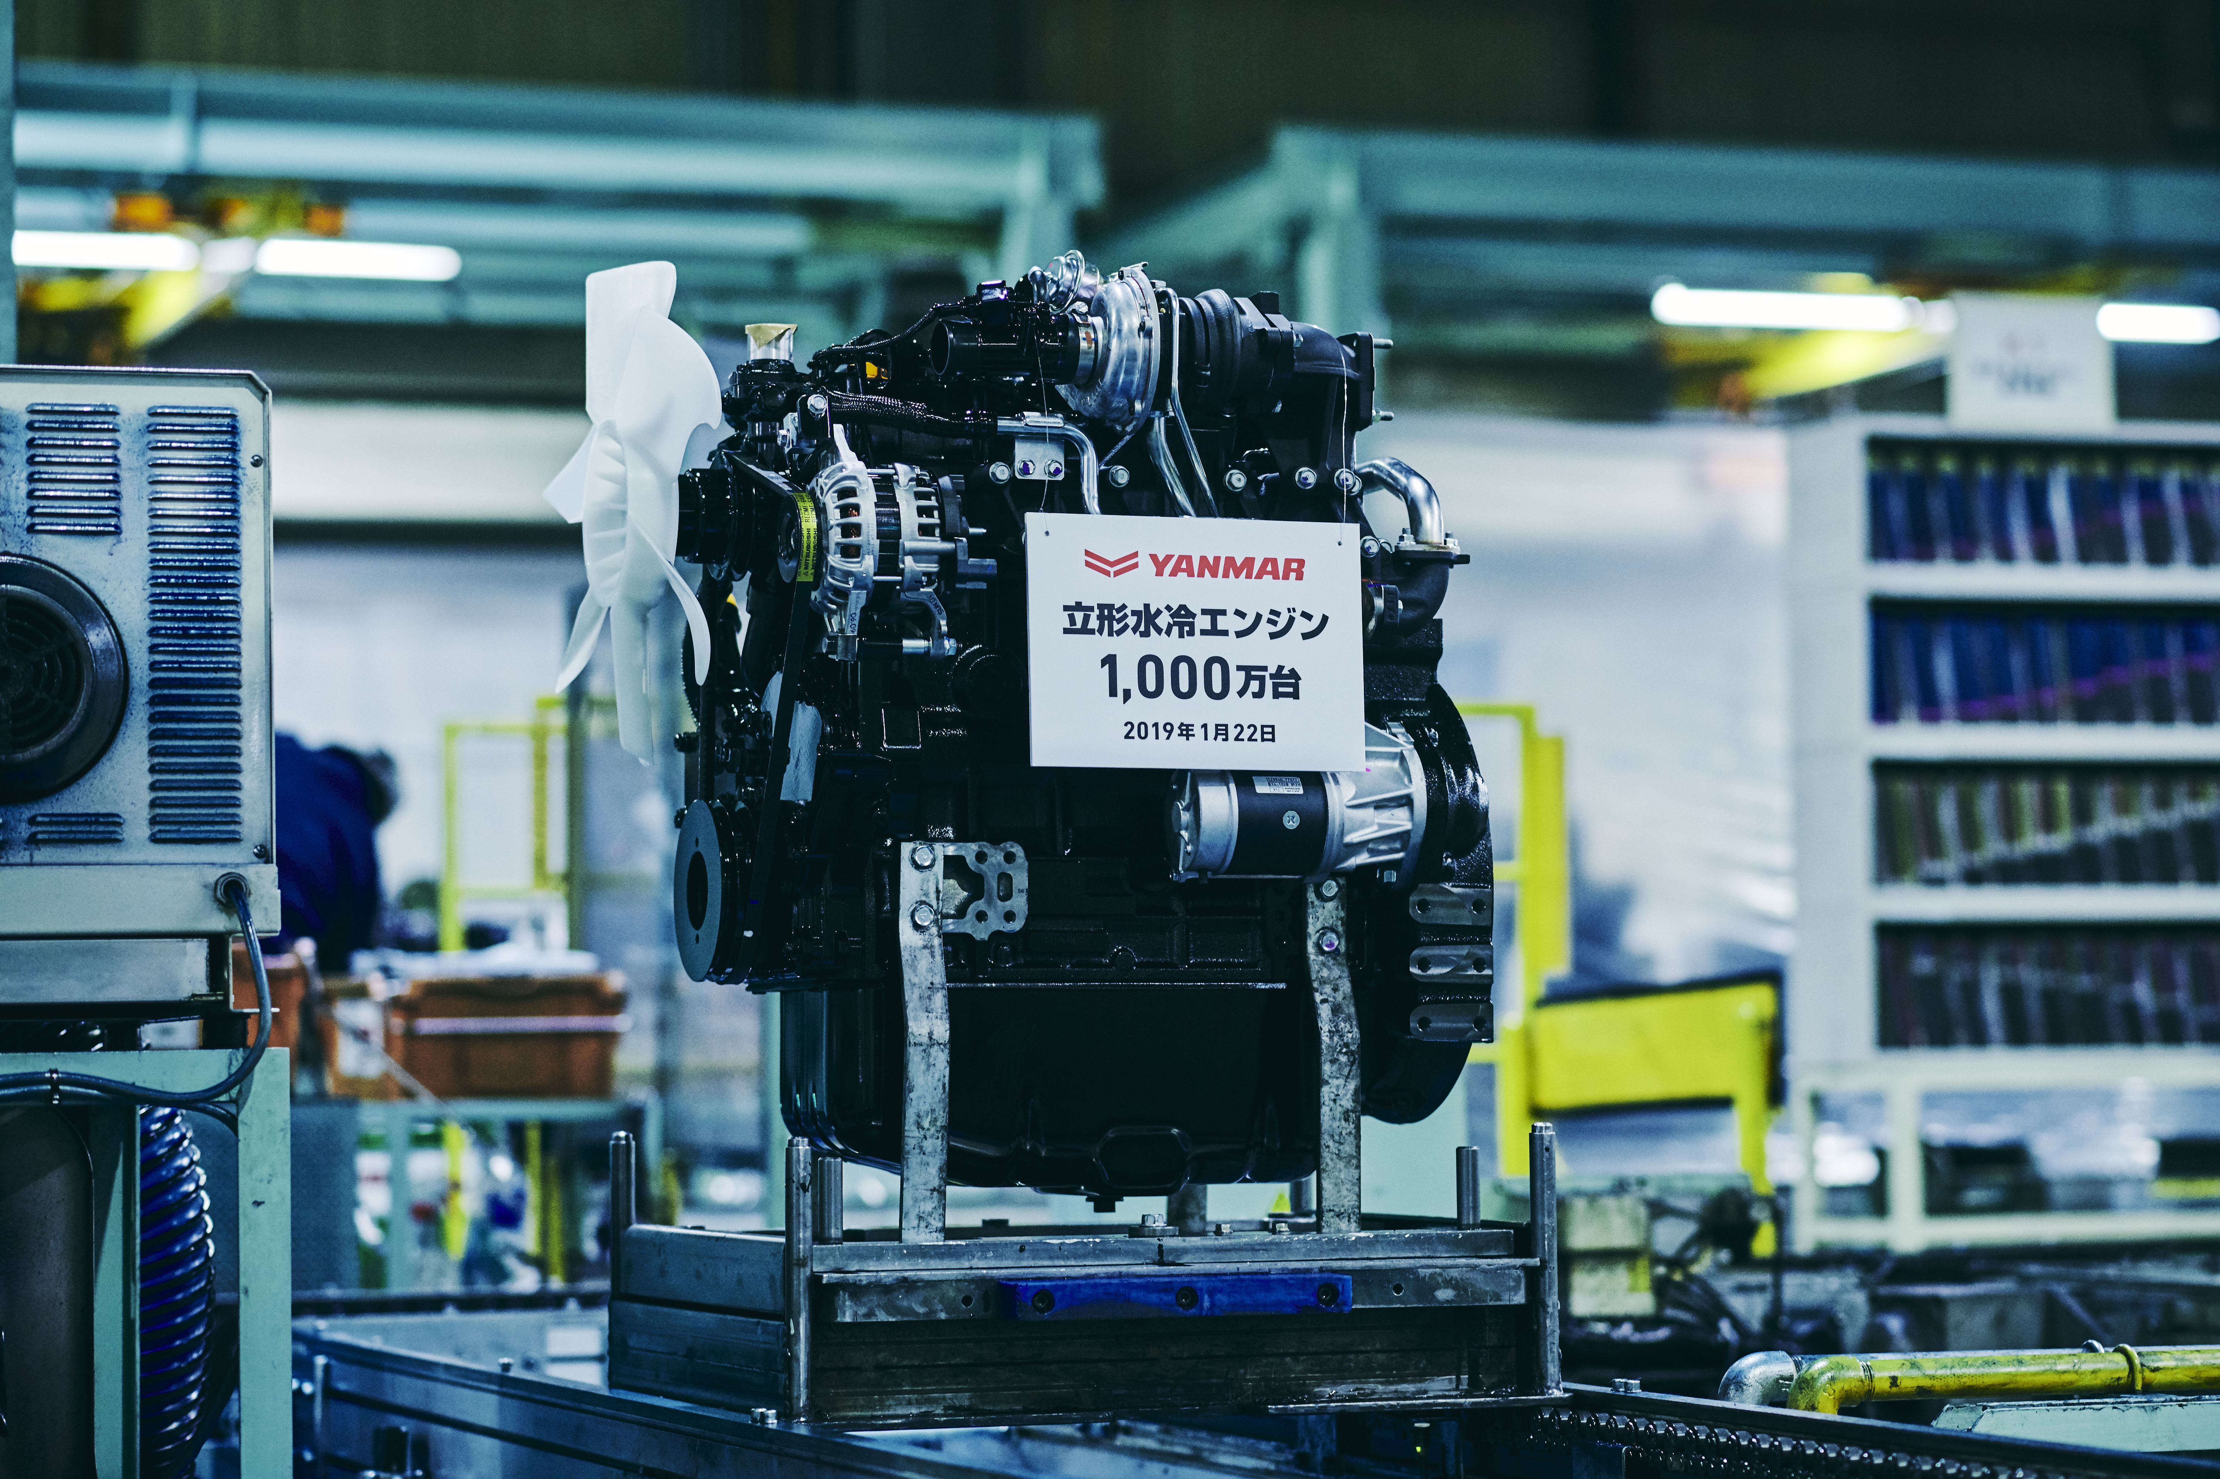
10 millionth vertical water-cooled engine 4TNV98CT

Osaka, Japan (April 8, 2019) - Yanmar has announced the production of its 10 millionth vertical water-cooled engine.

Yanmar started production of vertical water-cooled engines - the main product of Yanmar's industrial power products business, at its former Nagahama factory in 1968 with most production currently taking place at the company’s Biwa factory - the so-called “mother factory” for this type of engine. Ibuki factory in Japan and Yanmar Engine (Shandong) Co., Ltd. in China also produce the engines. As the first company to succeed in making a compact diesel engine of a practical size in 1933, Yanmar has long been a leader of innovation in the industry. With the introduction of ever stricter emissions regulations, Yanmar has once again taken the initiative and met the various environmental regulations, while pursuing lower fuel consumption and higher output, pioneering industry-leading industrial engine technology.

Yanmar regards the achievement of this 10 millionth unit as a major milestone and will continue to work on development and production of high-quality, highly reliable engines that meet the diverse needs of our customers.

<About Yanmar>
With beginnings in Osaka, Japan, in 1912, Yanmar was the first to succeed in making a compact diesel engine of a practical size in 1933. Then, with industrial diesel engines as the cornerstone of its enterprise, Yanmar has continued to expand its product range, services, and expertise to deliver total solutions as an industrial equipment manufacturer. As a provider of small and large engines, agricultural machinery and facilities, construction equipment, energy systems, marine equipment, machine tools, and components, Yanmar’s global business operations span seven domains.

On land, at sea, and in the city, Yanmar’s mission of “providing sustainable solutions focused on the challenges customers face, in food production and harnessing power, thereby enriching people's lives for all our tomorrows” is a testament to Yanmar's determination to provide us with “A Sustainable Future.”

For more details, please visit the official website of Yanmar Co., Ltd.: https://www.yanmar.com/global/about/

＜NOTE＞
The contents of this news release reflect what was mentioned in the press announcement. Please be aware that the contents of this release may differ with new information and developments.

