Press release
Düsseldorf, 15/03/2024
Global Recycling Day: used machinery in the circular economy
On 18 March, Global Recycling Day is celebrated, focusing on utilising waste as a secondary resource for as long as possible. This process is also known as the circular economy. But what does this have to do with machinery? A globally interconnected second-hand machinery market acts as a circular economy for production resources, thereby contributing to a sustainable future.
Initiated by the Global Recycling Foundation, the Global Recycling Day is observed annually on 18 March. Since its inception in 2018, the day aims to raise awareness of recycling to conserve valuable primary resources and thus contribute to securing the future of our planet. Waste should not be seen as worthless rubbish, but as a potential resource, making recycling an indispensable part of the resource conservation process.
The role of used machinery in the circular economy
In this context, second-hand machinery also plays a central role. Their reuse and life extension reduce the need for new installations, thereby lowering the consumption of raw materials and energy. This sustainable business model reduces the ecological footprint of manufacturing companies while simultaneously offering them economic benefits.
ALICIA: a further step towards a digitised machinery circular economy
An example of progress in the circular economy is ALICIA, a Horizon Europe research project aiming to develop a digitised marketplace for used assembly lines and machinery. The goal is to reduce the material and energy requirements for new production lines by 70% and achieve a 100% reuse rate for equipment. Digital tools will enable efficient matching of companies with suitable machinery and promote seamless cooperation between different facilities. The consortium behind ALICIA is led by the Technical University of Munich and includes twelve partner organisations from eight different European countries, including institutes, SMEs, and large corporations.
Surplex is also part of the ALICIA consortium. Surplex, one of the leading European industrial auction houses, trades worldwide in used machinery and operating equipment – especially for metal and woodworking, but also for the construction industry and other sectors. Thus, Surplex is an integral part of the machinery circular economy system.

Sustainable strategies for unsold machinery at Surplex
But what happens to a machine that has not found a buyer at an auction? Initially, an extensive post-sale process begins, where long-standing customers – such as other machinery dealers – are contacted. In addition, the unsold machines are stored temporarily and later offered again in collective auctions. The aim is to find a meaningful reuse for almost every machine. Since Surplex operates worldwide and has so far sold machinery to over 170 countries, there is almost always a suitable buyer somewhere.
When companies are liquidated, waste and unusable machines inevitably occur. Sometimes the scrapping of machines is unavoidable. In these cases, particular attention is paid to environmentally friendly and responsible handling, especially with contaminated materials. Thanks to the comprehensive presence in 16 European countries and a network of reliable business partners, it is possible to carry out disposal efficiently and in compliance with the law.
The Global Recycling Day provides an excellent opportunity to reflect on one’s own company’s approach to recycling and the circular economy. Through consistent recycling and reuse of resources, not only is the environment protected, but sustainability in production is also promoted. Therefore, commitment to recycling should extend far beyond a single day and be understood as an integral part of the company strategy for a sustainable future.

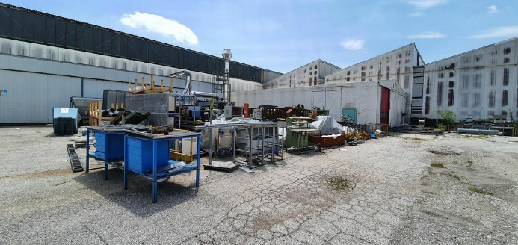 | Photo  Even in scrap, a treasure is hidden: In the dissolution of entire factories, consistent recycling transforms waste into valuable resources for tomorrow.  (© Surplex).

