

**Kenya prepares to host the DStv Eutelsat Star Awards!**

**Pan-African student competition, now in its fifth year, shines a spotlight on value of science learning for Africa’s development**

***Nairobi, Johannesburg, Paris 3 February 2016***

**Record year for participation**

East Africa is abuzz with excitement as Kenya prepares to host government dignitaries, the academic community, the scientific world, students and guests for the fifth edition of the prestigious **DStv Eutelsat Star Awards**. The winning poster and essay entrants from 18 African countries will be revealed on 9 February at an awards ceremony in Nairobi, Kenya. This year’s edition of the DStv Eutelsat Star Awards received a record 1959 entries, almost doubling entries in 2014 and showing the increasing interest in this unique event.

**Astronaut Paolo Nespoli to chair jury for the third time**

Since it was set up in 2011 by MultiChoice Africa and Eutelsat, the DStv Eutelsat Star Awards has attracted the interest of over 5000 students across the continent and more than met its goal to invigorate a passion for science in secondary school. ESA (European Space Agency) astronaut Paolo Nespoli is presiding over the Awards as Jury Chairman for the third year in a row, assisted by an international panel of skilled industry experts: Ronke Bello, CEO at Innovative Technology Literacy Services Ltd, Nigeria, Dr Jane Munga, the Information, Communication and Technology Ministry Research and Policy Advisor, Kenya, Dr Perkins Muredzi, Dean of School of Industrial Sciences and Technology, Harare Institute of Technology (HIT), Zimbabwe, Melt Loubser, GM: Broadcast Technology, MultiChoice Africa and Rodney Benn, Regional Director, Eutelsat.

Nespoli has an illustrious career spanning stints at the European Astronaut Centre (ESA/EAC) and NASA’s Johnson Space Centre in Houston before being selected by the Italian Space Agency to fly as an ESA astronaut. Besides crewing on the 2007 Discovery shuttle mission, Nespoli spent over five months in space aboard the International Space Station (ISS) where he was responsible for a range of science and technology experiments and educational activities. He is preparing a third trip into space in 2017 to the International Space Station where he will spend five-months.

Students in Nairobi will this year have the opportunity to meet him during an outreach event where he will share his adventures in space.

**Focus on past winners**

The DStv Eutelsat Star Awards has uncovered a wealth of talent from the East African region, with six winners since the awards were set up 2011.

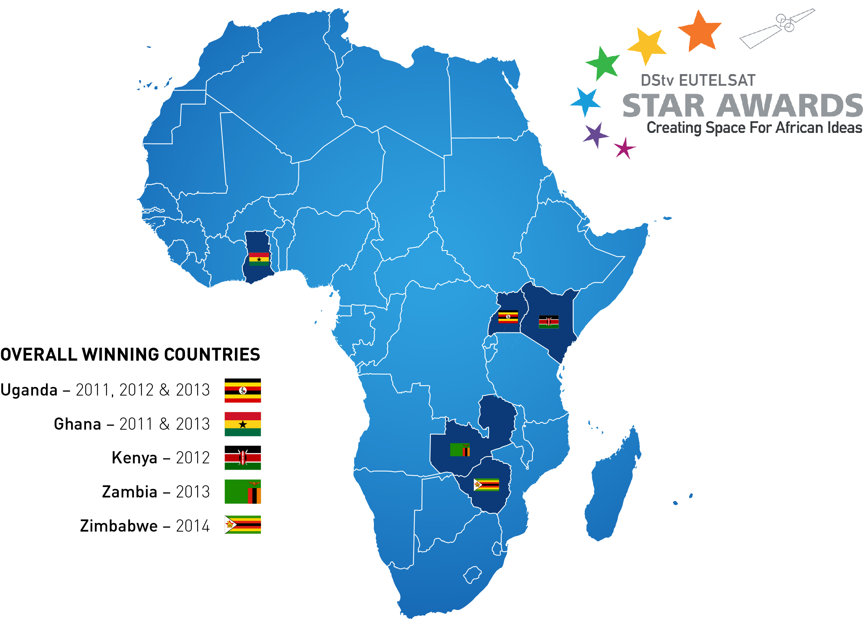

Full list of past winners and their profiles available on <http://www.dstvstarawards.com>

Will East Africa continue to produce stars in 2015? All will be revealed on 9 February. Follow all the action on the following social media platforms and **#DStvEutelsatStarAwards** to be part of the conversation.

**Twitter:** @Eutelsat_SA and @DStv_Kenya ~ **Facebook:** Facebook.com/eutelsat.SA

**About the DStv Eutelsat Star Awards**

In 2010 MultiChoice Africa and Eutelsat combined their expertise to initiate an annual pan-African student competition called the DStv Eutelsat Star Awards. The **DStv Eutelsat Star Awards** encourages 14-19 year-old students to write an essay or design a poster on a satellite-related topic. Country winners from across Africa then compete in the overall awards for a trip to the Eutelsat facilities in Paris, with the essay winner travelling onwards to witness a live rocket launch. Runners-up win a trip to South Africa as guests of MultiChoice Africa and the South African National Space Agency at Hartebeesthoek. Schools attended by the overall winners also receive a DStv installation, including dish, television, state-of-the-art PVR decoder and free access to the DStv Education Bouquet. Winners at national levels win prizes such as computers or tablets.

**About Eutelsat Communications**

Established in 1977, Eutelsat Communications (Euronext Paris: ETL, ISIN code: FR0010221234) is one of the world's leading and most experienced operators of communications satellites. The company provides capacity on 40 satellites to clients that include broadcasters and broadcasting associations, pay-TV operators, video, data and Internet service providers, enterprises and government agencies. Eutelsat’s satellites provide ubiquitous coverage of Europe, the Middle East, Africa, Asia-Pacific and the Americas, enabling video, data, broadband and government communications to be established irrespective of a user’s location. Headquartered in Paris, with offices and teleports around the globe, Eutelsat represents a workforce of 1,000 men and women from 37 countries who are experts in their fields and work with clients to deliver the highest quality of service.

For more about Eutelsat please visit [www.eutelsat.com](http://www.eutelsat.com)

**For further information contact :**

Violaine du Boucher Tel: + 33 1 53 98 37 91 [vduboucher@eutelsat.com](mailto:vduboucher@eutelsat.com)

**About MultiChoice Africa**

MultiChoice Africa Limited (“MultiChoice Africa”) is a leading video entertainment service provider with over twenty years’ digital television experience. The company provides premium video entertainment for subscribers in 49 sub-Saharan African countries and its adjacent Indian Ocean islands. For over two decades, MultiChoice has positively impacted the television production and creative industries while creating employment and empowering small businesses in related industries, from being the best provider of home video entertainment to launching on demand services – including Box Office, Catch Up, DStv Now and AMGO which truly meet the evolving needs of Africa’s tech-savvy consumers. MultiChoice Africa provides video entertainment content varying from blockbuster movies, the latest series, the world’s greatest sport, up to the minute news, great children’s programmes, music and an array of specialist genres including language specific channels available on both the DStv and GOtv bouquets. Video Entertainment is available on a number of different subscription platforms including direct to home satellite, Digital terrestrial Television (DTT), Live streaming, Video-On-Demand and Mobile. As a corporate citizen, MultiChoice has an unmatched community investment record stretching back two decades creating a meaningful legacy on the continent.

For more about MultiChoice Africa please visit [www.dstv.com](http://www.dstv.com)

**For further information contact:**

Nonye Mpho Omotola Tel: +27 11 289 3524 [nonye.omotola@multichoice.co.za](mailto:nonye.omotola@multichoice.co.za)