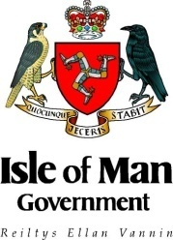 | 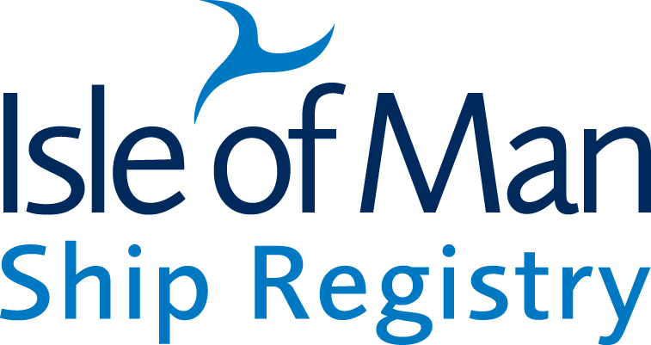
Isle of Man Government | Isle of Man Ship Registry

MEDIA RELEASE
9 January 2012
Isle of Man Ship Registry Sails into
The Year of The Dragon with Record Tonnage

The Isle of Man ship registry, one of the world’s leading ship registries, just announced record tonnage for the year ending 2011, entering the Year of the Dragon with a bang.

Gross Registered Tonnage (GRT) is the datum used to compare the world’s ship registers and a year on year comparison shows a 12% increase in total GRT, climbing steadily from 12.36m GRT at the end of 2010 to 13.84m GRT as we enter 2012.

With the new numbers, it is now among the top 15 ship registries in the world. This demonstrates significant growth in the larger types of vessels registering given that the register topped 10m GRT for the first time in its history in April 2009. The market segment which saw a rapid take-up rate, was the Asia Pacific region, particularly Japanese and Singapore-based corporations, who are now more perceptive of the flag’s value.

Dick Welsh, Director of the Isle of Man Ship Registry, said: “The growth in numbers shows that we are well placed to provide a more cost effective solution for registration without any compromise in quality or service for ship operators and owners.”

“Having just recovered from the global crisis of 2008, ship owners are bracing themselves for another rocky year in 2012. An oversupply of ships together with the global economic downturn is keeping freight rates down and making it difficult to keep vessels operating profitably in many sectors. “

“Despite the bleak outlook, the uptake on the flag registration has been encouraging. We are seeing an increased level of enquiries for vessels under construction or in-service which are planning to register, or change to Isle of Man registration. This hopefully will translate to an increase level of activities for us over the next 2-3 years especially across the Asia Pacific region.”

The ship registry’s offering of high quality and high service levels combined with a low cost fee structure is continuing to attract larger corporations involved in wet cargo (oil and gas) and dry bulk trades. The cost savings are significant especially for their larger vessels.

Maintaining the quality of the fleet and the Isle of Man’s results in the world’s port state control statistics and other quality benchmarks is still paramount. This year once again, the Isle of Man was recognised by the US Coast Guard and shared top place on the annual ‘Flag State Performance Table’ issued by the industry bodies.

Ends

For further information, please contact:-
Edward Ion, Helix Media – Public Relations Consultant to Isle of Man Ship Registry
Telephone: 65 9111 6871 or email edward.ion@helixmedia.asia

Dick Welsh, Director, Isle of Man Ship Registry
Telephone: 01624 688509 or email Dick.Welsh@gov.im

Notes to Editors
Isle of Man Ship Registry
The Isle of Man Ship Registry was established as an international register in 1984. Since then it has become highly recognised as a quality register offering unrivalled levels of service. It boasts some of the world’s most highly respected shipping companies among its clients. The Isle of Man Ship Registry offers:
- Quality – it is highly rated in the industry’s Flag State Performance table.
- Port State Control status - highly positioned on the white lists of the Paris and Tokyo MOUs permitting ships to trade worldwide without restriction
- A modern flag registry with a strong emphasis on quality, high standards and efficient service to its clients
- Low cost – no annual tonnage dues
- No insurance premium tax
- Ease of Registry – simple process with friendly and approachable staff available out of normal hours
- Flexible and pragmatic approach to the regulation of ships
- Parallel (demise) registration (both ‘in’ and ‘out’ ) with other jurisdictions ‘see overleaf’
- Ship Registry team of island-based maritime professionals providing sound practical and technical support and assistance ~ 24/7
- Island-based survey teams provide survey and audit services worldwide
- Ships fly the “Red Ensign” and are entitled to British consular services worldwide
- Flexible ownership criteria including limited partnerships
- Flexible crewing requirements and manning arrangements plus a fast, friendly and responsive turn-around for STCW certification.
- Available network of ‘representative persons’ on Island for ships to satisfy the registration criteria
www.iomshipregistry.com

