FOR IMMEDIATE RELEASE

Intellian’s new R&D Center boosts growth for satcom innovation and production

New premises in Pyeongtaek, South Korea demonstrate Intellian’s
commitment to ongoing growth and new technology

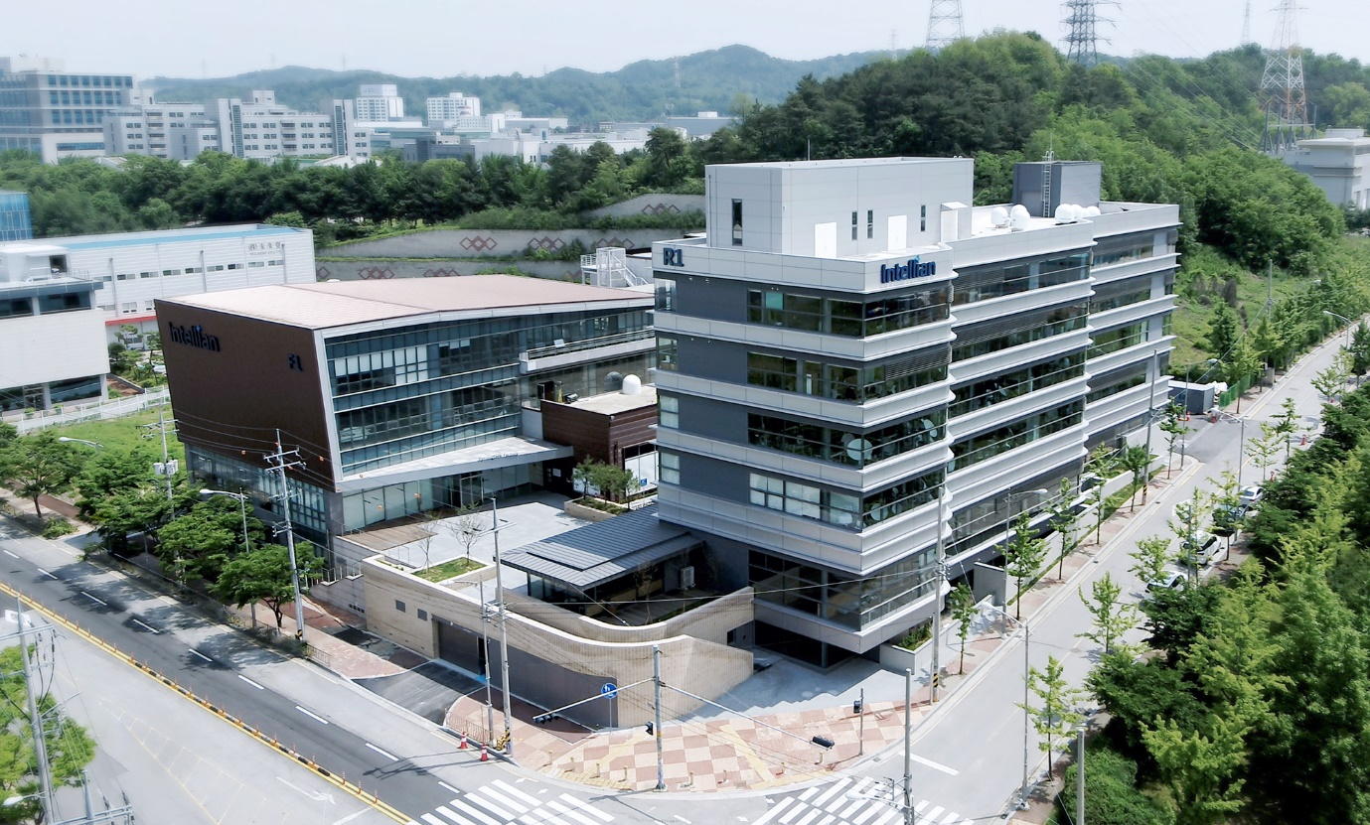
Intellian’s new R&D Center (front right) is built adjacent to the existing Innovation Center, expanding the available space by nearly 80% and boosting both development and production capacity

14 June 2021 – Intellian is pleased to announce that its new state-of-the-art Research and Development Center in Pyeongtaek, South Korea, is now complete and operational. The facility provides a new home for the continually growing engineering team, houses state of the art product and quality verification facilities, and will accelerate product development. In particular, antennas using emerging phased array technology will benefit from a new compact test range to assist with development and testing.
The expansion also allows production to be significantly increased in the existing Innovation Center, meeting the increased order volume recently experienced by Intellian and providing capacity for new product lines.
“This new building, which extends our headquarters by nearly 80%, is a clear demonstration of our commitment to rapid growth and continuing advancement through new technology,” said Eric Sung, CEO, Intellian Technologies. “With several new markets soon expected to come to prominence, we are investing in the future through development, innovation and expansion, determined to further our mission to empower connectivity for all. Our R&D Engineering team is at the heart of this strategy, and we’re pleased to give them the facilities they need to grow from strength to strength.”
Growth and innovation are key to Intellian’s plans for the future, and this construction project is the first of several new premises which will open in the coming months. A new European Headquarters and Logistics Center will be completed this summer in Rotterdam, reaffirming Intellian’s commitment to the region and providing the fastest, most cost-effective product delivery to customers. Intellian’s UK team will take up new offices in London, making space for the growing team and offering close proximity to many key partners. Finally, a new R&D facility focused on emerging technologies will also begin operations in Maryland, USA.
These new facilities will further enable Intellian’s strategy to devise and deliver innovative, customer-focused and future-proofed solutions, as demonstrated by recent product launches. In particular, the imminent launch of multiple new low-orbit (LEO) networks – a key driver in the development of phased array antennas – is expected to generate new business opportunities and facilitate increased use of satellite communications across the maritime, land and government markets.
“Global connectivity is now essential to modern life, whether business or leisure,” explains Sung. “We’re seeing this across every market vertical, and Intellian needs to be ready with the connectivity solutions our customers need, whether their business is on land, sea or both. For this reason, we are investing heavily in both R&D and logistics, ensuring that Intellian will always be first to innovate and meet new demands.”
The new eight-floor building, which is adjacent to the existing Korean headquarters, houses a Global Control Center together with state-of-the-art R&D laboratories, quality and product testing capabilities. It will also expand production capacity significantly. The Global Control Center will allow Intellian to remotely monitor installed antennas anywhere in the world, supporting remote diagnosis and enabling a swift response if a customer reports an issue. Other new facilities within the building include offices, meeting rooms, an auditorium, lounge, cafeteria and gym.
-Ends-

For further enquiries, please contact:
Sadie Brown / Marketing Manager
Intellian Ltd
T +44 2380 019 021 ext. 1612
Sadie.Brown@intelliantech.com
David Pugh
Saltwater Stone
T +44 1202 669 244
d.pugh@saltwater-stone.com

About Intellian Technologies
Intellian is a leading global technology and solutions provider for satellite communications, empowering connectivity for the maritime, government, military, energy, cruise and enterprise sectors. Founded in 2004, Intellian is renowned for its innovative design, future-proofed technologies and outstanding customer support, which combined with continued investment in its partners, logistics network, quality control and low environmental impact production facilities make it a trusted enabler within the satellite communications industry. Its bold, pioneering solutions include the award-winning v240MT – the world’s first tri-band, multi-orbit antenna system – and the future-proof NX series antennas, optimized for high performance and low cost of ownership.
Intellian has a worldwide presence with over 400 employees, 10 global offices and five logistics centers on three continents. Intellian Technologies Inc. is listed on the Korean Stock Exchange, KOSDAQ (189300:KS).

