
9/14/2010
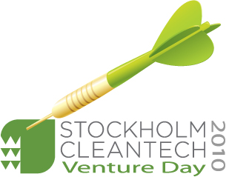

Press invitation: UN Sustainable Energy Investment expert Eric Usher at Scandinavia’s foremost cleantech investment day.

Eric Usher, at the United Nation's Sustainable Energy Finance Initiative, is one of two prime key note speakers at the Stockholm Cleantech Venture Day in Kista Science City this year. He will speak on the subject of new ways to foster innovation by means of financing emerging markets and resillient technologies.

Journalists will have the opportunity to meet Eric Usher and the key Note speakers at the pressroom the during the conference.

For a full list of Key Note speakers and the programme please visit
http://www.stockholmcleantechventureday.com/Programme/Cleantech/2010.html?Idother=122

and

http://www.stockholmcleantechventureday.com/Speakers/Cleantech/speakers-2010.html?Idother=122

Press and accreditations:
Annica Englund, Media & Press at Stockholm Cleantech Venture Day
annica.englund@kista.com

For more information about the event contact:
Magnus Rehn, STING (Stockholm Innovation & Growth, +46 705 12 05 48
magnus.rehn@stockholminnovation.com

…………………………………………………………………………………………………………….

STING (Stockholm Innovation and Growth) and Kista Science City AB powered by KIC InnoEnergy have joined forces to co-organise Stockholm Cleantech Venture Day 2010, which will be held in Kista Science City on September 30th .
Phone: +46 707 71 92 04
Application for accreditation required no later than September 23.

More about the event and registration:
http://www.stockholmcleantechventureday.com


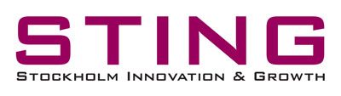
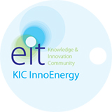
Organisers:

Partners/Sponsors:
VINNOVA, Bird & Bird, PricewaterhouseCoopers, SBRD, WWF, Bornicon & Salming



Official Media partner:
Metro Teknik

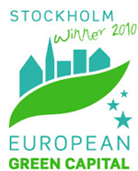
Official event of:

