**Strong drive by Andreas Bäckman at Gelleråsen Arena**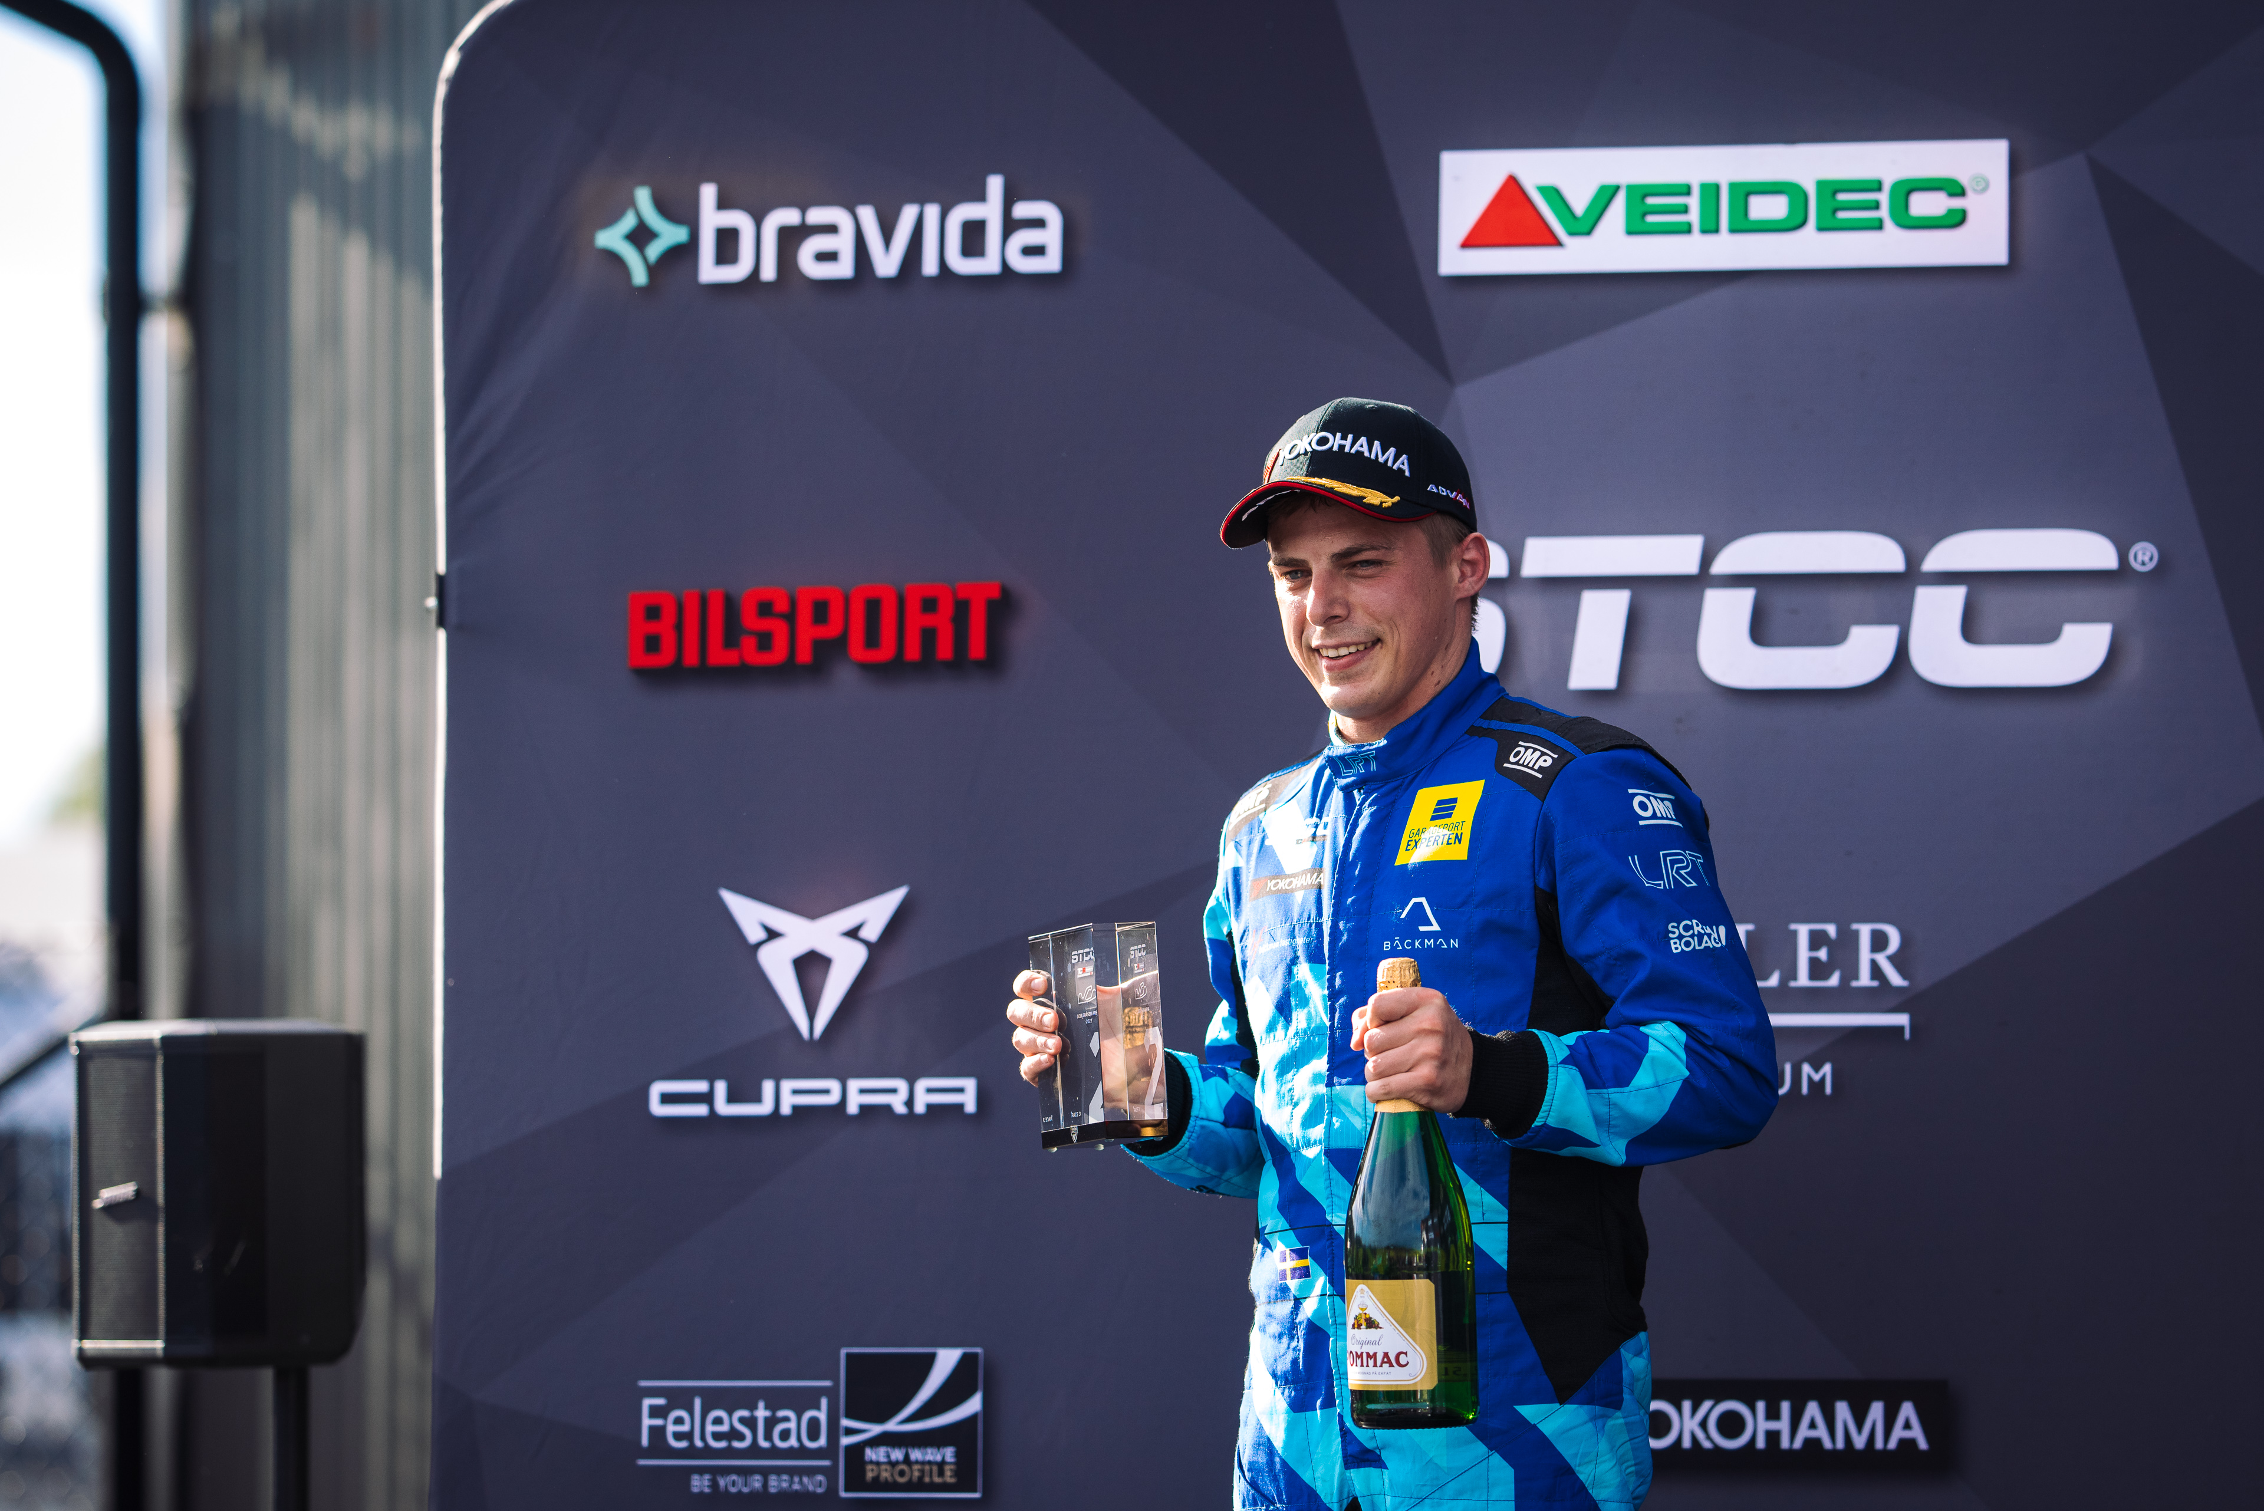Andreas Bäckman had a strong Saturday with two podium positions and a lot of overtakes during the three races at Gelleråsen Arena.  
Photo: Martin Öberg (Free rights to use the images)

**This year's fourth STCC event was held last weekend, August 18th-20th, at Gelleråsen Arena in Sweden. After a difficult qualifying for Andreas Bäckman, he got his revenge on the race day and took two podium positions.  
– Good race day with two podiums, a lot of overtaking and fun to show that the speed is there for the upcoming races, Andreas Bäckman says.**

Last weekend, August 18th-20th, it was time for this year's fourth round of the STCC, Kanonloppet, at Gelleråsen Arena and Sweden National Team driver Andreas Bäckman was on the starting line, competing for the Lestrup Racing Team in an Audi RS 3 LMS TCR car. Gelleråsen Arena is a challenging track that was built in 1949 and is located outside Karlskoga in Värmland, Sweden and is Sweden's oldest permanent racing track.

**Tough qualifying for Andreas**The weekend began with free practice on Thursday afternoon and on Friday, where the conditions alternated between dry and wet during the sessions.

During the timed qualifying on Friday afternoon, the rain held off and it was a dry qualifying. Andreas qualified 5th in Q1 and 6th in Q2. The right feeling in the car wasn't quite there during qualifying and he was also blocked on two of his laps in Q1 by another driver. The qualifying result meant 5th starting position for Race 1 and 6th starting position for Race 2 on Saturday's race day.

- It was a tough qualifying where I had hoped for better positions, but it still felt good for the three races on Saturday as I felt I had good race speed in the car, so I was looking forward to trying to pick up places during the race, **Andreas Bäckman** says.

**Good recovery in the three races**In the first race, Andreas made a great start and climbed up to 3rd place after only two corners. Then the distance became a little too far to be able to challenge the top two, but the speed in the car was good and Andreas was the fastest driver on the track at the end of the race.

In Race 2 he started 6th but with an overheated clutch at the start he almost had the engine stop completely at the start moment. Despite this, he made a good run from being next to last into the first corner to a final 5th place at the finish.

In the final race, Race 3, the starting order of the top eight drivers from Race 2 was reversed, which meant a 4th starting position for Andreas.

The clutch didn't work as well anymore after the race start in Race 2 and both the team and Andreas were worried that he wouldn't get away at the start at all. With that in mind the start was very good, and he was out in 4th place from the start and five corners later he had worked his way up to 2nd place. He then started to chase the leader, who had gained a substantial gap, but it wasn't quite enough to catch up, so he had to settle for 2nd place at the finish.

- I am happy with the results from the race day. A 3rd place, a 5th place and a 2nd place despite everything that happened shows that I have good race speed and I took the opportunities straight away when I had the opportunity to overtake the cars in front. Many thanks to the Lestrup Racing Team for all the support during the weekend, already looking forward to the next race at Anderstorp, **Andreas Bäckman** says.

***Next up for Andreas is the fifth round of the STCC championship in three weeks’ time, September 9th-11th, at Scandinavian Raceway in Anderstorp, Sweden.***

**Andreas’ results:**Official Test (Test 1): 7th place  
Free Practice 1 (Test 2): 3rd place  
Free Practice 2 (Test 3): 12th place  
Qualifying (Q1): 5th place  
Qualifying (Q2): 6th place

Race 1: 3rd place  
Race 2: 5th place  
Race 3: 2nd place

**STCC Championship Standings**

**STCC – TCR Scandinavia – Drivers’ Championship Standings – Overall (Top 3)**STCC 2022 (After 4 of 6 race weekends)

1: Robert Dahlgren (SWE), 185 p.

2: Mattias Andersson (SWE), 138 p.

3: Oliver Söderström (SWE), 137 p.

–

**5: Andreas Bäckman (SWE), 135 p.**

[See the full standings here](https://www.stcc.se/poang/stcc-2022/)

**STCC – TCR Scandinavia – Teams’ Championship Standings – Overall (Top 3)**STCC 2022 (After 4 of 6 race weekends)

1: CUPRA Dealer Team - PWR Racing, 297 p.

**2: Lestrup Racing Team, 272 p.**3: Brink Motorsport, 254 p.

[See the full standings here](https://www.stcc.se/poang/stcc-make-2022/)

**Did you miss this weekend’s STCC race?**

[Click here](https://plus.stcc.se/video/s-kanonloppet-gellerasen-arena-djbz2c) to see the replay from this weekend’s STCC race at STCC+

**Follow the STCC season at:**

Live-stream: [plus.stcc.se](https://plus.stcc.se/)

Other information: [stcc.se](https://www.stcc.se/)

Facebook: [facebook.com/STCCOfficial/](https://www.facebook.com/STCCOfficial/)

Twitter: [twitter.com/stcc_official](https://twitter.com/stcc_official)

Instagram: [instagram.com/stcc_official/](https://www.instagram.com/stcc_official/)

YouTube: [youtube.com/c/STCCTV](https://www.youtube.com/c/STCCTV)

***Free rights to use the images.***

***Download press-photos here:***[***http://bit.ly/jabaeckman-photos***](http://bit.ly/jabaeckman-photos)[***https://www.mynewsdesk.com/se/ja-backman/images***](https://www.mynewsdesk.com/se/ja-backman/images)

