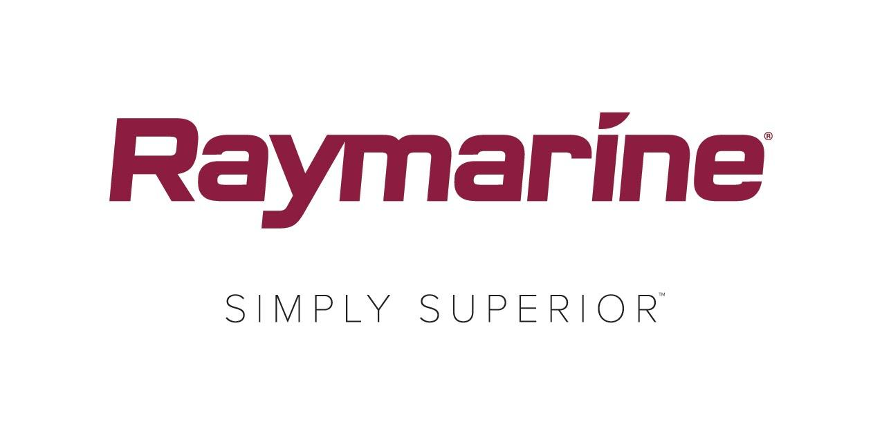
Raymarine Encourages Competitive Racers to put Safety First

Participants in this year’s Round the Island Race in association with Cloudy Bay, are being encouraged by Raymarine, as official Tracking Partner, to sign up to use the Race’s new tracking app. This will not only help organisers observe yachts throughout the Race for safety reasons but also encourage them to compete against their rivals as part of a new campaign for the 2018 event, #ItsYourRace.

While onlookers can enjoy the spectacular sight of a sea of sails across the Solent, the number of boats within these restricted waters does raise the risk of collisions. Safety is paramount to both the race organisers and sponsors so as Tracking Partner, Raymarine is supporting the organiser’s intention to urge more entrants to use an Automatic Identification System (AIS) transceiver to enhance their visibility to other yachts. An AIS will also provide an improved awareness of other boats around them, provide clear knowledge of the speed and course of vessels in the locality and warn of predicted areas of danger.

While few could ever hope to compete with the elite front-runners, many competitors will have friends and rivals taking part that they will be keen to beat. The #ItsYourRace campaign encourages competitors to create their own ‘race within the race’ by using the new tracking app to select individual boats to follow and race against, increasing the competitive element within the 1600 strong fleet.

It’s easy for competitors to sign up to the Race’s official tracking app, simply follow the instructions on this link http://rtir.me/track

Raymarine is offering registered competitors a significant discount by giving them £150 cash back on purchases of the new Raymarine AIS700 transceiver. Further details of this offer can be found here. http://www.raymarine.com/events/rtir/.

To find out how AIS can benefit you as a competitor, watch Raymarine's video here

###

About FLIR Systems
Founded in 1978 and headquartered in Wilsonville, Oregon, FLIR Systems is a world-leading maker of sensor systems that enhance perception and heighten awareness, helping to save lives, improve productivity, and protect the environment. Through its nearly 3,500 employees, FLIR's vision is to be "The World's Sixth Sense" by leveraging thermal imaging and adjacent technologies to provide innovative, intelligent solutions for security and surveillance, environmental and condition monitoring, outdoor recreation, machine vision, navigation, and advanced threat detection. For more information, please visit www.flir.com and follow @flir.

About Raymarine:
Raymarine, a world leader in marine electronics, develops and manufactures the most comprehensive range of electronic equipment for the recreational boating and light commercial marine markets. Designed for high performance and ease of use, the award-winning products are available through a global network of dealers and distributors. The Raymarine-branded product lines include radar, autopilots, GPS, instruments, fishfinders, communications, and integrated systems. Raymarine is a brand of FLIR Systems, a world leader in thermal imaging. For more information about Raymarine please go to www.raymarine.com.

Media contact:
Karen Bartlett
Saltwater Stone
+44 (0) 1202 669 244
k.bartlett@saltwater-stone.com

