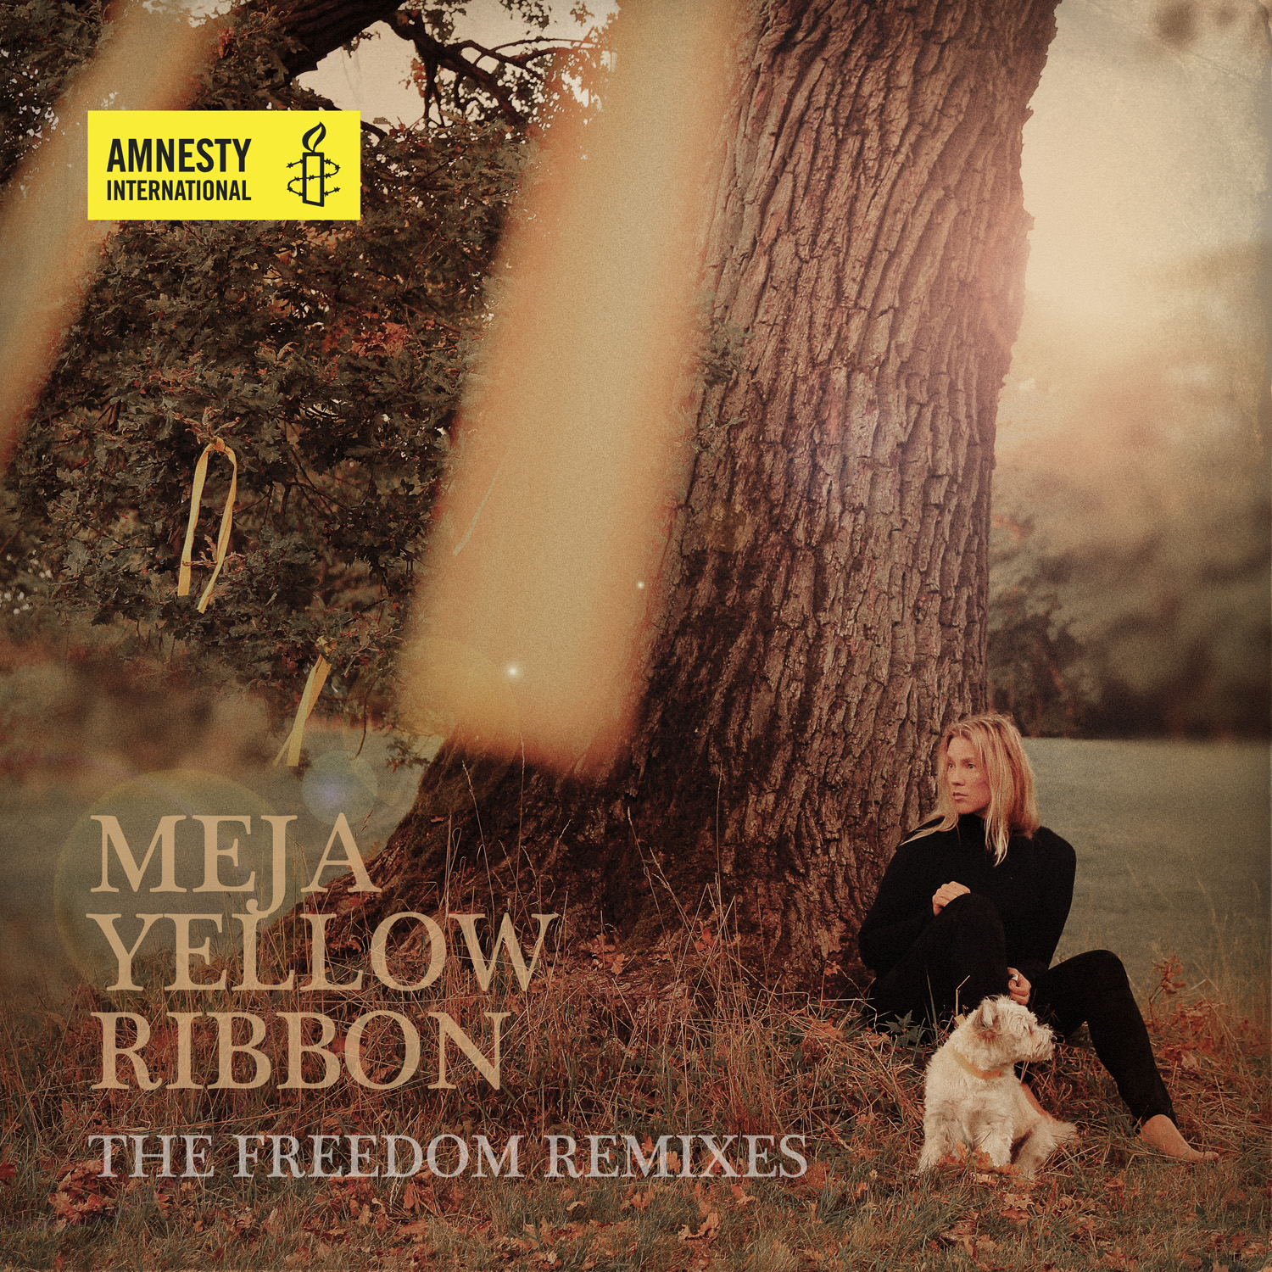
Today, on April 17, Albert Woodfox has been held in solitary confinement for the inconceivable 43 years. Mejas call for Freedom and Justice for Albert Woodfox continues and today she releases ” Yellow Ribbon Freedom Remixes” in a collaboration with several DJ´s.

Yellow Ribbon The Freedom Remixes
Mejas call for Freedom for Albert Woodfox continues……..
In January, 2015 the single ”Yellow Ribbon” was released and Meja invited Amnesty International, Freed the Angola 3 and Robert King to Stockholm Sweden for a joined venture to call for Justice for Albert Woodfox.
Today, April 17, Woodfox has been held in solitary confinement for 43 years in the state of Louisiana USA To raise further awareness to this cruel and unusual punishment, Meja has released an Remix EP with Deep Forest ( France) Gota Yashiki+Shinichi Osawa ( Japan) Diamond Duggal ( UK) NORD (Sweden) samt DF Tram ( US) participating with their versions of Albert Woodfox Freedom song ” Yellow Ribbon”

For further information:
Amnesty US http://www.amnestyusa.org/our-work/cases/usa-the-angola-3
Amnesty Sweden:
https://www.amnesty.se/engagera-dig/agera/ovriga-aktioner/usa-frige-albert-woodfox/

Tracklist:
1) Yellow Ribbon - (Deep Forest Remix Radio Edit )
2) Yellow Ribbon - (NORD Remake Remix) (feat.Nord)
3) Yellow Ribbon - (G+S Remix)
4) Yellow Ribbon - (Diamond Remix)
5) Yellow Ribbon - (DF TRAM Remix)
6) Yellow Ribbon - (Deep Forest Analog Remix)
7) Yellow Ribbon - (original version)

PARTICIPATING DJ-PRODUCERS ON THE FREEDOM REMIXES
CREDITS AND FACTS

DEEP FOREST Analog Remix and Radio Edit ( France)

Yellow Ribbon (Yellow Deep Analog mix)
Remix by Deep Forest - Eric Mouquet at EMM Studio, France.

Deep Forest is a musical group originally consisting of two French musicians, Michel Sanchez and Eric Mouquet.^{[2]} They compose ethnic electronica world music, mixing ethnic electronic sounds and dance beats Their sound has been described as an "ethno-introspective ambient world music."^{[3]} They were nominated for a Grammy Award in 1994 for Best World Music Album,^{[4]} and in 1995 they won the Award for the album Boheme.^{[5]} The group also became World Music Awards Winner - French group with the highest 1995 world sales of 10 million copies

G+S Remix ( Japan)

Gota Yashiki
Gota Is both an acid Jazz artist and drum/bass player, as former member of the band Simply Red.
He has collaborated with various artists such as Soul II Soul, Sinnead O´Connor and Seal. Alanis Morissette credits Gota as "Groove Activator" on her album Jagged Little Pill, for which samples of his works were used. Also, UK dance act Chicane used his drum samples, most prominent on the Chicane Mix of the Bryan Adams song Cloud Number Nine.

Shinichi Osawa (大沢 伸一 Ōsawa Shin'ichi), also known as Mondo Grosso is an artist currently signed onto Avex Trax's "Rhythm Zone" label.^{[1]} Previously he was signed to Sony Music Japan's FEARLESS RECORDS division and released albums under the title of 'Mondo Grosso', which is Italian for "big world". He has worked in genres from acid jazz to house, with strong influences of underground club music, though his recent work has been in the genre of electro house. HMV Japan rated Mondo Grosso at #95 on their "Top 100 Japanese Pop Artists" and Shinichi Osawa is ranked as Japan's #1 electro house DJ and #2 overall DJ by TopDeejays.com.

DIAMOND DUGGAL ( UK)

Diamond Remix
Remixed by Diamond Duggal at DesiRock Studios, London UK.

Is an international Producer with numerous international collaborations and awards. Such as Shania Twain on her album Up!. The album was produced by a totally international team co-ordinated between producer Mutt Lange, Diamond and Simon Duggal. Shania Twain’s Up! topped the American Billboard for six weeks in late 2002 with multi-platinum sales exceeding 15 million and received two Grammy nominations in 2004.

In 2005, Swami won "Best Producer" at the UK Asian Music Awards.^{[1]}
In April 2010, DJ Swami won best Mix Engineer at the South Africa Music Awards (SAMA).

NORD (Sweden)
Meja Feat.NORD Remake Remix
Re-Made & produced by: Mathias Andersson & Andreas Bergström
@ NORD MUSIC STUDIOS Sweden 2015

NORD is a renound swedish producer collective and participating on this EP with this Remake of ”Yellow Ribbon” are Mathias Andersson and Andreas Bergström
Mathias Andersson is a respected name in the international underground club scene with his projects Ibojima & Duotekk. In the commercial world o fmusic he has been involved in several hits with Gravitonas and Pandora amongst others. Contact: info@nordmusic.se

DF Tram Remix (USA)

DF Tram is an enigmatic dj and producer from San Francisco who is highly regarded in the North American underground electronic music scene .Known for his unique style of mixing and producing ,his chill dj sets are second to none as far as innovation is concerned. When not behind the decks DF Tram is busy creating beautiful and thought-provoking music with projects like The Sound Capsule, Jump/Cut and also as a member of The Ambi-Sonic Collective .You can catch his weird and wonderful sound at one of his regular gigs in the bay area or in clubs and festivals around the world. DF Tram has played at some of the best electronic music venues in the world such as “the big chill” festival (uk) ,"Niceto" in (buenos aires, argentina),”chillits” (sf) and much more. DF Tram was also nominated for a dj award in the downtempo/eclectic category at the ibiza dj awards 2008. 2013 saw DF Tram being the dj support for the orb, on their 25th anniversary tour. mixing/remixing/bookings: dftram@gmail.com. His new album “Illegal Lingo” produced by Steve Miller aka Afterlife will be release June 2015.

