

PRESS RELEASE

2014-12-08

**Zlatan’s first choice of beverage: Swedish Vitamin Well**

**Zlatan Ibrahimović is the new ambassador for the Swedish beverage Vitamin Well. The vitamin drink was launched in 2008 and is a true success story. Zlatan himself has consumed the drink for a long time and has followed the development of the Swedish company with great interest.**

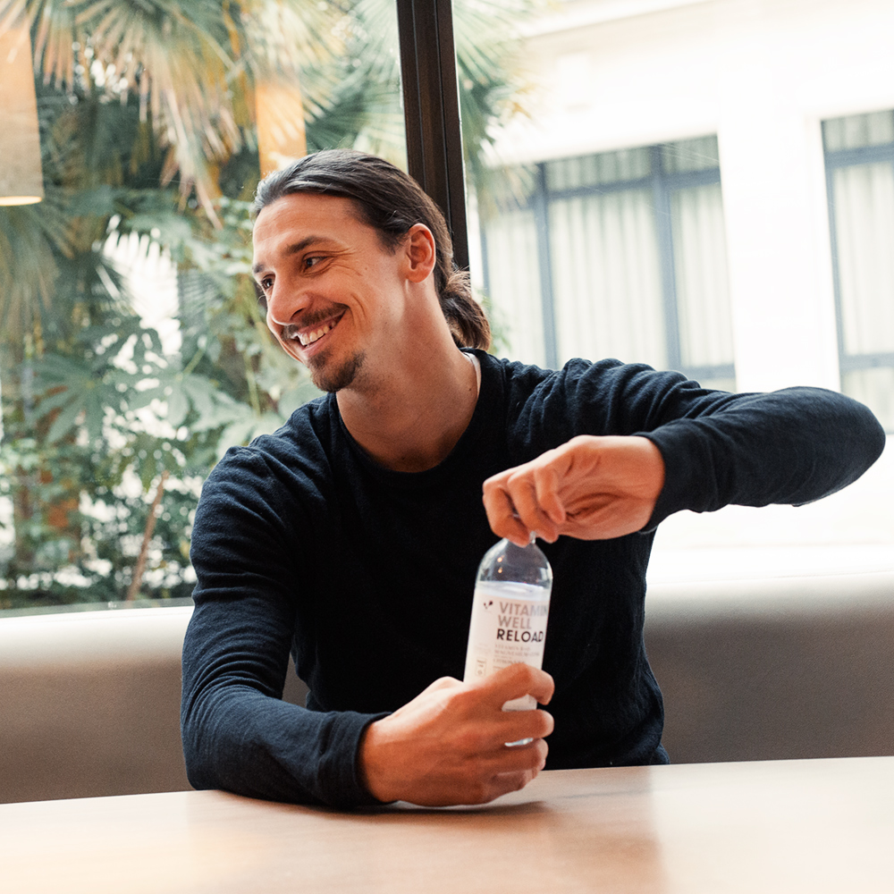Vitamin Well and Zlatan has established a cooperation where Zlatan Ibrahimovićwill operate as an ambassador for the brand in Europe. Vitamin Well is a Swedish company where everything from production to development takes place in Sweden. The purpose of the ambassadorship is for Vitamin Well to reach the international market in association with a person who has one of the sports world's most powerful brands.

- We are of course delighted to have Zlatan in our team. Vitamin Wells Swedish origin is something we are very proud of and what better than to work with a Swedish living legend as Zlatan Ibrahimovic. The fact that he also has an urban, smart and healthy profile makes the collaboration even more obvious, says Jonas Pettersson, CEO of Vitamin Well.

The partnership will be announced in December and Vitamin Well and Zlatan will conduct several activities together during 2015.

- It´s going to be truly exiting to work together with team Vitamin Well. To help a young and hungry, and above all a Swedish company, out into the world feels like the right challenge for me, says Zlatan Ibrahimović.

**For more information, please contact:**

Catharina Carlsdotter, head of marketing, Vitamin Well, Tel: + 46 708-91 95 08 [catharina.carlsdotter@vitaminwell.se](mailto:catharina.carlsdotter@vitaminwell.se)

**About Vitamin Well**

Vitamin Well is a Swedish company since 2006 with the ambition to create a more healthy alternative to sodas and sugary juices. Vitamin Well is a challenger in the Nordic beverage market and strive to produce smarter and better tasting beverages for the Nordic countries. And now the rest of Europe. All production and development takes place in Sweden.

Today, Vitamin Well has three beverage categories on the market; Vitamin Well Originals are available in eight different flavors, Vitamin Well stevia sweetened with steviolglycosider and comes in three different flavours and Vitamin Well Sparkling Water, which comes in three different flavours. For more info: [www.vitaminwell.se](http://www.vitaminwell.se).