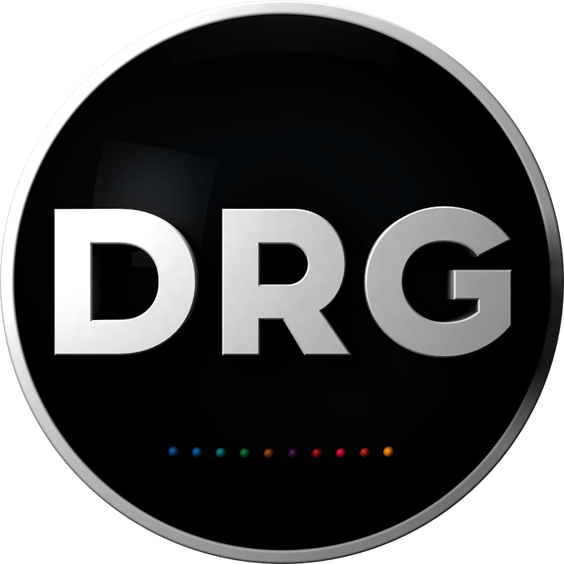

**NEWS**

**NEWS**

**DRG AND UKTV JOIN FORCES TO CO-COMMISSION**

**NEW COOKERY AND LIFESTYLE TITLE**

***Rachel Khoo: My Swedish Kitchen* to launch at MIPTV**

**1st April 2019: DRG today announces that it has joined forces with UKTV to co-commission *Rachel Khoo: My Swedish Kitchen*, a new cookery and lifestyle series that’s due to air on the broadcaster’s Good Food channel this summer.**

The 8 x 30 series, produced by the Swedish company Splay One, part of the NENT Group, follows the popular British chef as she puts her own twist on traditional Swedish dishes in the kitchen of a ‘stuga’, an old-style wooden house. However, this is more than just a cookery show: Rachel spends time immersed in nature in the local countryside, making the most of her new way of life, as well as meeting with food producers and other local craftspeople. There’s also a sprinkling of witty anecdotes, charming stories and entertaining observations about her new homeland.

The show has been commissioned by DRG’s SVP of acquisitions, Mette Kanne-Behrendsen and Kirsty Hanson, commissioning editor at UKTV. It was ordered for Good Food by Vicky Walker, channel director.

**Mette Kanne-Behrendsen, DRG’s SVP of acquisitions and executive producer, struck the co-commissioning deal with UKTV. She comments:** “When we heard that Splay One, a sister company within the NENT Group, were talking to Rachel Khoo we were very excited. Rachel is such a fresh talent and her mouth-watering recipes, combined with the stunning Swedish backdrop, make for a compelling watch. I could immediately see this series finding a home with UKTV’s Good Food, so was delighted that they agreed and we were able to co-commission it in partnership.”

**Kirsty Hanson said**: “Having lived in Sweden for the past few years, Rachel is the perfect person to help Good Food viewers explore the country’s culture and food. The series is not only beautifully shot, but also the Swedish landscapes are breathtaking and escapist. A relatively undiscovered culinary history, the simplicity of the dishes really translates well on screen.”

**Rachel Khoo commented:** “I’m excited to share my culinary adventures around Sweden and the delicious recipes inspired by them from my little Swedish kitchen.”

**Vicky Walker, Good Food’s channel director adds**: “We are always on the lookout for distinctive new cookery content for Good Food. Rachel is an incredibly watchable and accessible cook and her ability to welcome viewers in to her new life and show a rarely seen, everyday Sweden is what makes this series so special.”

DRG retains the international rights for ***Rachel Khoo: My Swedish Kitchen***and will be officially launching the title to international broadcasters at MIPTV this month. The series is DRG’s second major commission, following documentary series ***Manson’s Bloodline***, and further endorses its strategy to be fully involved with all aspects of content from development and financing, through to commissioning, production and distribution.

- ends -

**About DRG**

DRG is an innovative, creative and fast moving business with content at its core. Starting life as a conventional programme distributor in 2007, the company has evolved into a 360-degree content business that today is involved with programme origination and development, financing, talent, production, production services and distribution. DRG also wholly owns Atrium TV, the new international drama ‘commissioning club’, focused on the development of blue chip scripted projects.

Covering scripted and unscripted content, as well as formats, DRG has built its reputation by working closely with, and investing in, a wide range of internationally recognised production companies, as well as by using its expertise in the domestic and international markets to help incubate promising start-ups. DRG has an extensive catalogue of more than 13,000 hours and 150 formats: the business has taken *Doc Martin* to more than 100 territories, including 7 international remakes, was a driving force in bringing Scandi Noir to the world and has nurtured *The Farm* to become one of the world’s most established competitive reality formats, with versions airing in more 50 territories over a 10-year period.

DRG is part of Nordic Entertainment Group (NENT Group). Headquartered in Stockholm, NENT Group is part of Modern Times Group MTG AB (publ), a leading international digital entertainment group listed on Nasdaq Stockholm (‘MTGA’ and ‘MTGB’).

**For further information, please contact:**

Michelle Waldron, Beyond the Box

[michelle@beyond-the-box.tv](mailto:michelle@beyond-the-box.tv)

+44 (0) 7768 568970