Discover the world on foot with Exodus
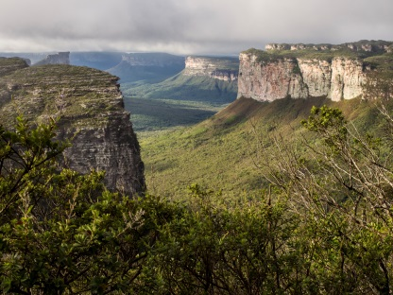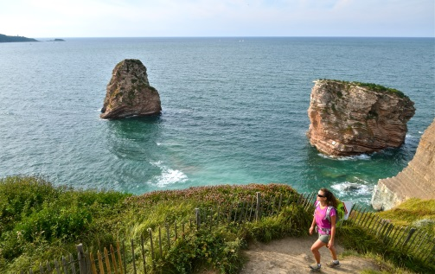
Adventure tour operator announces new walking and trekking tours for 2015/2016
London, 20 October 2014: As walking and trekking tours remain the largest part of the Exodus portfolio, customers new and old can expect a great selection of fantastic new adventures in 2015. Exodus, the UK’s leading adventure tour operator, is introducing 14 new walking and trekking trips for the coming year, taking travellers to some of the most beautiful locations all over the world - from New Zealand to the French Pyrenees and Brazil to the Basque Country.

Exodus has noticed an increasing demand for trips to iconic holiday destinations, illustrating a movement away from mainstream holiday packages to those with an added challenge or element of discovery. With short-haul walking trips proving a huge hit in 2014, the operator has built on these successes and is introducing trips where guests can experience the highlights of the Basque Country, with its colourful fishing towns and glorious coastline, or the famous Cinque Terre region of Italy, with its stunning views, quiet woodland and authentic wine-tasting classes.

Trips to Peru to trek the magical Inca Trail have also become increasingly popular, with Exodus seeing a growth of 8% over the past year. 2015 will see a new Brazil ‘Diamond Trail’ tour, visiting the Chapada Diamantina (Diamond Plateau), a remote mountainous area which was the scene of the 1842 diamond rush. Other new long haul trips include trekking in New Zealand, where travellers will enjoy an unimaginably varied landscape, visiting both Kiwi islands, rainforest and glaciers. Or why not really take on a more extreme challenge and conquer Everest with a climb to the North Col? Adrenaline junkies can also now climb 3000m peaks in the Queryas, the Southern Alps, or the Hinku Valley in Nepal.

Chloe Knott, product manager for Walking and Trekking at Exodus, said “This year we decided to focus more on the destinations themselves as we wanted to offer more on each trip. Trips to short haul destinations such as the Amalfi Coast and French Riviera have performed very well recently, so we have responded to this demand for Europe with trips to the Basque country, the Portofino peninsula and Burgundy. Our more adventurous customer-base will be pleased to see trips to Indonesia, Brazil and Everest.”

New trips for 2105 include:

Highlights of the Basque Country
Straddling the Franco-Spanish border and boasting a unique culture that pre-dates both its neighbours, the Basque Country has much to offer. The sparkling coastline, with sweeping golden beaches, colourful fishing ports and dramatic Atlantic surf, forms a perfect backdrop for the week of relaxed walking. Eight day trip from £1,049 per person, including flights from London, all accommodation, all breakfasts and a tour leader throughout. First departing 2 May 2015.

Walks of the Cinque Terre and Portofino
Located on some of Italy's most beautiful coastline, the trip’s base in the seaside town of Moneglia is a real treat for visitors. In the Ligurian ‘Gulf of the Poets,’ a UNESCO World Heritage Site since 1997, the walk includes a section of the famous Ligurian Blue Path which takes the group through terraced vineyards and olive groves on old mule tracks. Eight day trip from £999 per person, including flights from London, all accommodation, all breakfasts, tour leader throughout and a wine tasting session. First departing 15 May 2015.

On Brazil’s Diamond Trails
In 1842, in this remote mountainous area of Brazil’s northeast, diamond deposits were found, sparking a 20 year diamond rush. This is a region where flattop mesas rise above grasslands and crystal-clear waterfalls tumble over limestone escarpments dotted with caves and grottos. The group will explore a land carved by time and uncover its natural treasures.11 day trip from £3,049 per person, including flights from London, all accommodation, all breakfasts and a tour leader throughout. First departing 12 June 2015.

Trekking in New Zealand
New Zealand epitomises contrasting scenery and culture and is an ideal country for adventure travel. The group explores both islands on this trip, visiting off the beaten track attractions as well as the main highlights. Trek through dense rainforest, kayak with fur seals, hike along a glacier, climb up volcanic peaks and enjoy fish and chips on the beach. 23 day trip from £5,699 per person, including flights from London, all accommodation, most meals and a tour leader throughout. First departing 10 January 2015.

Walking in the French Pyrenees
This trip is based in the village of St Lary in the Aure Valley and explores the rugged ridges, peaks and passes of the region, including some sections of the famous GR10. The five daywalks are designed to show the best of the region while the evenings offer the chance to enjoy high mountain cuisine and, of course, a range of local wines. Eight day trip from £1,049 per person, including flights from London, all accommodation, all breakfasts and a tour leader throughout. First departing 16 May 2015.

Summits & Ridges of the Queyras
Nestled deep in the heart of the Southern Alps are the jagged peaks and rolling hills of the Queyras. One of the oldest mountain ranges of the Alps and one of the last to be opened to the public, it offers both an undisturbed natural beauty and an off the beaten track feel. This trek is not for beginners as it offers a challenging week of walking through wild, craggy terrain summiting numerous peaks, many of them over 3,000m. Eight day trip at £1,079 per person, including flights from London, all accommodation, all breakfasts and a tour leader throughout. First departing 12 July 2015, with further trips in August.

Mera Peak Expedition
A tough but rewarding expedition, this tour takes climbers away from the trails leading to Everest Base Camp to the sparsely-inhabited Hinku Valley. The group walks through a beautiful high alpine environment, where Mera Peak, the highest trekking peak in Nepal at 6,476m, towers over the valley. With good acclimatisation and plenty of willpower, climbers can reach the summit of this beautiful Himalayan peak. 23 day trip from £2,899 per person, including flights from London, all accommodation, all breakfasts and all meals on trek. First departing 20 March 2015.

Everest Advanced Base Camp Trek
After the success of the 2013 expedition to the North Col, Exodus is returning to the high climbs of Mount Everest. Led by legendary Exodus leader Valerie Parkinson, and joined by an expedition to the North Col, this trek allows climbers to experience the Everest only ever seen by those who dare to venture further than the comfort of Everest Base Camp. This shortened version of the North Col Expedition means climbers will reach a high-point of 6,400m at Advance Base Camp. 19 day trip from £4,799 per person, including flights from London, expedition tents, all meals outside Kathmandu and qualified climbing sherpas.

-ENDS-

For more information or to book please visit www.exodus.co.uk or call 0845 863 9601.

Press Information
For more information or to discuss a trip, please contact Paul Stokes, Carolyn van Vliet, Sara Whines or Natalie Amos at Four bgb on 0203 697 4200. Email: exodus@fourcommunications.com
About Exodus
Celebrating its 40th year, leading adventure tour operator Exodus has a vast range of adventure and activity holidays across seven continents, offering places as diverse and as exhilarating as Kilimanjaro, Machu Picchu, the Ice Hotel and Antarctica.
Whether it is solo travellers, couples, groups or families, Exodus offers an incredible choice of different trips for all ages.
Operating in 90 countries with over 500 tours, Exodus insists on low impact tourism and increasingly looks to bring benefit to local communities.
Activities on offer include walking, trekking, cycling, mountain biking, rafting, kayaking, caving, cross-country skiing, snowshoeing and dogsledding as well as many many more…
For the second year running Which?, the consumer champion, has listed Exodus in the top five holiday companies out of over 40 other travel providers.
Do you have an iPhone, iPad or iPod touch? Then download the new Exodus App for free from iTunes or from the App Store.

