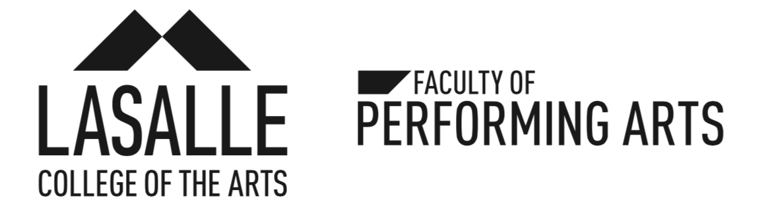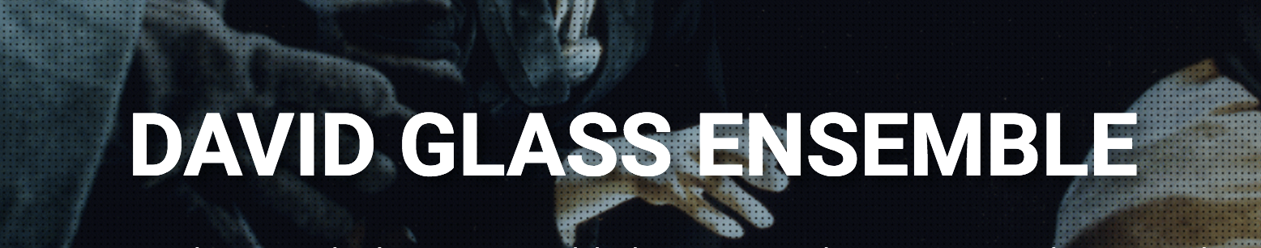

**———— FOR IMMEDIATE RELEASE ————**

**Contact:** Elisabeth Gunawan (Betty)

**Phone:** +65 9457 3029

**Email:** [davidglassensemble.betty@gmail.com](mailto:davidglassensemble.betty@gmail.com)

**REQUIEM FOR CHANGE — Singapore Premiere of a Visceral Physical Theatre Piece at LASALLE**

*A Global Collaboration Against Climate Change Between LASALLE College of the Arts (Singapore), the David Glass Ensemble and East 15 Acting School (UK)*

*“History came knocking at your door. Did you answer it?” -* Naomi Klein

Inspired by Naomi Klein’s earth-shattering book *This Changes Everything*, the David Glass Ensemble, LASALLE College of the Arts (Faculty of Performing Arts) and East 15 Acting School presents a global collaboration. ***Requiem for Change*** is an epic devised work about the titanic struggle between late-Capitalism and Climate Change; potentially the last great story of humanity. According to the UN’s recent report on Climate Change we have only 12 years to reverse the perils of global warming--and the world is watching.

This performance by a cast of 12 LASALLE actors and musicians will be running at the Singapore Airlines Theatre from November 20 - 24. The production is directed by David Glass, and features original music by John Sharpley, lighting design by Tommy Wong and costume design by Leonard Choo.

***Requiem for Change*** tells the story of mankind through the history of one family. Klein is an investigative journalist researching Capitalism’s effect on Climate Change, while her sister Naomi is a reclusive cellist who is battling nature to become pregnant. Naomi’s husband, Mahler is struggling to write a requiem to be performed at the close of the World Climate Change Summit in November 2016. *Requiem for Change* moves across fragments of time — from the liberation of the Nazi concentration camps in 1945, to the story of Nature, Naomi and Mahler’s young daughter, in today’s world. It chronicles the biggest global undertaking ever envisaged and enacted by human beings to save the planet and ourselves.

In keeping with the subject and the urgency of the situation, the piece has been developed internationally by young performers whose lives will be affected by the choices and actions we are taking—or failing to take—now. Over the course of two years, David Glass and his ensemble have worked with the same group of students to develop the piece in the UK at East 15 Acting School and in Singapore at the LASALLE College of the Arts, concurrently. The final year students at East 15 Acting School had premiered their version of the work in December 2017 under the title *This Changes Everything.* Now, the final year Acting students at LASALLE College of the Arts are preparing to present their **Requiem for Change**. Each group of students have contributed the nuances of their own artistry, leading to two pieces of theatre that are united, and yet uniquely individual.

In addition to the production, LASALLE College of the Arts, under the Faculty of Performing Arts, is hosting *Urgency: A Forum for Change* (on Saturday, 24 November at 4.30pm) to discuss and debate the calamity of climate change raised by the recent UN report and the increasingly deteriorating condition of our environments. Climate change experts, government officials, artists, students and the public-at-large are invited to use the Forum to register collective alarm and seek ways to force more public accountability to ensure Change.

*Requiem for Change* does not seek to preach. It is a visually and emotionally charged piece of physical theatre for the heart and mind, balancing satirical farce and epic tragedy. The story unfolds with the audience on three sides on the actual stage of the Singapore Airlines Theatre, reminding the audience that we are ‘actors’ in this global drama of survival and that we have the power to affect the future of the planet.

*Requiem for Change* will be running from November 20 - 24 at LASALLE’s Singapore Airlines Theatre on 1 McNally Street. Free tickets will be released through Peatix.com. The show times are as follows:

Wednesday, November 21 at 8pm

Thursday, November 22 at 8pm

Friday, November 23 at 8pm

Saturday, November 24 at 2pm and 8pm

“Energetic and visceral, uses the physicality of the performers to full effect, skilfully weaving together a strong visual language with narrative. David Glass has created an epic yet intimate production, which engages the audience to question their humanity, through stories which are personal and universal.” —Tracey Low, Producer - Manchester International Festival

“The images and set pieces were totally stunning. This is clearly the beginning of an important piece of epic theatre.”

—Mike Alfreds, Theatre Director

“David Glass remains one of the pioneers and key figures of British and International Theatre.”

—John McGrath, Artistic Director - Manchester International Festival

**

1.1 East 15 Production of *This Changes Everything.* Photo Credit Robert Golden.



1.2 East 15 Production of *This Changes Everything.* Photo Credit Robert Golden.

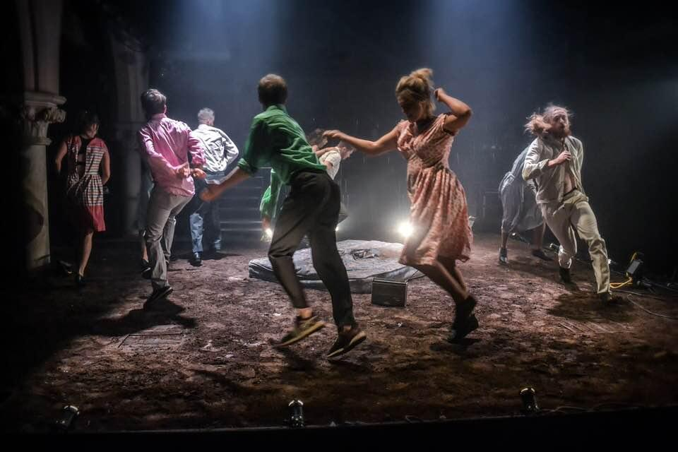

1.3 East 15 Production of *This Changes Everything.* Photo Credit Robert Golden.

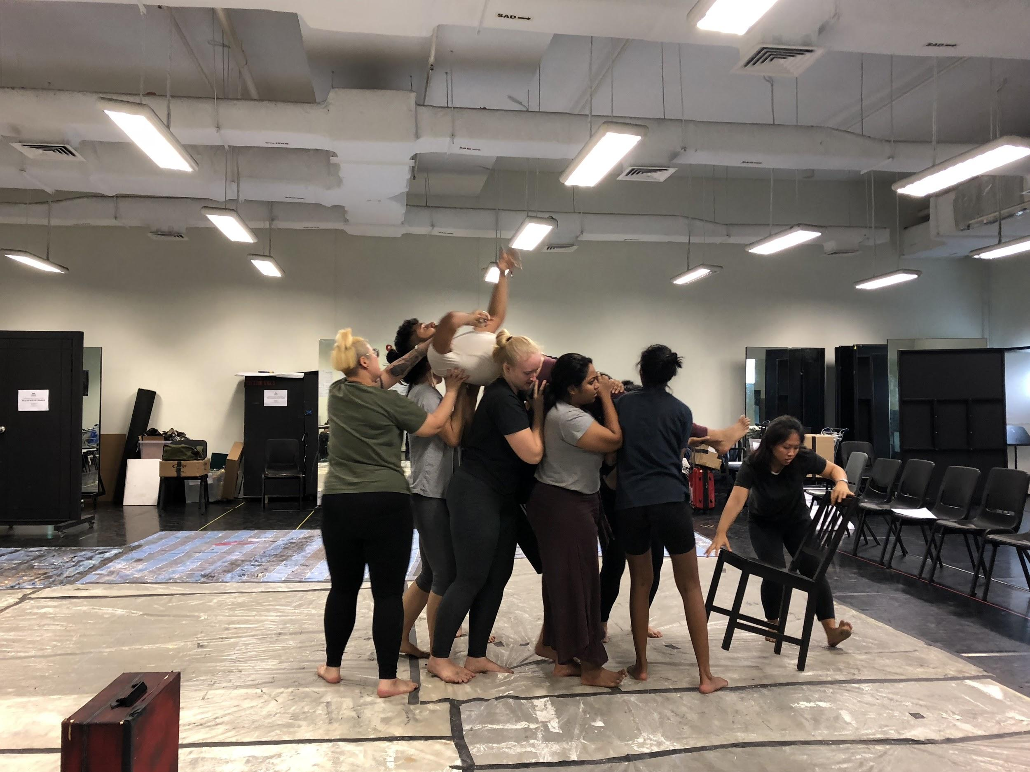

2.1 LASALLE students rehearsing a scene from *Requiem for Change.*

**LASALLE College of the Arts**

LASALLE College of the Arts in Singapore is a leading tertiary institution in cutting edge contemporary arts and design education and practice. The college offers more than 30 diploma, undergraduate and postgraduate programmes in fine arts, design communication, interior design, product design, film, animation, fashion, dance, music, theatre, arts management, arts pedagogy and practice, art therapy, Asian art histories, and creative writing.

Its faculty is led by a community of award-winning artists, designers, educators and researchers, and their practice-led research sets LASALLE apart as an international centre of excellence. Critically acclaimed alumni form the core of the cultural and creative sectors in Singapore and increasingly, internationally.

Founded in 1984 by De La Salle Brother Joseph McNally – a visionary artist and educator – LASALLE is a not-for-profit, private educational institution. LASALLE receives tuition grant support from the Singapore Ministry of Education. Its degree programmes are validated by Goldsmiths, University of London.

**David Glass Biography**

David Glass is an international award-winning solo performer, theatre director, writer, designer, filmmaker, teacher and creative thinker.

He is a leading international theatre teacher and has taught and influenced three generations of theatre makers in 73 countries including Simon McBurney (Complicite), Emma Thompson (Actress), Amit Lahav (Gecko Theatre), Hayley Carmichael and Paul Hunter (Told by An Idiot), Tom Morris (Warhorse) and John McGrath (Artistic Director Manchester International Festival) among others. He was also the first Mime to teach Footlights review in Cambridge, influencing a generation of actors and comedians such as Stephen Fry, Hugh Laurie and Emma Thompson to think with their bodies.

In 1999 he established David Glass Ensemble and has toured to 32 countries including Mervyn Peake’s *Gormenghast* which won him TMA Best Director award in 1992. He spearheaded theatrical adaptations of films including *Les Enfant de Paradis* –with Mike Alfreds-and Fellini’s *La Dolce Vita.*

His *Lost Child* Trilogy broke the mould of how theatre could be made. It was a collaboration with over 6000 street children in 22 countries.

Always visually stunning and provocative, his recent work includes an acclaimed production of *Bleak House*, a site specific Hotel version of *The Shining*, an epic work of physical theatre inspired by Naomi Klein’s seminal work on Capitalism and climate change titled *This Changes Everything*, and an outrageous work on the the Feminine Principle just as the MeToo movement was unfolding called *The Brides*. Always planting new seeds David has also helped establish Hong Kong’s Theatre Ash with his hugely visual work based on Kowloon Walled City titled *City Of Darkness,* which opened the Yogyakarta International Festival 2018.

David continues to work Internationally in 24 countries. The reformed Ensemble has strong partnerships with many institutions globally including Bath Spa University, East 15 Acting School, LASALLE College of the Performing Arts, the Central Academy of Dramatic Art Beijing, The Haque Centre for Acting and Creativity Singapore, Damansara Performing Arts Center in Malaysia, Marphy’s Playhouse Chengdu, National Theatre Of Serbia, Artogether Guangzhou, and Athens Festival. The ensemble’s reach is growing as he focuses on the coming generation of artists around the world.

As he enters his fortieth year in the arts David believes, more than ever, in a fast changing world, that the arts and creativity is the only possible way forward. He believes that culture creates windows, doors and bridges. The way forward is to empower through creative learning for ‘the young’ who will grow that future. He is a citizen of the world who resides in London.

###